The Wavemill Concept for Direct Measurement of 2D Ocean Surface Currents
Christopher Buck ⁽¹⁾, Marco Caparrini ⁽²⁾, José Marquez ⁽²⁾, Byron Richards ⁽³⁾ David Lancashire ⁽³⁾
⁽¹⁾ ESA/ESTEC, Keplerlaan 1, PO Box 299, 2200 AG, Noordwijk, The Netherlands, Christopher.Buck(at)esa.int
⁽²⁾ Starlab, Edifici de l'Observatori Fabra, Muntanya del Tibidabo, C. de l’Observatori Fabra s/n 08035, Barcelona, Spain, Marco.Caparrini(at)Starlab.es, Jose.Marquez(at)Starlab.es
⁽³⁾Astrium Ltd, Anchorage Road, Portsmouth, Hampshire, PO3 5PU, UK, byron.richards(at)astrium.eads.net, dave.lancashire(at)astrium.eads.net

Abstract
Mapping changes in the circulation of the ocean is a key occupation of oceanographers. The currents on the surface may or may not reflect the underlying ocean current due to the effects of wind, tide, bathymetry etc. This paper presents a new concept for an instrument that can not only measure directly the ocean surface currents but, at the same time, can map the surface topography from which the underlying geostrophic currents may be determined.

Introduction
Conventional altimeters provide extremely accurate measurements of the height of the ocean at the sub-satellite point. A time series of these measurements is used in models to determine the larger scale ocean circulation, however, smaller scale features such as ocean eddies, are poorly sampled by conventional altimeters and their relatively fast movement means that it is very difficult to track them using these measurements. In addition, in general the data provided by conventional altimeters is unreliable close to coasts due to land contamination of the received signal.
A means of mapping and monitoring such mesoscale ocean features was proposed by Rodriguez [1] in the form of the Wide Swath Ocean Altimeter (WSOA). This made use of across-track interferometry over swaths on either side of the sub-satellite track to determine the ocean height over these swaths.
The ‘Wavemill’ concept (Buck [2]) shares some of the same principles of WSOA but by means of multiple squinted beams fore and aft of the satellite, it is able to combine both across-track interferometry, as in the WSOA case for the determination of sea-surface topography, with along-track interferometry, for direct measurement of the ocean surface current. Moreover, since the antenna beams are squinted both fore and aft, the surface current is imaged from different (nearly orthogonal) directions from which true two dimensional ocean surface currents may be determined.
A further possibility, which is currently under investigation, is that as with the WSOA instrument, errors in baseline length and attitude of millimetres and arc seconds respectively, can result in sea-surface topography errors of tens of centimetres. However, due to its slightly asymmetric observation of the sea-surface from two different vantage points (fore and aft) deterministic and independent error profiles for both baseline length and attitude may be retrieved and hence eliminated from the final products.

The Wavemill Concept
To reiterate, the Wavemill concept is an attempt to retain all the benefits of WSOA while at the same time both finding a solution for its calibration limitations and measuring directly the ocean surface currents in two dimensions. In essence this is achieved by modifying the WSOA antenna configuration. This modification basically consists of separating the two antennas in both the across-track and along-track directions (i.e. parallel to the flight track). This configuration allows the 2D ocean surface currents to be measured directly by means of along-track interferometry (ATI) while maintaining the ability of WSOA to measure ocean topography over swaths by means of across-track interferometry (XTI). The baselines required for the Ku-band (13.3GHz) system under study are around 3.5m across track and 12.5m along track. Despite these relatively modest dimensions, as will be reported, the system performance is reasonable.
The possibility of measuring surface currents together with surface topography by combined ATI/XTI, also known as hybrid interferometry, has been successfully demonstrated in the past from airborne platforms e.g. Siegmund et al [3] as well as from space as in the SRTM mission [4]. The difference with the Wavemill instrument is that it aims to provide 2D ocean current measurements with a satellite single pass while at the same time determining the ocean surface topography over a wide swath. In this way it should be possible to separate the ocean surface currents from the geostrophic currents. If the results of the ongoing study prove conclusive in this respect then it can be said that Wavemill represents the most ambitious instrument to date regarding the study of the oceans.
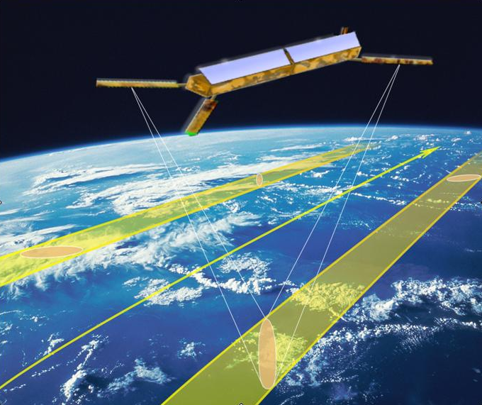
Figure 1: Wavemill Illumination Geometry

The first part of an ESA funded feasibility study of Wavemill by a consortium led by Starlab of Barcelona and including, Astrium UK and IFREMER has recently been completed and the finding are summarized below.

Main features of Wavemill:
- Interferometric side-looking reduced synthetic aperture radar (SAR) operation
- Right- and left-hand-side-looking observation to acquire a total combined swath of approximately 200 km
- Two beams squinted 25º fore (ahead of the satellite) and aft (behind the satellite) to measure ocean surface currents from different directions with an angular separation of 50º from which the 2D surface currents can be determined
- Incidence angle of 16º at mid swath as the best compromise for allowing the measurement of both ocean topography and currents
- Two channels per observation: mono-static and bi-static – one antenna both transmits and receives; a second only receives
- Four beams pulsed sequentially in burst operation mode

Due to the very high data rate and multiple beams, on-board processing will be necessary. Wavemill will therefore produce a total of eight different interferograms on board; four co-time interferograms (fore-right, fore-left, aft-right and aft-left) containing only topographic information and four hybrid interferograms containing both topographic and current velocity information.
The four co-time interferograms will have a dual purpose in that they will be used for both baseline calibration as well as sea surface height retrieval. The four hybrid interferograms also have dual application since this phase data will be split into topographic and velocity information from which sea surface height and 2D ocean currents shall be deduced.
The main system parameters for the Wavemill concept considered in the current feasibility study are given in table 1.

Parameter | Value | Units
Satellite altitude | 546 | km
Carrier frequency | 13.3 | GHz
Chirp bandwidth | 100 | MHz
Peak transmit power | 2.3 | kW
Noise Figure | 5.7 | dB
Pulse length | 74 | μs
PRF | 2700 | Hz
Total processed Doppler Bandwidth | 1400 | Hz
Burst length | 22.8 | ms
Antenna length | 4 | m
Antenna height | 0.2 | m
Effective XT baseline (co-time) | 3.38 | m
Effective XT baseline (hybrid) | 1.86 | m
Effective AT baseline (hybrid) | 12.41 | m
Sea current horizontal resolution | 1 | km
Sea topography horizontal resolution | 15 | km
Table 1: Wavemill – Main System Parameters

Performance
The performance of the Wavemill concept currently under study can be summarized by saying that the Wavemill system is able to measure sea surface topography with an absolute accuracy of better than 7.5cm the relative accuracy (pixel to pixel) should be significantly better than that.
The magnitude of the current velocity accuracy is better than 10cm/s for the whole swath. In terms of the sea surface current direction, however, it not possible to give a single figure of performance since this parameter depends on the both the strength of the sea surface current and, to a lesser degree, its direction and therefore, cannot be defined independently of the sea surface velocity magnitude. In other words, the directional accuracy is better for stronger currents. It is however possible to give a good idea of the achievable performance by saying that the current direction accuracy is better than 5º for currents faster than 85cm/s in the 90 percentile case.
Figure 2a shows the absolute sea surface topography accuracy as a function of along-track and ground range position, figure 2b shows the absolute sea surface current velocity as a function of current direction and figure 2c shows the sea surface current direction accuracy as a function of the magnitude of the current velocity.
Table 2 summarizes the main performance parameters in terms of the achievable accuracy for each of the geophysical variables to be measured by the Wavemill instrument.

Geophysical Variable | Accuracy
Sea Surface Topography | <7.5cm
Sea Surface Current Velocity | <10cm/s
Sea Surface Current Direction | <5º @ 85cm/s
Sea Surface Current Direction | <10º @ 42cm/s
Sea Surface Current Direction | <20º @ 21cm/s
Table 2: Performance summary of Wavemill

Figure 2: Performance Graphs (from top to bottom) a) Sea Surface Topography Accuracy, b) Sea Surface Current Velocity Accuracy, c) Sea Surface Current Direction Accuracy

Summary
The Wavemill concept currently being investigated within an ESA funded feasibility study has been presented. The main system parameters not only look reasonable but the concept seems to be very interesting in terms of the achievable performance. There is work on-going to look at the validity of the self-calibration concept for baseline attitude and length as well as the best choice of antennas. Already though, it is clear that Wavemill could prove to be an invaluable tool in providing ocean current data to the oceanographic community. Wavemill is unique in this respect due to its ability to separate out surface currents from the underlying geostrophic currents.

REFERENCES
1. Pollard B, Rodriguez E, Veilleux L, The Wide Swath Ocean Altimeter: Radar Interferometry for Global Ocean Mapping with Centimetric Accuracy, AEEE Aerospace Conference Proceedings 2002, 2, 1007-1020
2. Buck C, An Extension to the Wide Swath Ocean Altimeter Concept, Proceedings of the IEEE International Geoscience and Remote Sensing Symposium IGARSS, July 2005, Vol. 8, pp 5436-5439
3. Siegmund R, Bao M, Lehner S, Mayerle R, First Demonstration of Surface Currents Imaged by Hybrid Along- and Cross-Track Interferometric SAR, IEEE Transactions on Geoscience and Remote Sensing, Vol. 42, No. 3 pp 511-519, March 2004
4. Romeiser R, Breit H, Eineder M, Runge H, Demonstration of Current Measurements from Space by Along-Track SAR Interferometry with SRTM Data, Proceedings of the IEEE International Geoscience and Remote Sensing Symposium IGARSS, vol. 1, pp. 158-160, June 2002

