**Observation of Ocean Biology on a Global Scale : Is New Technology Required for Bio-GOOS?**

John Gunn1, Alex Rogers2, Ed Urban3

1Australian Antarctic Division, Hobart Australia; 2Institute of Zoology, London, UK; 3SCOR, Johns Hopkins University, Baltimore, USA.

1. **Abstract**

**One of the key messages to come from the Ocean Obs ’09 Conference was that the 1990’s revolution in technology for observing ocean physics (e.g. ARGO and remote sensing) provided the scope for a truly operational Global Ocean Observing System (GOOS) for key ocean physics variables during the first decade of the 21st century. Over the same period however, there had been limited progress in development of biological components within GOOS, the expansion of the Continuous Plankton Recorder network and the development of an Ocean Tracking network being promising exceptions.**

**Excitingly, there have been quantum advances in the technology to study biological components of ocean ecosystems over the last few years. These include microbial samplers employing genetic and optical systems to identify and count the lower levels of the trophic webs; smart electronic tagging technologies that allow animals to be tracked, their habitats and feeding habits revealed, and their physiology monitored; acoustic sensors and associated processing software to undertake qualitative and quantitative studies of animals in the water column; and mobile and fixed observation systems to explore benthic habitats and processes.**

**The potential for these technologies to be deployed over the next decade is explored, along with the desirable advances in sensor technology.**

**The urgent need for enhanced data on the state of ocean ecosystems – under pressure from multiple human stresses – demands that the ocean biology community work together, with some urgency, to drive implementation of a more comprehensive “Bio- GOOS. Mature technologies are available now, and several others may reach this status over the next decade, make BioGOOS a feasible prospect over this period.**

1. **The Motivation for Biological Observation Systems**

The significant human impacts on the physical properties of the global oceans and the resilience of marine ecosystems, from the coastal margins to those of the deep open ocean, are becoming obvious even before the most serious impacts of climate change begun to be felt:

### 25-30% of fish stocks are overexploited, depleted, or recovering worldwide (FAO, 2009). Illegal, unregulated, and unreported fishing is rampant. Increasing human population worldwide and pressures on other food sources will place increasing pressure on fishery resources.

* Disruption of food webs through overharvesting and trophic cascades is leading to the “rise of slime” (Jackson, 2008).
* The number of marine animals, particularly predators, such asfishes, sharks, birds, marine mammals, and turtles, that are endangered is increasing (Myers and Worm, 2005)
* Coral reefs, and indeed many coastal ecosystems, are under serious threats from various sources.
* There is a growth in “dead zones” from hypoxia/anoxia (Gilbert et al., 2009).
* Harmful algal blooms seem to be increasing in many ecosystems worldwide (Glibert et al., 2005).

Few would argue with the thesis that understanding the abundance, distribution, and biodiversity of marine biota, and what controls these, are essential for maintenance of the diversity of life on the planet, and the goods and services provided by the ocean (MA, 2005). The ocean is a critical sink for anthropogenic carbon, an essential contributor to food security globally, is growing in importance as a source of pharmaceuticals, and for communities in the developing and developed world is a source of valuable tourism income (e.g. Arico & Salpin, 2005; Ehrlich et al., 2006; Houghton, 2007; FAO, 2009; Hoegh-Guldberg et al., 2009; Sabine & Tanhua, 2010). Meta-analyses have identified strong relationships between species richness and measures of ecosystem function, and resilience to exploitation in marine ecosystems (Worm et al., 2006; Danavaro et al., 2008; Ruhl et al., 2008).

In short, we know our ocean ecosystems are important on many levels, and that we’ve been stressing them badly over the last century. Yet we have failed in many ways to develop an adequate, let alone comprehensive, system for observing and understanding the health of these biological systems.

The economic costs of not responding effectively and in a timely fashion have been, and are likely to continue to be, significant. The World Bank/FAO (2008) concluded that in many parts of the world we have been managing the ocean almost blindly and that mismanaging marine ecosystems may be costing society billions of dollars annually. Poor management of marine capture fisheries alone has been reported to lead to a difference between the potential and actual economic benefit of the industry of about US$50 billion per annum (World Bank and FAO, 2008).Population and ecosystem models have grown in sophistication over the last decade and have provided valuable insights into the trends and dynamics of some ocean ecosystems (Fulton et al., 2005, Myers and Worm 2003). However, there is now growing awareness that models alone cannot solve the problems but sustained, long-term observations of marine life are also required to detect bioinvasions, ecological regime shifts, and changes in phenology in marine communities, as well as the effects of over-exploitation (e.g., Edwards et al., 2008).

Improved observation capabilities and increased observation effort are crucial now because the physical nature of the global ocean and the abundance and diversity of life within them are changing more rapidly than in previous human history, due to fishing, habitat destruction, increasing temperatures and decreasing pH and oxygen levels with associated regime shifts (ecological, physical and chemical). These changes will continue to drive global-scale changes in the Earth system and already we have evidence that they will have a significant impact on marine ecosystems and increase the risk of extinction of the species within them. Long-term sustained monitoring with increased spatial and temporal resolution are important for understanding long-term cycles upon which human-induced changes are superimposed, and for providing a base from which forecasting is possible. With adequate investment in observations, it will be possible to make the necessary progression from understanding and describing the nature of change, to prediction and mitigation (Cury et al., 2008).

In this brief review we examine: the nature of the challenge of developing sustained global observation systems for ocean life; the state of technology available to observe the gambit of biological systems, from microbes to apex predators, species to ecosystems; and the feasibility of making significant progress over the decade 2010-2020.

1. **The Challenge**

Ocean life is not easy to observe. The ocean’s dynamic nature, opacity, vast scale and hostile environments tend to make the logistics and technological requirements of observation difficult and expensive. The ocean covers more than two-thirds of Earth’s surface and its average depth is 3790 m. Seawater is relatively opaque to light; even in the clearest ocean areas, light is reduced to 1% within 200 m below the surface. The deep ocean is particularly difficult to observe because of the immense pressures there and the need to develop sensors that can withstand such pressures. Until recent decades, most observations were made with surface-deployed gear, such as nets and dredges that remained relatively unchanged since the time of the expeditions of *H.M.S. Challenger*. Today, technology is available to observe biological phenomena over the large spatial (horizontal and vertical) and temporal scales relevant to understanding marine ecosystems.

However, because of the difficulties of observation, the ocean is still under sampled in both space and time, particularly for non-commercial species and in remote locations. Observations of many ocean organisms have required techniques other than light, such as acoustic sensing, to bring “visibility” to the depths, and collection devices to bring organisms to the surface. Each of these approaches has benefits and drawbacks. Systematic observations are almost totally focused on lower trophic levels, so there is a gap in our understanding of organisms at higher trophic levels. An exception is for surveys of commercial fish and endangered marine species such as marine mammals, turtles, and birds. But such observations are oftenlimitedin focus and may miss species that are key to ecosystem structures and functions.

The United Nations Assessment of Assessments (AoA) (UNEP and UNESCO, 2009), which has been referred to as the “IPCC of ocean status” concluded that models for process understanding, ocean health/risk assessment, and prediction are ahead of the supply of data (UNEP and IOC-UNESCO, 2009). To achieve the goals of future versions of the AoA, namely sustainability and building resilience on a global scale, we need vastly improved observation systems, networks, and information bases.

In discussion of what an ocean biology observing system “should be”, the choice between two basic designs is often a subject for debate. Should the focus be on :

1. A system with a regional-to-global reach focused on selected variables and employing remote and/or expendable observation technology that is relatively inexpensive to operate on a sustained basis, or
2. A network of systems with more local reach, focused on a more comprehensive suite of variables, using technology that is re-deployable and is often more expensive, and requires more support to be run on a sustained basis.

The Ocean Obs ‘09 white papers, presentations and workshops on observing ocean biology provided ample evidence of a revolution in biological sensors and technology over the last decade. Most importantly, we also learned of the successful deployment of systems/networks in a wide variety of environments. The goal of this paper is to present the state of the technologies, most of which could be deployed widely in 2010-2020, and to offer some suggestions on which of the two alternative system designs might be most achievable and useful over the next decade in observing “the global ocean”.

1. **Whistlestop Tour of Existing/Developing Systems and Sensors**
   1. **Microbes To Zooplankton**

It has long been understood that the structure of planktonic communities (summarized in Table 1) is vital to ocean health and function. Populations of microbes (viruses, bacteria, phytoplankton, protozoans, etc.) and zooplankton are the links between ocean biogeochemistry and organisms higher in ocean food webs.

Table 1 Size groups of plankton (based on Sieburth 1979)

|  |  |  |
| --- | --- | --- |
| **Name** | **Size range** | **Examples of organisms** |
| Femtoplankton | <0.2 µm | Virus |
| Picoplankton | 0.2-2 µm | Autotrophic prokaryotes *Synechococcus* sp., *Prochlorococcus* sp. Autotrophic eukaryotes  *Bathycoccus* sp.  Heterotrophic bacteria and arkaea |
| Nanoplankton | 2-20 µm | Auto and heterotrophic flagellates, ciliates, small diatoms and dinoflagellates |
| Microplankton | 20-200 µm | Ciliates, diatoms and dinoflagellates |
| Mesoplankton | 0.2-2 mm | Copepods |
| Macroplankton | >2 mm | Copepods, krill, gelationous plankton, e.g. jellyfish |

Satellites currently provide global synoptic coverage for chlorophyll at and near the ocean surface, but not species and community information, or information much below the ocean surface. There are a few, notable, long-term, in-situ, time series of phyto- and zooplankton collected using relatively simple technology, for example, (1) Continuous Plankton Recorder (CPR) transects have run since 1925. The longest CPR series has been conducted in the North Atlantic Ocean by the Sir Alistair Hardy Foundation for Ocean Science (SAHFOS) (Burkill and Reid, 2010), but four other CPR series have been developed since the SAHFOS survey was started and others are being planned, (2) the California Cooperative Fisheries Investigations (CalCOFI) have run repeat plankton surveys since 1949 (Mantyla et al., 2008), and (3) zooplankton have routinely been sampled at reference sites as part of local, national and regional oceanographic programs throughout the global ocean, many for decades. The attractiveness of these sampling programs and approaches is that they use relatively simple and inexpensive technologies that have been employed for long periods of time. CPR surveys have demonstrated shifts in the distribution of planktonic species, invasions, and changes in phenology in surface plankton communities (Reid et al., 2007: Edwards et al., 2008). The sixty-year CalCOFI time series has proven useful for charting and understanding the fluctuations of marine organisms ranging from microbes to fish (e.g. Hsieh et al., 2009) and their interactions with biogeochemistry (Rau et al., 2003).

All of these programs involve intensive sampling, sorting, counting and identification of plankton communities by researchers – so while the technology is relatively inexpensive, the total cost is often high. The “holy grail” of observations of planktonic communities is to develop technologies that permit fast, automated, inexpensive species identification and counting.

The paradigm shift in recent years to include the “microbial loop” in ocean food webs, and the quantum advances in genetic methods, have provided increased impetus to development of automated or semi-automated technologies. In particular, the development of massively parallel DNA sequencing or ultrasequencing using pyrosequencing (454) technology has enabled scientists to assess the true diversity of bacterial and viral communities in the oceans for the first time (Angly et al., 2006; Sogin et al., 2006). This technology has also been applied to analyses of the gene expression of environmental samples of bacteria (Frias-Lopez et al., 2008) opening the prospect of detecting responses of entire microbial communities to changes in physical conditions of the ocean. Although many of the new generation of sophisticated instruments are too expensive to deploy widely, they provide new understanding of ocean ecosystems and, as with most instruments, there is hope for decreased prices as technologies develop and the number of instruments increases. Application of such methods to in-situ monitoring will depend on miniturisation of these technologies or the development of methods to take archival samples over extended time-periods for later analyses.Three notable examples of *in situ* technologies that are already in development or use include the following (Figure 1):

1. Imaging Flow Cytobot (Olson et al., 2003)—This device allows discrimination of different types of individual phytoplankton cells through flow cytometry and imaging. The instrument has been deployed in coastal areas on a profiling platform that travels up and down through the water column on a cable. It was first tested in the waters off Cape Cod (USA). Recently, this device was deployed in the Gulf of Mexico to detect blooms of the harmful algae *Karenia brevis*, but in early 2008 detected a different harmful algae species (*Dinophysis acuminata*) and allowed a closure of the shellfishery before any humans were sickened (WHOI, 2008)
2. Autonomous Microbial Genosensor (Fries et al., 2007)—This device uses RNA amplification in situ to detect algal species, and its main application presently is for detection of harmful algal blooms.
3. Environmental Sample Processor (ESP) (Scholin et al., 2009)—This instrument was developed by Chris Scholin’s group at the Monterey Bay Aquarium Research Institute (MBARI) and has been deployed on MBARI’s deepwater cabled observatory MARS (Monterey Accelerated Research System: <http://www.mbari.org/mars/>). The ESP is currently capable of real-time deployment of chemical sensing arrays to detect a variety of specific proteins, real-time application of quantitative polymerase chain reaction (PCR), and archival of samples for whole-cell microscopy and Fluorescence *In Situ* Hybridization (FISH), nucleic acid analysis, and determination of phytotoxins from harmful algae (Mikulski et al., 2008; Preston et al., 2009).
   1. **Higher Trophic Levels**

Fishery catch data represent the most significant investment in and data holdings of observations of global ocean biology. The limitations of fishery-dependent data for estimating single species abundance and distribution are well documented. In brief: fishery data tell us where the fishers go (not necessarily where the fish are). The interpretation of catch and effort data as a basis for estimating absolute abundance, and impacts of environmental influences on this, requires many assumptions about effective effort, distributions of animals relative to the fishing effort and population responses to stock depletion (the “stock-recruitment relationship” (Garcia 1996)). Nevertheless, the wealth of fishery data, and the availability of long time series in some areas have provided valuable insights into the impacts of fishing on fish populations and the ecosystems that support them. The Census of Marine Life ([www.coml.org](http://www.coml.org)) History of Marine Animal Populations (<http://www.hmapcoml.org/>) and Future of Marine Animal Populations (<http://www.fmap.ca/index.php>) programs, in particular, have mined significant data resources and through meta-analysis examined global trends in the health of populations, taxa, and ecosystems. Based on these metanalyses, predictions of future states of the high trophic levels of the oceans are now being made (Worm et al., 2006; Heithaus et al., 2008).

For species either not caught by fisheries or taken as bycatch, observational data are less abundant. Surveys of endangered marine species (mammals, turtles, and birds), most often involving counts and collection of demographic information, have chronicled the demise, and in some cases rebuilding, of populations. The advent of routine and well-designed observer programs to monitor by-catch have also provided much needed information on the biodiversity of under-explored regions and the impact of fisheries on ecosystems (e.g. Hall, 1996; WGEAFM, 2008, 2009).

Fishery data, fishery surveys, population censuses and by-catch studies provide relatively little understanding of the behavior, habitat use and eco-physiology of the upper trophic levels of ocean biological systems. Thus, teasing out the relative impact of environmental change and other effects of human disturbance has been problematic. A revolution in the observation of behavior, habitat use, biology and physiology of larger marine animals (including cephalopods, crustaceans, fish, sharks, birds and marine mammals) has occurred over the last 30 years with the advent of a suite of electronic tagging technologies. The Census of Marine Life (CoML) (http://www.coml.org/) has been a major supporter of the development and deployment of new tags, as have been some national research organizations, such the Centre for Environment, Fisheries and Aquaculture Science in the UK (<http://www.cefas.co.uk/>), the Sea Mammal Research Unit in Scotland (<http://www.smru.st-and.ac.uk/>) and the Australian Commonwealth Scientific and Research Organization (CSIRO: <http://www.cmar.csiro.au/tagging/>) (Figure 2). The CoML Tagging of Pacific Predators (TOPP) project has been particularly active in developing and deploying animal-based tags. Such tags were first used to determine the three-dimensional tracks of marine organisms over time, allowing inferences about feeding, breeding, and nursery activities and travel among areas used by the animals for these purposes. They have allowed delineation of stock interactions (Rooker et al., 2008). Over time, “biologging” scientists began to include sensors of environmental parameters on the same tags, so that better understanding could be developed regarding how environmental parameters affect the distribution and movement of marine organisms. Many of the tags available today can relay information via satellite or acoustic links to moored listening stations. Sensors on animal-based tags can now provide data about the position of a tagged animal, temperature, light, pressure, salinity, fluorescence, a chlorophyll proxy, foraging events, heart rate, and speed and acceleration of the tagged animal. More than 50 different marine species have been tagged, spanning three trophic levels, covering a geographic range from the tropics to the polar oceans, and from the coast to the open ocean. The measurements provided from these tags have helped us better understand habitat utilization, foraging and breeding behavior, physiology, and population biology, and are useful for management of habitat, commercial fish species, and protected species. In addition, tags deployed on animals in the Southern Ocean have helped us understand the physical dynamics of this area and how it is changing.

One final application of tags is that used by the CoML Pacific Ocean Shelf Tracking (POST) project, which has used the approach of placing transmitting tags in a large number of fish and setting up curtains of receivers in rivers and coastal areas of the U.S. and Canadian west coast to track their movements (Chittenden et al., 2009). The POST system has made it possible to develop better estimates of natural mortality and to determine where fish spend their time when in the open ocean. One practical result has been the ability of scientists to provide information to managers about survival of salmon smolts following stress as they pass through dams (Rechisk et al., 2009). The POST technology is being extended to other parts of the global ocean as part of the Ocean Tracking Network (O’Dor et al., 2010). Passive acoustics has been used by the CoML Census of Coral Reefs (CReefs) project in the form of Ecological Acoustic Recorders (EARs) for monitoring of coral reefs, including the appraisal of coral reef biodiversity, activity of sound-producing organisms, and human activities in reef areas (Lammers et al., 2008).

Marine vertebrates can help us understand the ocean in new ways. Their movement and activities can provide a new window through which to observe physical and, potentially, biological structure in the ocean. They can allow us to see where other technologies are blind, providing a cost-effective complement to other approaches. Marine vertebrates can be fitted with sensors that measure various ocean parameters, and thatsend the data through satellite links or store it in archival tags. These sensors do not increase mortality of tagged animals or damage their health, but do provide data that will ultimately help us protect their environment (e.g., Biuw et al, 2007; Tremblay et al., 2009). Observations collected by marine vertebrates have a lower ecological impact and smaller carbon footprint compared tomostother methodologies, such as ship-based measurements. Studies of the movements of marine vertebrates and the environmental conditions they encounter can provide sensitive indictors of medium- and large-scale variability in the ocean, as well as change (Boehme et al., 2008; Chariassin et al., 2008).

* 1. **Benthic Systems**

Benthic ecosystems – spanning from inshore embayments through to coral reefs, seamounts and abyssal plains - require a broad spectrum of observations, from biogeochemistry to upper trophic levels. Increasingly, we are understanding the importance of these systems in carbon sequestration, breakdown of pollutants, nutrient regeneration and secondary production. Yet we know less about many of the deep ocean habitats than we do about the Moon.

# The variety of benthic habitats and the challenges and costs of operating in the open ocean have driven the development of a suite of observational tools and approaches – from the standard trawls, sleds and grabs used through the last century, to sophisticated (and costly) ocean observatories.

The Porcupine Abyssal Plain Observatory, established in 1989 by the National Oceanography Centre, Southampton (UK)**,** in the North Atlantic Ocean off the coast of Ireland has been sampling using photography, benthic landers and trawl sampling at the seafloor and basic chemical and biological measurement throughout the water column for over two decades, and since 2002 has used instruments moored at the site (e.g., Wigham et al., 2003). Likewise, studies deploying landers in the NE Pacific over a period of a decade have demonstrated that climate-driven variations in food supply were significantly related to were faunal abundance, benthic community composition and remineralization over seasonal and interannual scales at depths of more than 4,000m (Ruhl et al., 2008). Such studies have given new insights into variation in biological communities in the deep ocean over contemporary timescales and provide an insight into the potential of a global network of benthic observatories to monitor the effects of environmental change on biogeochemical cycling even in the deep ocean.

# Over the past two decades, generations of remotely operated vehicles (ROVs) and autonomous underwater vehicles (AUVs), deployed from ships or land (Figure 3) have provided capabilities to explore (film, sample and map) habitats ranging from coral reefs (NOAA, 2009) to the world’s deepest ocean floors (JAMSTEC 2009). In combination with powerful new bathymetric mapping and visualization technologies, such as vehicle-mounted multibeam bathymetry, laser swath mapping, sub-bottom profiling and high definition digital cameras, the scope for broad and detailed examination of benthic habitats has never been greater.

# For the more detailed, process studies of benthic systems, fixed observatories, cabled to shore based facilities (providing power and allow high data throughput) are operating or being developed in many parts of the Atlantic and Pacific Oceans and neighboring regional seas – e.g. the US Ocean Observatories Initiative (<http://www.oceanleadership.org/programs-and-partnerships/ocean-observing/ooi/>), the MARS observatory in California (http://www.mbari.org/mars/ ), the European Community’s EuroSITES (http://www.eurosites.info/) ; the CanadianNeptune Observatory (<http://www.neptunecanada.ca/>). As an example, the Neptune Observatory has deployed a benthic system equipped with active and passive acoustics; sensors for salinity, temperature, and density; a sediment trap and a plankton pump; a fluorometer; and still and video cameras (Figure 4). Free-fall devices, including landers, baited landers, “camera traps”and baited deep-ocean autonomous experimental devices (Oceanlab) can photograph and capture fish and perform experiments, such as measuring respiration rates (Ruhl et al., 2008).

1. **Feasibility of a Truly Integrated GOOS for 2010 to 2020**

The technology briefly introduced above, and described in detail in the Ocean Obs ’09 white papers, vary in sophistication, durability, maturity and cost. They undoubtedly provide the potential for a revolution in the observation of ocean biological processes, biodiversity and ecosystem change. Some could be deployed throughout the world’s oceans to provide synoptic coverage, much as Argo floats have done over the last decade, while others are designed to focus on local processes (Figure 5).

With such a wide range of technology available, what are the prospects for including a suite of new biological variables/observations within the Global Ocean Observing System (GOOS) in 2010-2020?

The instruments and approaches included in Fig. 5 could be combined to make this goal feasible and there is substantial potential synergy available by using several approaches together in an integrated way. Considerations for deployment of new GOOS sensors relevant to ocean biology are as follows:

* Platforms are available now for global measurements of biogeochemistry and for movements of marine organisms. New capabilities are rapidly developing, but existing instruments could be deployed now; the limitation is primarily financial and not technical.
* Different systems need to be designed to approach local versus global questions. Specifically, global deployments require standardization and relatively low-cost instruments.
* Following the concepts developed within the Regional GOOS Alliances, a federation of standardized local biological observing systems contributing to global databases could be considered, as distinct from a centralized global system.
* Development of biologically relevant GOOS components will require a willingness of scientists from different nations to compromise on a standardized system design and to share the resulting data.
* Deployment of global biological observations as part of GOOS will require support from the scientific community in terms of using the systems for their science and from governments to both use the observations and pay for the system.

There are still untapped opportunities in integrating sampling technologies to provide cost-effective interdisciplinary observations, for example, the combination of simultaneous observations of oceanographic conditions and animal abundance and distributions. Advances need to be made in automation of analysis, because the increased observation effort will result in greater amounts of data, requiring improved methods (ideally rapid and automated) to analyze and distribute data to a broader community of oceanographers and biologists working together.

The SCOR Workshop on Ocean Biology Observatories focused on five applications of ocean observations that could be particularly fruitful in 2010-2020[1]:

*Observational approaches to ocean acidification and oxygen depletion*—Low oxygen levels (hypoxia) have been known in specific areas of the ocean for a long time, but hypoxia seems to be an increasing problem in some areas and, overall, oxygen concentrations are set to continue to decline in the future (Keeling et al., 2010). Ocean acidification, a decrease in ocean pH caused by increasing CO2 entering the ocean from the atmosphere, has been discussed for less than 10 years. These two problems can have negative synergistic effects (Brewer and Peltzer, 2009). Increasing hypoxia and ocean acidification are two issues that require extensive observations of biogeochemistry and biological communities.

Organisms growing in waters along the west coast of the United States may already be experiencing large impacts as a result of the synergistic effects of coastal upwelling and ocean acidification (Feely et al., 2008). During upwelling along this coast, water with increased CO2 levels and decreased pH (due to organic mineralization through respiration at depth) is brought onto the shelf and into the surface ocean. Recent observations of the decline in growth rates of tropical shallow-water coral reefs are also thought to be a response to ocean acidification in combination with other changing environmental parameters (Cooper et al., 2008; Bak et al., 2009; De’ath et al., 2009; Tanzil et al., 2009).

There is evidence for an increase in the occurrence of hypoxic and suboxic conditions in coastal waters (Diaz and Rosenberg, 2008). In these areas, low subsurface O2 levels can be generated by shoaling of the oxic/hypoxic boundary, natural high biological productivity in upper waters, or eutrophication from agricultural runoff or sewage inputs (Vaquer‐Sunyer and Duarte, 2008).

What are the priority observations to address these issues? At this time, systems exist for autonomous measurement of p(CO2). These take two forms: one based on equilibrating the water with a gas phase and measuring the CO2 concentration in the gas phase using an infra‐red technique (e.g., the Seaology® Monitor of Battelle), the other is based on equilibrating the CO2 through a membrane and measuring the resulting pH change in the solution (e.g., the SAMI instrument of Sunburst Sensors, Ltd.). pH can be measured using either a spectrophotometric approach (*e.g.* the SAMI‐pH instrument) or a potentiometric approach (e.g., based on a Honeywell Durafet® as is being developed at MBARI). Although both systems show promise, additional work will be needed to provide high‐quality stable calibrations over the range of temperature and pressure that might be experienced on a mooring or profiling float. Unfortunately, using this pair of parameters is not ideal since both parameters are functions of temperature and pressure and they are significantly correlated with each other. To obtain a detailed picture of ocean acid‐base chemistry, these parameters need to be measured precisely with a low uncertainty, but such low uncertainties have not yet been demonstrated for oceanic pH measurements. Perhaps the ideal measurement pair would be pH and total inorganic carbon. Work is progressing on developing an autonomous system for TIC (Sayles and Eck, 2009), but such an instrument is not yet commercially available.

There is currently no standard commercial off-the-shelf set of sensors for alkalinity/pH/p(CO2) and so work needs to be done on developing these to a point where they can be operationally deployed for reasonable periods (six months or more) and in a profiling mode. It is not yet practical for autonomous measurement systems to fully characterize the acid-base composition of a seawater sample, but sensors to monitor seawater pH on a long-term basis should be available in the 2010-2020 period. The measurement of dissolved oxygen in seawater is well established and some oxygen sensors have been deployed on Argo floats. Additional floats should be equipped with oxygen sensors to expand the spatial coverage of the ocean, even though there is a significant cost. Moored oxygen sensors could and should be deployed in key locations. Key species representing different trophic levels and functional groups from diverse ecosystems/biomes across the global ocean, need to be observed. These should include examples of key species from individual ecosystems that drive the biogeochemical cycle in each region. Measurements should include primary production, remineralisation, abundance and biomass, shifts in community structure and phenology, and levels of calcification.

Open ocean strategies like those articulated by Gruber et al. (2009) for oxygen (on Argo floats) and Iglesias et al. (2010) for ocean acidification, that leverage systems designed for measurement of physical parameters, should be implemented. For coastal areas, on the other hand, there is no well-developed global strategy even though there is significant work being done at regional and national levels through the GOOS Regional Alliances and others. There is a need for design and integration of a global coastal network of observations and data management, particularly for regional (large‐scale, but potentially geographically limited) coverage for the coastal ocean/continental shelves, because interpretation of local changes in coastal systems requires a 3D-context. A sensible approach may be to pick coastal regions that are known to be important from ecological or economic points of view, and pick representative cross‐sections of different systems (Figure 6).

The sampling strategy at each location should include a few high-resolution (moorings) and

high-precision measurements (ships), combined with slower spatially distributed (glider, tagged animals) sections. Ship-based measurements should include both commercial ships that voluntarily make oceanographic observations (e.g., for carbon system parameters: <http://www.ioccp.org/UW.html>) and hydrographic programs that repeat the sections occupied by the World Ocean Circulation Experiment (see <http://www.go-ship.org/>). Glider and tagged animal observations overlap with the open ocean Argo float coverage. Algorithms developed from the high-resolution and -precision measurements would be used to estimate the few parameters that gliders and tagged animals are able to measure. Models can then assimilate the full set of data to provide high-resolution 3D fields so that biologists can predict the impacts of the environment on ecosystem properties.

Development of a number of O2/pH/p(CO2) reference stations is highly desirable. A suite of 10‐12 global sites that are regularly maintained and calibrated along with a simpler downscaled set of observatories based on other platforms (e.g., gliders, existing moorings, modified Argo floats, ships of opportunity) is a minimum requirement.

*Observational approaches to community structure, from microbes to zooplankton—*Phytoplankton constitutes the base of most of the marine food web and provides about 50% of the global primary production. Zooplankton forms a critical link to higher trophic levels, such as fish and cetaceans. Calcium carbonate-containing organisms, such as coccolithophorids and foraminifera, have a special role in the carbonate cycle and may also be among the first organisms affected by ocean acidification. Harmful algal blooms cause ecological and socio-economic problems through fish mortalities, shellfish toxicity and hypoxia. Plankton community structure in the ocean shows a large temporal and spatial variability. It is essential to make observations at frequencies high enough to resolve this natural variability. Point measurements at a low temporal frequency (e.g., monthly) do not provide information with adequate detail on the variability of phyto- and zooplankton biomass, biodiversity, primary production, secondary production and other important parameters.

Existing observations are often biased towards surface layers due to methodological limitations. However, recent work has identified that the biological communities of the mesopelagic zone play a critical role in the remineralization and repackaging of production sinking from the surface and dramatically effect the transfer efficiency of carbon into the deep ocean (Buesseler et al., 2007, 2008).Information on plankton communities in both surface waters and through the mesopelagic zone (i.e., 200-1000meters depth) is urgently needed, as these are important areas for biogeochemical cycling. In order to advance our understanding of the role of planktonic communities in regional and global processes, we rely on models, which require information on both the structure (status) and the dynamics (rates) of the system. Unfortunately, technology limitations often hamper the estimation of rates *in situ*. Characterization of the plankton community structure requires a precise identification of species, rather than bulk measurements of the whole (or partial) biomass.

Ideally, all the biogeochemical / biogeographic provinces (Longhurst et al., 1995; Vierros et al., 2009) should include observing sites to estimate variability in each area. Initially, existing ocean observation sites such as those described at www.oceansites.org and at www.ferrybox.eu should be expanded with more biological observations. In addition, coastal systems should be established by all GOOS Regional Alliances. Existing locations with long-term observation series should be extended with new biological observations. The systems should include both automated instruments and research vessel-based sampling. All *in situ* instrumentation must include appropriate anti-biofouling measures.

The priority biological parameters to observe and understand the community structure at the lower levels of marine food webs include

* Biomass and abundance of phytoplankton, zooplankton (including microzooplankton), bacteria, and archaea
* Abundance of viruses
* Diversity of phyto-, zoo- and bacterio- and archaeaplankton as well as viruses
* Abundance of HAB species
* Size structure of plankton community
* Rates, e.g. primary production, grazing, respiration, mortality, nutrient uptake/excretion
* Simultaneous measurements of physical quantities, e.g. density structure, velocity shear and/or turbulence

A cost-efficient observing system of plankton communities should include the following platforms:

* Moored systems with instrument platforms on automated vertical profilers. Single depth systems should be used only if the water column is very well mixed.
* Research vessels for water sampling, zooplankton net tows, use of *in situ* imaging systems and reference measurements that include optical parameters.
* Ships of Opportunity (SOOP) with automated instruments in flow-through systems and automated water sampling.
* Towed instrument platforms, e.g. the Continuous Plankton Recorder (CPR).
* Profiling floats (e.g., Argo floats with new sensors relevant to ocean biology)
* Automated Underwater Vehicles (AUV)
* Remote sensing of ocean colour should be used together with the data from the above platforms
* Moored or towed acoustic instruments for monitoring biomass, community structure and behavior of zooplankton, micronekton and nekton communities.

At present, the main source for large-scale measurements of plankton are satellites measuring ocean colour. Being based on the optical backscatter from photosynthetic pigments this approach gives important estimates of the distribution of the total phototrophic biomass near the sea surface. However, it gives very little or no information about the phytoplankton community composition and no information about zooplankton, bacteria, and viruses. In addition, phytoplankton have a heterogeneous vertical distribution, with concentration maxima in sub-surface layers that are not detected from space. Thus, estimates of phytoplankton biomass based on remote sensing have a relative bias towards surface concentrations.

*In situ* measurements can be made with optical sensors, acoustical methods, and molecular biological techniques. Phyto- and microzooplankton can be observed using a variety of optical sensors, including *in situ* flow cytometry, fluorometry, scattering, hyperspectral, and imaging sensors. Flow cytometers use autofluorescence and scattering properties to discriminate different types of phytoplankton, although not to species level. A more advanced type of flow cytometer has a camera that produces images of each particle/organism. Automated image analysis makes it possible to identify organisms automatically, after training the system, but not usually to the species level. *In situ* fluorometers using blue excitation light and measuring the red fluorescence from chlorophyll are widely used to estimate phytoplankton biomass. *In situ* fluorometers with excitation and emission wavelengths suitable to detect phycocyanin and phycoerythrin are also available and multi-wavelength fluorometers can discriminate different groups of phytoplankton. To utilise the information found in pigment composition of different phytoplankton, hyper-spectral techniques can be used, and can help link *in situ* data to remote sensing observations of ocean color. Imaging flow cytometers and holographic systems have been developed to image phyto- and microzooplankton, but are not yet commercially available.

Optical sensors can also be used for observations of meso- and macrozooplankton, but not through sensing of pigments. Instead, these optical sensors count and size particles and/or capture the images of individual particles (Benfield et al., 2004). Particle detectors use the interruption of a light source by zooplankton and other objects to detect, count, and measure targets as they pass through a sampling tunnel. Image-forming optics use various types of cameras to image organisms along the tow path of the instrument. Several different instruments are now available to observe zooplankton, such as the Laser Optical Plankton Counter (LOPC), the Video Plankton Recorder (VPR) (Davis et al., 1996), the Underwater Vision Profiler (UVP) (Gorsky et al., 2000), the Shadowed Image Particle Profiler and Evaluation Recorder (SIPPER) (Remsen et al., 2004), and submersible digital holography (Katz and Sheng, 2010).

Bioacoustics (active transmitted sound) is a cost effective, non-destructive, and efficient technology and the only method available to assess the near-synoptic distribution of zooplankton (acoustic targets) over relatively large spatial scales (m to km) (Daly et al., 2004; Barange, 2005). Quantitative conversion of acoustic backscatter to a biological meaningful number (e.g., abundance of species) is challenging, however, and more validation work is needed. One promising alternative is to use the acoustic signature of a “validated” species (i.e., species with well-defined acoustic properties verified by biological samples) to train a software for further automatic species recognition (Korneliussen et al., 2009). Single frequency echosounders can be used to estimate abundance of a specific size range of organisms. Multi-frequency echosounders are required to obtain a full size spectrum. The continuing development of zooplankton acoustic techniques is an active area of research.

Molecular techniques are used widely for plankton research. To date these methods have been primarily used in laboratories (on shipboard or on land) but recent developments have included the molecular analyses of formalin-fixed samples from Continuous Plankton Recorders opening up the possibility of detailed taxonomic studies on archival time-series collections (Kirby & Lindley, 2005). Molecular methods have a high potential to be used in automated *in situ* systems for investigating plankton community structure. However, only a few *in situ* systems exist today (e.g., Paul et al., 2007; Scholin et al., 2009).

Existing technology leaves some gaps in observations that will need to be addressed in the coming decade. Gelatinous zooplankton larger than 10 cm are hard to observe with available technology, yet are important components of ocean food webs and appear to be increasing in some locations. Individual sensors need to be linked together more effectively in multiple-sensor packages and programmed to be capable of adaptive sampling. Satellite remote sensing needs to be available from a greater number of satellites, with greater spatial and spectral resolution. Observing systems need to be advanced to better quantify rates and processes. Sharing of biological data worldwide in real time or near-real time should be made possible. Finally, inter-calibrations and development of best practices need to be undertaken, to make measurements from different locations more comparable.

Essential *in situ* instrumentation for observations of phyto- and microzooplankton and plankton community structure includes imaging flow cytometers and molecular techniques, and for meso- and macrozooplankton, video systems and multi-frequency echosounders. For the continuation of long time series, continued support of the Continuous Plankton Recorder is essential. New instrumentation under development that shows great potential includes *in situ* molecular techniques and 3D holographic cameras.

*Observational approaches to distribution and movement of marine organisms in relation to physical/chemical structures—* One result of better ocean biology observations may be increased ability to distinguish among ecosystem changes due to climate, relative to other forcing factors such as pollutants and fisheries. These data will provide the basis for ecosystem-based management (EBM), development of marine protected areas, and to better define Large Marine Ecosystems (LMEs) as many organisms move among different LMEs. Further, EBM will require an understanding of the oceanographic processes and features that create areas of high or low abundance and/or diversity of organisms. Observatories will also provide rigor to fisheries data, models and projections, allowing for better management and assessment. From this context it is important to ensure that the physical and chemical measurements are appropriately matched to the biological observations. In order to observe and document changes and responses we need long time series that are three-dimensional, covering long time periods.

Unfortunately, very few such times series exist and those that do are primarily two-dimensional.

Tagging data provide time series that can last from months to, in some cases, years and provide behavioral information that can be used to identify behaviors and associated habitats. Depending on the type of tag deployed, data acquired can range from a simple surface track, to a surface track with a dive profile, or a surface track and dive profile with associated environmental data (temperature, salinity and or light level). Such behavioral data are important to identify differences in the movement patterns and habitat utilization of different species.

Tagging approaches that link animal position with oceanographic conditions are a primary source of information to address this topic. Tagging technologies are already applied by the TOPP program and national tagging programs, but new sensors are being developed and miniaturized for deployment on marine animals.

*Observational approaches to changes in trophic structures—*The function and resilience of an ecosystem depends on the strength and versatility of its trophic links. Changes in trophic structure have been broadly identified as having major energy transfer and biogeochemical impacts:

* Changes in planktonic and benthic primary producers (e.g., HABs, macroalgae) that have major impacts on grazers and higher trophic levels, including humans (i.e., toxicity).
* Planktonic grazer populations can shift away from crustacean/fish to gelatinous zooplankton, with major implications for secondary grazers and carnivores (e.g. Atkinson et al., 2004).
* Top‐down impacts can be driven by overfishing on carnivorous and/or zooplanktivorous fishes (sardines and anchovies off Namibia; sardines in the Black Sea), which have led to cascading effects on the food web as well as biogeochemical cycling (e.g. Daskalov et al., 2007; Oguz & Gilbert 2007).

To detect the ecological impact of global changes, it is necessary to measure trophic structures on a global scale. Large-scale measurements should be bounded by process studies and observing systems that introduce process and time‐scale contexts to the global scale.

Observing and monitoring marine ecosystems structure and energy flux variations poses a particular challenge for modern ecology. No instruments exist for direct measures, and indirect methods are commonly expensive, effort consuming, and system specific. In order to observe trophic structure and change, ideal measurements would include energy flow, biomass, density and biodiversity across spatial and temporal scales, globally. Ecosystem modeling is essential, and methods must continue to be developed to assimilate observations into current and future models. Comparable metrics and associated uncertainties should be produced from observational and modeling studies.

In the context of the global ocean observations required to approach this task, basic core measurements across observing systems would be biomass, abundance and distribution information on primary producers, primary consumers and secondary consumers. Current technology for global-scale observations includes sea‐surface colour, fluorometry, optical imagery, active and passive acoustics and tagging that could be cost effective across large numbers of observing sites. Resulting observations, combined with physical and chemical data, will detect trophic structure and changes at local, regional, and global scales, as well as challenge and validate ecological models.

It is important to consider environmental impacts on trophic structure in the context of physical forcing factors, biogeochemical cycling, biodiversity, and overall water quality and habitat conditions/change. These are essential ingredients for observations of changes in trophic structures, especially if such components are to be included in larger scale, comprehensive monitoring and modeling efforts as part of ocean biological observatories.

There have been many advances in the detection, characterization (species, functional groups, and communities) and quantification of key species and communities mediating these changes in trophic structures. These include acoustic, optical (e.g., laser, fluorescence, bioluminescence), molecular (e.g. real‐time PCR, chip technology, 454-sequencing), and electrochemical detection and characterization techniques; remote sensing (aircraft and satellite‐based systems, lidar); and “low tech” but potentially powerful and highly useful techniques such as by-catch analysis. Furthermore, conceptual and technical advances in modeling have opened up avenues for incorporating the effects of environmental factors on trophic structure changes and the impacts such changes have on

* biodiversity and food web function,
* primary production (photoautotrophy vs. chemoautotrophy),
* secondary production dynamics (i.e. food availability and fisheries),
* biogeochemical fluxes and the fate of carbon,
* limiting nutrients (N, P), and
* water quality (e.g. HAB outbreaks) and habitat condition (e.g. hypoxia, anoxia, loss of biodiversity).

Quantitative models are necessary for trophic modeling; lists of species or qualitative relationships between trophic functional groups are not sufficient.

Large-scale, long-term observations are necessary to generate time series for detecting and tracking change on global or large ecosystem scales. Selective supplemental observations of key species, and unique or relatively bounded ecosystems should be conducted. Low diversity within a trophic functional group is a cause for extraordinary concern and should be a criterion for selecting a species or multiple species for more focused study. Trophic flow under such circumstance is highly sensitive to the life cycle of the ‘bottleneck” species, causing trophic flow in the ecosystem to track the life history characteristics of these pivotal species. Some life stages may be more sensitive to physical parameters, such as water temperature, and these pivotal stages might be the most appealing for joint physical and biological models. The value of identifying ‘hotspots’ of trophic importance is unclear, given how little we understand about what makes good indicators of such productivity and how frequently such productivity depends on physical and biological processes outside the ecosystem under consideration.

Commercial fluorometry sensors and active acoustic plankton profilers are useful, relatively inexpensive sensors to incorporate into moorings, drifters, and underwater vehicles carrying physical and chemical sensors. Combined data on pH, dissolved nitrogen, phosphorus, oxygen and other chemical data should provide useful datasets for trophic system modeling, recognizing that microplankton and top predators will need to be assessed by other methods to complete the picture. Trophic analysis calls for quantitative data about biomass and energy transfer. A list of species or an inventory of trophic functional groups is not sufficient to support useful, meaningful trophic models. There is value in comparing minimally disturbed ecosystems (e.g., the Antarctic, or isolated oceanic islands such as Palmyra in the Pacific) with highly disrupted ecosystem.

*Observational approaches to changes in benthic dynamics—*When considering long-term observational programmes benthic ecosystems are often not considered or only included as a low priority. However, coral reefs are among the most valuable marine ecosystems to humankind providing goods and services with an estimated annual value of $172 – 375 US billion per annum (Moore and Best 2001; Wilkinson, 2002; Fischlin et al. 2007; Martínez et al. 2007). Time series of benthic observations are significant, especially as changes in benthic communities can act as early indicators of the ecosystem impacts of climate change, overexploitation in fisheries, and other human disturbances of ecosystems, such as runoff of agrochemicals or sewage resulting in eutrophication. It is a sobering thought that globally it is a marine ecosystem, tropical coral reefs, that is likely to be the first to collapse as a result of climate change through the combined impacts of rising sea surface temperatures and ocean acidification (Veron et al., 2009). Even deep-sea benthic ecosystems have been shown to be highly sensitive to climatic variability, with changes in surface productivity, temperature or small-scale hydrographic phenomena resulting in significant changes in the abundance, biodiversity, population dynamics and ecosystem functioning in benthic communities (Wigham et al., 2003; Company et al., 2008; Danavaro et al., 2008; Ruhl et al., 2008).

One of the primary obstructions to interpreting the impacts of human activities on marine

ecosystems is a lack of understanding of the distribution of marine populations, species, and

habitats. This is critical in determination of exposure of benthic communities to different human

disturbances, and contributes to our understanding of their vulnerability and resilience. This is

also a major impediment to ecosystem-based management of marine ecosystems as well as the

selection of the location, number and area of networks of marine protected areas that will

effectively conserve populations, species, and habitats on the coasts and in the ocean.

Identification of the location, spatial distribution and number of benthic observatories to achieve

research objectives is also severely hampered without accurate bathymetry and maps of the

distribution of substrata and habitats.

There is very little understanding of the role of benthic ecosystems in the uptake and storage of

carbon. Some marine ecosystems have a large potential for the storage of carbon, including

wetlands, extreme oxygen minimum zones and polar ecosystems. Understanding the fate of

carbon in benthic ecosystems is key to understanding the impacts of climate change. There are

potential positive and negative feedbacks to climate change from benthic ecosystems as a result

of disturbance in the physical environment and biological communities of the ocean surface and

water column. In addition, other human activities, such as deep-sea fishing, also affect the function of benthic ecosystems through mechanical disturbance of the seafloor as well as

removal of biomass from ecosystems.

Many human impacts on the ocean have the potential to change the diversity, abundance and biomass of marine organisms in ecosystems and such changes can result in significant shifts in the cycling of carbon in the benthos. It is not yet possible to sample many of the components of biological communities, especially the infauna, using remote observatories, although recent advances in high-throughput sequencing of environmental samples of metazoan represent a major step forward in this field (Creer et al., 2010). Biological observatories will require, at least in the short-term, repeated sampling to assess species richness, biomass and abundance of benthic communities. However, observatories of benthic systems should include the following:

* Moorings with fixed horizontal sensors and profilers (seafloor up)
* Seafloor stations: Landers (multidisciplinary core and guest experiments), Docking stations for mobile platforms e.g. AUVs, ROVs, gliders,
* Cabled instruments, for example, where real-time data and bi-directional flow (intelligent sampling) are essential, and where deployment of cabled instruments is cost efficient (e.g., in shallow waters)
* Harnessing power from the environment in less accessible deep-sea areas (e.g., thermal power, chemosynthetic, and reduction-oxidation reactions)
* More links/collaboration with other marine users for infrastructure/power (e.g., telecommunications cables (hubs/nodes for ocean observation), oil/gas industry)

*Cross-cutting Issues*—Any observation system needs to have a set of best practice methodologies and approaches, including deployment, calibration, inter‐calibration work, and technology transfer. These need to be applied to all deployed sensor systems and should be developed and propagated at the community level. Sites with existing long term time series should be given priority for deployment of new instruments to observe biologically relevant parameters. An approach is needed that incorporates a combination of sampling protocols that provide the large-scale synoptic context along with more focused measurements that provides a higher resolution time series with a more process-oriented view. Existing and future observation locations and time‐series data should be identified as benchmark sites critical to the detection of change, and its likely causes and outcomes. Where possible the aim should be to integrate with existing or already planned observatories. However, in some cases the science will demand development of new observatories.

Global change is not stopping while decisions are being made about deploying new observing systems and it is possible that we will reach a tipping point in degradation of the global ocean if we do not decide quickly. Expanded, systematic, and long-term observatories of ocean biology are desperately needed. Send et al. (2010) present a vision for *in situ* observations that integrate physics, chemistry, and biology.

1. **Literature Cited**

Angly, F.E., Felts, B., Breitbart, M., Salamon, P., Edwards, R.A., Carlson, C., Chan, A.M., Haynes, M., Kelley, S., Liu, H., Mahaffy, J.M., Mueller, J.E., Nulton, J., Olson, R., Parsons, R., Rayhawk, S., Suttle, C.A., Rohwer, F. 2006. Marine viromes of four oceanic regions. PLOS Biology 4, e368: 2121-2131.

Arico S, Salpin C (2005) Bioprospecting of Genetic Resources in the Deep Seabed: Scientific, Legal and Policy Aspects. United Nations University, Institute of Advanced Studies Report. UNU-IAS, Yokohama, Japan, 73pp.

Bak, R.P.M., Nieuwland, G., Meesters, E.H., 2009. Coral growth rates revisited after

31 years: what is causing lower extension rates in Acropora palmata? Bulletin of Marine Science 84, 287–294.

Atkinson, A., Siegel, V., Pakhomov, E., Rothery, P. 2004. Long-term decline in krill stock and increase in salps within the Southern Ocean. Nature 432: 100-103

Barange, M. 2005. ICES International symposium on fisheries and plankton acoustics. Conference report. Reviews in Fisg Biology and Fisheries 5 (4): 457-459.

Biuw, M. L. Boehme, C. Guinet., M. Hindell, D. Costa, J.-B. Charrassin, F. Roquet, F. Bailleul, M. Meredith, S. Thorpe, Y. Tremblay, B. McConnnell, Y.-H. Park, S. Rintoul, N. Bindoff, M. Goebel, D. Crocker, P. Lovell, J. Nicholson, F. Monks, and M.A. Fedak. 2007. Consequences of in-situ ocean variability for a Southern Ocean top predator. *PNAS* 104:34:13705–13710. [www.pnas.org/cgi/doi/10.1073/pnas.0701121104](http://www.pnas.org/cgi/doi/10.1073/pnas.0701121104)

Boehme, L., M. P. Meredith, S. E. Thorpe, M. Biuw, and M. Fedak (2008), Antarctic Circumpolar Current frontal system in the South Atlantic: Monitoring using merged Argo and animal-borne sensor data, *J. Geophys. Res.*, 113, C09012, doi:10.1029/2007JC004647.

Brewer, P.G., and E.T. Peltzer. 2009. Limits to marine life. *Science* 324:347-348.

Buesseler, K.O., Lamborg, C.H., Boyd, P.W., Lam, P.J., Trull, T.W., Bidigare, R.R., Bishop,

J.K.B., Casciotti, K.L., Dehairs, F., Elskens, M., Honda, M., Karl, D.M., Siegel, D.A., Silver, M.W., Steinberg, D.K., Valdes, J., Van Mooy, B., Wilson, S. 2007. Revisiting Carbon Flux Through the Ocean*’*s Twilight Zone. Science 316: 567-570.

Buesseler, K.O., Trull, T.W., Steinberg, D.W., Silver, M.W., Siegel, D.A., Saitoh, S.-I. Lamborg,

C.H., Lam, P.J., Karl, D.M., Jiao, N.Z., Honda, M.C., Elskens, M., Dehairs, F., Brown, S.L., Boyd, P.W., Bishop, J.K.B., Bidigare, R.R. 2008. VERTIGO (VERtical Transport In the Global Ocean): A study of particle sources and flux attenuation in the North Pacific. Deep-Sea Research II 55: 1522-1539.

Charrassin, J.B., M. Hindell, S.R. Rintoul, F. Roquet, S. Sokolov, M. Biuw, D. Costa, L. Boehme, P. Lovell, R. Coleman, R. Timmerman, A. Meijers, M.P. Meredith, Y.-H.Park, F. Bailleul, Y. Tremblay, C.A. Bost, C.R. McMahon, I.C. Field, M.A. Fedak, and C. Guinet. 2008. Southern Ocean frontal structure and sea ice formation rates revealed by elephant seals. *PNAS* 105:11634-11639.

Chittenden. C.M., R.J. Beamish, C.M. Neville, R.M. Sweeting, and R.S. McKinley. 2009. The use of acoustic tags to determine the timing and location of the juvenile coho salmon migration out of the Strait of Georgia, Canada. *Transactions of the American Fisheries Society* 138:1220-1225.

Cooper, T.F., De’ath, G., Fabricius, K.E., Lough, J.M., 2008. Declining coral calcification

in massive *Porites* in two nearshore regions of the northern Great Barrier Reef. Global Change Biology 14, 529–538.

Creer, S., Fonseca, V.G., Porazinska, D.L., Giblin-Davis, R.M., Sung, W., Power, D.M., Packer,

M., Carvalho, G.R., Blaxter, M.L., Lambshead, P.J.D., Thomas, W.K. 2010. Ultrasequencing of the meiofaunal biosphere: practice, pitfalls and promises. Molecular Ecology 19 (Suppl. 1): 4-20.

Cury, P.M., Y.-J. Shin, B Planque, M. Durant, J.-M. Fromentin, S. Kramer-Schadt, N. Christian Stenseth, M. Travers and V. Grimm. 2008. Ecosystem oceanography for global change in fisheries. *Trends in Ecology and Evolution* 23:338- 346.

Daly, K.L., Byrne, R.H., Dickson, A.G., Gallager, S.M., Perry, M.J. and Tivey, M.K. 2004. Chemical and biological sensors for time-series research: Current status and new directions. Marine Technology Society Journal 38 (2): 122-144.

Danavaro, R., C. Gambi, A. Dell’Anno,C. Corinaldesi, S. Fraschetti, A. Vanreusel, M. Vincx and A.J. Gooday. 2008. Exponential decline of deep-sea ecosystem functioning linked to benthic biodiversity loss. *Current Biology* 18:1-8.

Daskalov, G.M., Grishin, A.N., Rodionov, S. Mihneva, V. 2007.¶Trophic cascades triggered by

overfishing reveal possible mechanisms of ecosystem regime shifts. *Proceedings of the National Academy of Science of the USA* 104: 10518-10523.

Davis, C.S., Gallager, S.M., Marra, M., Stewart, W.K. 1996. Rapid visualization of plankton abundance and taxonomic composition using the Video Plankton Recorder. Deep-Sea Res. II 43: 1947–1970.

De’ath, G., Lough, J.M., Fabricius, K.E., 2009. Declining coral calcification on the Great

Barrier Reef. *Science* 323, 116–119.

Ehrlich, H., Etnoyer P, Litvinov SD, Olennikova M, Domaschke H, Hanke T, Born R, Meissner H,

Worch H (2006) Biomaterial structure in deepsea bamboo coral (Gorgonacea: Isididae): perspectives for the development of bone implants. *Materialwissenschaft und Werkstofftechnik* 37:553–557.

Fischlin, A., Midgley, G.F., Price, J., 2007. Ecosystems, their properties, goods and services. In:

Parry, M.L., Canziani, O.F., Palutikof, J.P., van der Linden, P.J., Hanson, C.E. (Eds.), Climate Change 2007: Impacts, Adaptation and Vulnerability. Contribution of Working Group II to the Fourth Assessment Report of the Intergovernmental Panel of Climate Change (IPCC). Cambridge University Press, Cambridge, UK, pp. 211–272.

Frias-Lopez, J., Shi, Y., Tyson, G.W., Coleman, M.L., Schuster, S.C., Chisholm, S.W., DeLong,

E.F. 2008. Microbial community gene expression in ocean surface waters. *Proceedings of the National Academy of Science of the USA* 105: 3805-3810.

Fries. D.P., J.H. Paul, M.C. Smith, A. Farmer, E. Casper, J. Wilson. 2007. The Autonomous Microbial Genosensor, an In Situ Sensor for Marine Microbe Detection. *Microsc Microanal* 13(Suppl 2). DOI: 10.1017/S1431927607078816

Food and Agriculture Organization (FAO). 2009. The State of World Fisheries and Aquaculture – 2008. Rome, Italy.

Fulton E.A., Smith, A.D.M, Johnson, C.R. (2005) Effect of complexity on marine ecosystem models. Mar Ecol Prog Ser 253: 1–16, 2003

# Gilbert, D., N.N. Rabalais, R.J. Diaz, and J. Zhang. 2009. Evidence for greater oxygen decline rates in the coastal ocean than in the open ocean. *Biogeosciences Discuss*. 6:9127-9160.

Glibert, P.M., D.M. Anderson, P. Gentien, E. Granéli, and K.G. Sellner. 2005. The global, complex phenomena of harmful algal blooms. *Oceanography* 18:136-147.

Gorsky, G., Flood, P.R., Youngbluth, M., Picheral, M. and Grisoni, J.M. 2000. Zooplankton distribution in four western Norwegian fjords. Estuar. Coast. Shelf Sci. 50: 129-135.

Gruber, N. et al. 2009. Adding oxygen to Argo; Developing an in-situ observatory for ocean deoxygenation and biogeochemistry. Community White Paper, OceanObs09 Conference, Venice, Italy.

Hall, M. 1996. On bycatches. Rev. Fisheries and Fish Biology 6 : 319-352.

# Haywood et al. 2007. *Journal of Phycology*

Heithaus M.R., Frid A., Wirsing A.J., Worm B. . 2008. Predicting ecological consequences of marine top predator declines Trends in Ecology and Evolution 23(4): 202-210.

Hoegh-Guldberg, O., Hoegh-Guldberg, H., Veron, J.E.N., et al., 2009. *The Coral Triangle and Climate*

*Change: Ecosystems, People and Societies at Risk*. WWF Australia, Brisbane.

Houghton, R.A., 2007. Balancing the global carbon budget. *Annual Review of Earth and Planetary*

*Sciences* 35, 313–347.

Hsieh, C.H., H.J.Kim, W. Watson, E. Lorenzo, and G. Sugihara. 2009. Climate-driven changes in abundance and distribution of larvae of oceanic fishes in the southern California region. Global Change Biology (2009) 1365-2486

Iglesias et al. 2010.

# Jackson, J.B.C. 2008. Ecological extinction and evolution in the brave new ocean. *Proceedings of the National Academy of Sciences* 105, Supplement 1:11458-11465.

JAMSTEC. 2009. URL http://www.jamstec.go.jp/e/about/equipment/ships/kaiko7000.html

Johnson, et al. 2009

Jones et al., 2008. *Molecular Ecology Notes*

Katz, J. and Sheng, J. 2010. Applications of holography in fluid mechanics and particle dynamics. Annual Review of Fluid Mechanics 42 (Volume publication date January 2010) (doi:10.1146/annurev-fluid-121108-145508).

Keeling, R.F., Körtzinger, A., Gruber, N. 2010. Ocean deoxygenation in a warming world. *Annual Review of Marine Science* 2: 199-229.

Kirby, R.R., Lindley, J.A. 2005. Molecular analysis of Continuous Plankton Recorder samples, and examination of echinoderm larvae in the North Sea. *Journal of the Marine Biological Association of the United Kingdom* 85: 451-459.

Kleypas, J.A., R.A. Feely, V.J. Fabry, C. Langdon, C.L. Sabine, and L.L. Robbins, 2006.

Impacts of Ocean Acidification on Coral Reefs and Other Marine Calcifiers: A Guide for Future Research, report of a workshop held 18–20 April 2005, St. Petersburg, FL, sponsored by NSF, NOAA, and the U.S. Geological Survey, 88 pp.

Korneliussen, R.J., Heggelund, Y., Eliassen, I.K. and Johansen, G.O. 2009. Acoustic species identification of schooling fish. ICES Journal of Marine Science 66: 1111–1118.

Lammers, M.O., R.E. Brainard, W.W.L. Au, T.A. Mooney, and K.B. Wong. 2008. An ecological acoustic recorder (EAR) for long-term monitoring of biological and anthropogenic sounds on coral reefs and other habitats. *Journal of the Acoustic Society of America* 123(3). DOI: 10.1121/1.2836780.

Longhurst, A., Sathyendranath, S., Platt, T. and Caverhill, C. 1995. An estimate of global primary production in the ocean from satellite radiometer data. J. Plankton Res 17: 1245–1271.

**Mantyla, A.W, S.J. Bograd, and E.L. Venrick. 2008.** Patterns and controls of chlorophyll-*a* and primary productivity cycles in the Southern California Bight. *Journal of Marine Systems*73:48-60.

Martínez, ML, A Intralawan, G. Vasquez, and others. 2007. The coasts of our world: ecological, economic, and social importance. *Ecological Economics* 63:254-272.

McManus, G.B. and L.A. Katz. 2009. Molecular and morphological methods for identifying plankton: what makes a successful marriage? J. Plankton Res. 31: 1119-1129.

Millennium Ecosystem Assessment (MA). 2005. *Ecosystems and Human Well-Being: Synthesis*. Washington, DC: Island Press.

Mikulski et al., 1998. *Harmful Algae*Moore, F., Best, B., 2001. Coral reef crisis: causes and consequences. In: Best, B., Bornbush, A. (Eds.),

*Global Trade and Consumer Choices: Coral Reefs in Crisis*. American Association for Advancement of Science, New York, USA, pp. 5–9.

Myers, R.A. and B. Worm 2003. Rapid worldwide depletion of predatory fish communities. Nature 423 : 280-283.

Myers, R.A. and B. Worm, 2005. Extinction, survival or recovery of large predatory fishes *Phil. Trans. R. Soc. B* 2005 360, 13-20

NOAA. 2009. URL: **(**<http://oceanexplorer.noaa.gov/explorations/08bonaire/welcome.html> **)**

O’Dor et al., 2010.

Oguz, T., Gilbert, D. 2007. Abrupt transitions of the top-down controlled Black Sea pelagic

ecosystem during 1960–2000: Evidence for regime-shifts under strong fishery exploitation and nutrient enrichment modulated by climate-induced variations. *Deep-Sea Research I* 54: 220-242.

Olson R.J., A. Shalapyonok, and H.M Sosik. 2003. An automated submersible flow cytometer for analyzing pico- and nanophytoplankton: FlowCytobot. *Deep-Sea Research Part I* 50:301-315.

Paul, J., Scholin , C., van den Engh, G. and Perry, M.J. 2007. A sea of microbes. *In situ* instrumentation. Oceanogr. 2(2): 70-78.

Preston et al., 2009. *Environmental Microbiology* **– John?**

Rau, G.H., M.D. Ohman, and A. Pierrot-Bults. 2003. Linking nitrogen dynamics to climate variability off central California: a 51 year record based on 15N/14N in CalCOFI zooplankton. *Deep-Sea Research II* 50:2431-2447.

Rechisky E.L., D.W. Welch, A.D. Porter, M.C. Jacobs, and A. Ladouceur. 2009. Experimental measurement of hydrosystem-induced delayed mortality in juvenile Snake River spring Chinook salmon (Oncorhynchus tshawytscha) using a large-scale acoustic array. *Canadian Journal of Fisheries and Aquatic Sciences* 66:1019-1024.

Reid, P.C., D.G. Johns, M. Edwards, M. Starr, M. [Poulin](http://proxy.nss.udel.edu:4556/DaisyOneClickSearch.do?product=WOS&search_mode=DaisyOneClickSearch&db_id=&SID=1A69eei1C2l2aBKE6aa&name=Poulin%20M&ut=000249222800007&pos=5), and P. Snoeijs. 2007. A biological consequence of reducing Arctic ice cover: arrival of the Pacific diatom Neodenticula seminae in the North Atlantic for the first time in 800,000 years. *Global Change Biology*  13:1910-1921.

Rooker et al., 2008.

Ruhl, H.A., Ellen, J.A., Smith, K.L. (2008) Connections between climate, food limitation, and carbon

cycling in abyssal sediment communities. *Proceedings of the National Academy of Sciences of the USA* 105: 17006-17011.

Sabine, C.I., Tanhua, T. 2010. Estimation of anthropogenic CO2 inventories in the ocean. Annual Review of Marine Science 2: 175-198.

Sayles, F.L. and C. Eck. 2009. An autonomous instrument for time series analysis of TCO2 from oceanographic moorings. *Deep-Sea Research I* 56:1590-1603.

Scholin, C., Doucette, G., Jensen, S., Roman, B., Pargett, D., Marin II, R.,Preston, C., Jones, W., Feldman, J., Everlove , C., Harris, A., Alvarado, N., Massion, E., Birch, J., Greenfield, D., Vrijenhoek, R., Mikulski, C. and Jones, K. 2009. Remote detection of marine microbes, small invertebrates, harmful algae, and biotoxins using the Environmental Sample Processor (ESP). Oceanography 22: 158-167.

Send, U., D. Roemmich, N. Gruber, P. Burkill, S. Rintoul, S., Wijffles, L. Talley, A. Koertzinger, T. Koslow, D. Checkley, H. Claustre et al. 2010. Towards an integrated observing system: In-situ observations. This volume.

Sieburth, J. McN. 1979. Sea microbes. Oxford University Press, New York. x + 491 p.

Sogin, M.L., Morrison, H.G., Huber, J.A., Welch, D.M., Huse, S.M., Neal, P.R., Arrieta, J.M.,

Herndl, G.J. 2006. Microbial diversity in the deep sea and the underexplored ‘‘rare biosphere’’. *Proceedings of the National Academy of Sciences of the USA* 103: 12115-12120.

Tanzil, J.T.I., Brown, B.E., Tudhope, A.W., Dunne, R.P., 2009. Decline in skeletal growth of the

coral *Porites lutea* from the Andaman Sea, South Thailand between 1984 and 2005. *Coral Reefs* 28: 519–528.

Tremblay et al., 2009.

UNEP and IOC-UNESCO. 2009. An Assessment of Assessments, Findings of the Group of Experts. Start-up Phase of a Regular Process for Global Reporting and Assessment of the State of the Marine Environment including Socio-economic Aspects. ISBN 978-92-807-2976-4.

Veron et al., 2009

Veron, J.E.N., Hoegh-Guldberg, O., Lenton, T.M., Lough, J.M., Obura, D.O., Pearce-Kelly, P.,

Sheppard, C.R.C., Spalding, M., Stafford-Smith, M.G., Rogers, A.D. 2009. The coral reef crisis: the critical importance of <350ppm CO2. *Marine Pollution Bulletin* 58: 1428-1437.

Vierros, M., Cresswell, I., Briones, E.E., Rice, J., Ardron, J. (2009) *Global Open Oceans and*

*Deep Seabed (GOODS) – Biogeographic Classification*. Paris, UNESCO-IOC. IOC Technical Series, 84: 87pp

WGEAFM (2008b) *Report of the NAFO SC Working Group on Ecosystem Approach to*

*Fisheries Management (WGEAFM) Response to Fisheries Commission Request 9.a*. NAFO Scientific Council Meeting October 2008, Serial Number 5592, NAFO SCS Doc. 08/24, 19pp.

WGEAFM (2009) *Report of the NAFO Scientific Council Working Group on Ecosystem*

*Approach to Fisheries Management (WGEAFM)*. Northwest Atlantic Fisheries Organisation Scientific Council Meeting - June 2008 Ser. No. N5511 NAFO SCS Doc 08/10, 70pp.

Wigham, B.D., I.R. Hudson, D.S.M. Billett and G.A. Wolff. 2003. Is long-term change in the abyssal Northeast Atlantic driven by qualitative changes in export flux? Evidence from selective feeding in deep-sea holothurians. *Progress in Oceanography* 59:409-441.

Wilkinson, C., 2002. *Status of Coral Reefs of the World: 2002*. Global Coral Reef Monitoring

Network and Australian Institute of Marine Science, Townsville, Australia.

Wood Hole Institution of Oceanography, 2008. URL: http://www.whoi.edu/page.do?pid=7545&tid=282&cid=40526&ct=162

World Bank/FAO. 2008. *The Sunken Billions: The Economic Justification for Fisheries Reform.* Agriculture and Rural Development, Sustainable Development Network, The World Bank, Washington, DC.

Worm, B., E.B. Barbier, N. Beaumont, J.E. Duffy, C. Folke, B.S. Halpern, J.B.C. Jackson, H.K. Lotze,F. Micheli, S.R. Palumbi, E. Sala, K.A. Selkoe, J.J. Stachowicz and R.Watson. 2006. Impacts of biodiversity loss on ocean ecosystem services*. Science* 314:787-790.

Figure Legends.

Figure 1: Examples of in-situ technology for collecting, identifying and counting microbial and planktonic communities. a. imaging flow cytobot (Campbell et. al.2003), b. autonomous microbial genosensor (Paul and Fries, 2007), c. environmental sample processor (Scholin et al.,2009)

Figure 2: Electronic tags for use on fish, marine mammals, sea birds and turtles (provided by Barbara Block and Daniel Costa - Census of Marine Life TOPP Program)

Figure 3 : Examples of Remotely Operated Vehicles and Autonomous Underwater Vehicles used to study benthic habitats. Provided by a. MIT Sea Grant USA, b. CSIRO Australia, c. AD Rogers, U.K.,, d. Jacobs University, Bremen, Germany

Figure 4 : Neptune Canada benthic observatory Vertical Profiler System (provided by Paul Snelgrove)

Figure 5 : A matrix of observation systems projects onto axes of spatial coverage and degree of maturity (ie ability to build and deploy multiple units in 2010). (OTN = Ocean Tracking Network of acoustic listening stations).

Figure 6 - The core of an observing strategy needs to include a broadly distributed set of regions over various latitudes, pH and oxygen. The boxes on this map are indicative only and the actual locations need further analysis (courtesy of Francisco Chavez).

Figure 1.

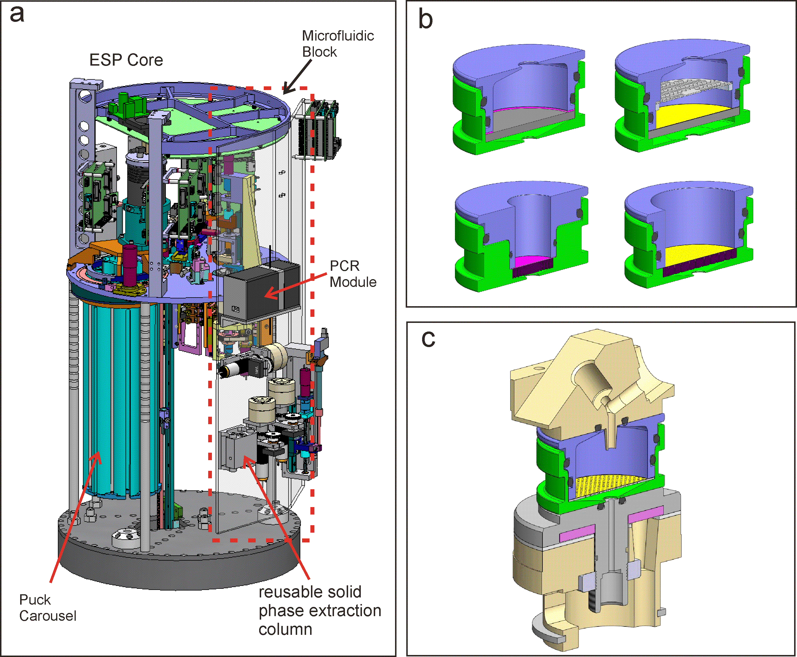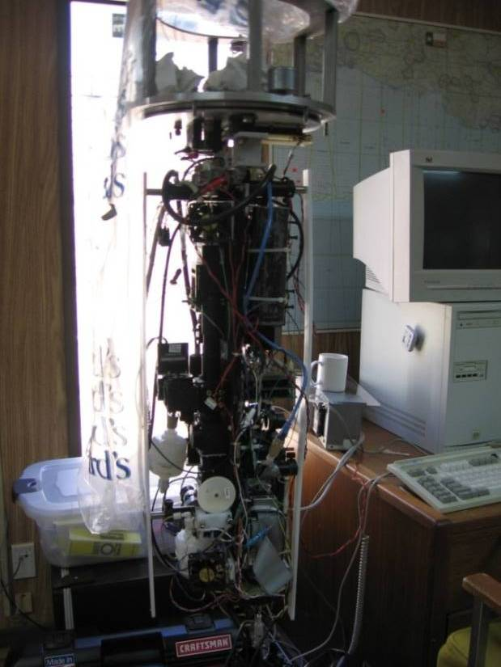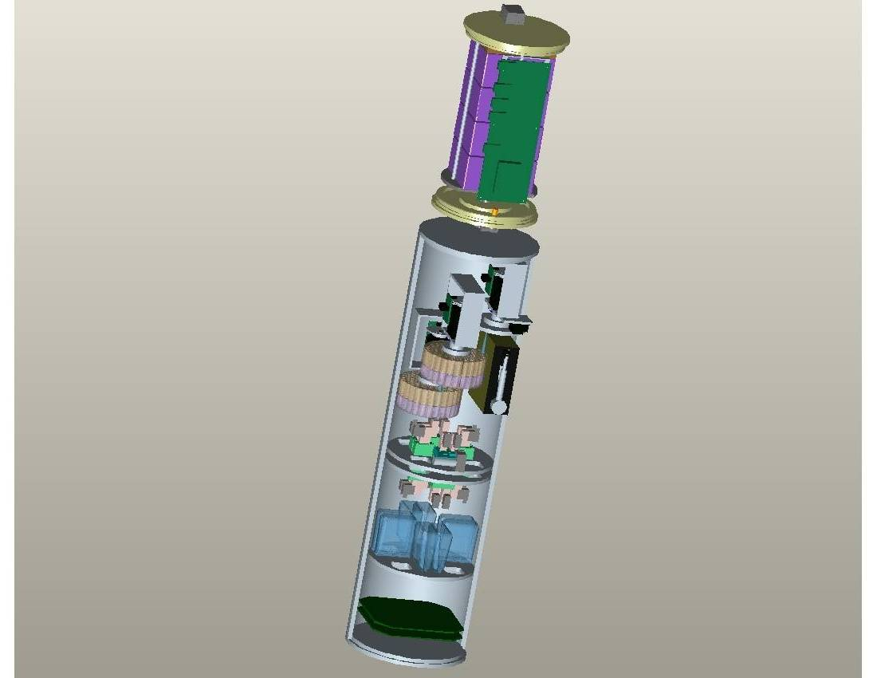

a. b. c.

Figure 2.

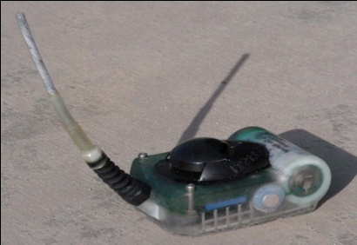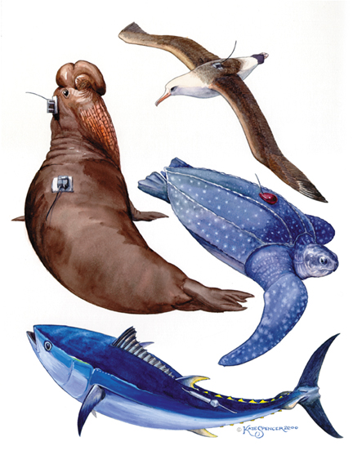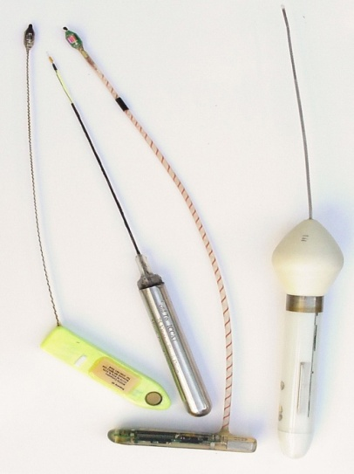

Figure 3.

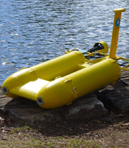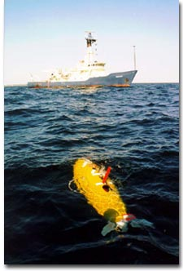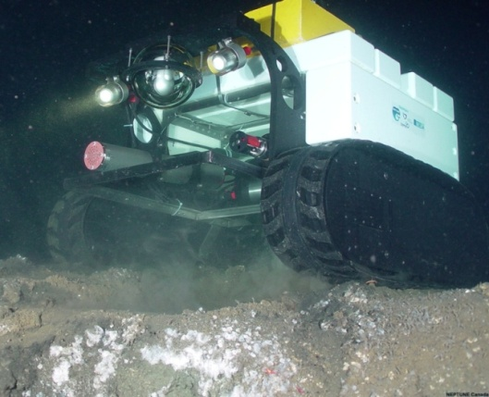

a. b.

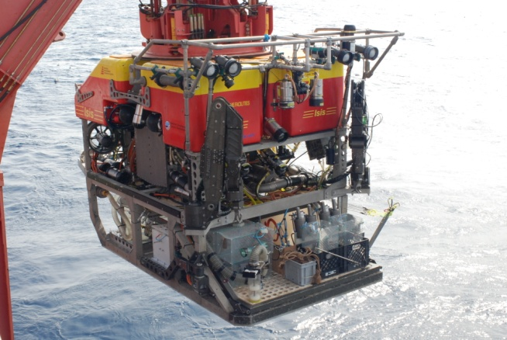

c. d.

Figure 4.

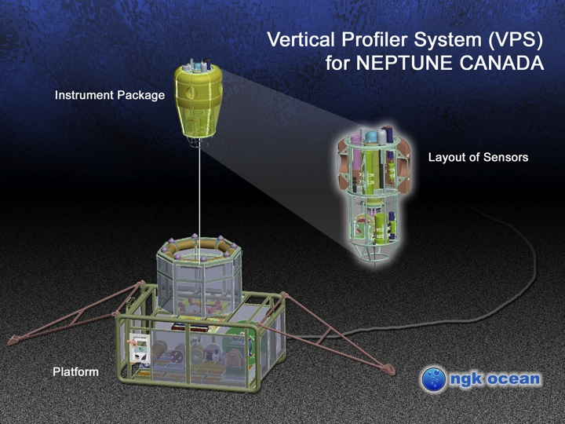

Figure 5.

Figure 6.

1. The following sections are summarized from reports prepared by discussion groups at the workshop, for which the following chairs and rapporteurs were responsible (in alphabetical order):, Scott Bainbridge, Dan Costa, Bob Gisiner Bengt Karlson, Kate Larkin, Rubens Lopes, Ron Os Lo, Hans Paerl, Alex Rogers, and John Volkman