Status and Outlook for the Space Component of an Integrated Ocean Observing System

Mark Drinkwater⁽¹⁾, Hans Bonekamp⁽²⁾, Bertrand Chapron⁽³⁾, Craig Donlon⁽¹⁾, Jean-Louis Fellous ⁽⁴⁾, Paul DiGiacomo⁽⁵⁾, Ed Harrison⁽⁶⁾, Pierre-Yves LeTraon⁽⁷⁾, Eric Lindstrom⁽⁸⁾, Stan Wilson⁽⁹⁾

⁽¹⁾ European Space Agency, ESTEC, Keplerlaan 1, NL-2201 AZ Noordwijk, The Netherlands, Email: mark.drinkwater@esa.int
⁽²⁾ EUMETSAT, Eumetsat-Allee 1, 64295 Darmstadt, Germany, Email: hans.bonekamp@eumetsat.int
⁽³⁾ IFREMER, Centre de Recherche et d'Exploitation Satellitaire, Pointe du Diable 29280 Plouzane, France, Email: Bertrand.Chapron@ifremer.fr
⁽⁴⁾ COSPAR c/o CNES, 2 Place Maurice-Quentin, 75039 Paris Cedex 01, France, Email: jfellous@noos.fr
⁽⁵⁾ NOAA Science Center, 5200 Auth Road, Camp Springs, MD 20746, USA, Email: Paul.DiGiacomo@noaa.gov
⁽⁶⁾ NOAA/PMEL, 7600 Sand Point Way, Seattle WA 98115, USA, Email: d.e.harrison@noaa.gov
⁽⁷⁾ IFREMER, Centre de Brest B.P. 70 29280, Plouzané France,
Email: Pierre.Yves.Le.Traon@ifremer.fr
⁽⁸⁾ NASA HQ, MS 3F71, 300 E St. SW, Washington, DC 20546, USA., Email: eric.j.lindstrom@nasa.gov
⁽⁹⁾ NOAA/NESDIS, 1335 East West Highway, Silver Spring, MD 20910, USA, Email: stan.wilson@noaa.gov

Abstract
The space component of global ocean observing system has developed and matured remarkably over the course of the last decade. Solid progress has been made towards a more coherent and internationally-coordinated satellite infrastructure through effective scientific and political advocacy and international coordination. This has led to the design and development of a number of mature operational systems delivering systematic and robust long-term measurements, coupled with a suite of complementary scientific satellite elements that feed innovative new measurement capabilities into the observing system infrastructure. Together with the in-situ system elements, these form a solid foundation for an integrated global observing system of systems of the future – to serve both research and operational interests. In spite of the relative success over the last decade, however, significant challenges remain for the next decade. The burgeoning expense of sustaining critical satellite measurement data-streams dictates that tools and methods must be developed to remove redundancies, to further optimise the satellite infrastructure, and to better link complementary observing system elements. Efforts to engage, involve and integrate satellite data streams of new participating space agencies, and furthering the ideal of unbridled data exchange will be rewarded by product synergies and vital added-value. Meanwhile, all such efforts must be underpinned by widespread promotion and adoption of best-practices, including rigorous data calibration and product validation, proven methods of quality control, and flagging of data quality and quantitative estimates of measurement uncertainties. The latter is of absolute importance to maximizing the use of data products in model data assimilation schemes to improve ocean state estimates and forecasting capabilities. As with numerical weather prediction, improved 3-d state estimation is also a foundation for development of sustainable services and initialisation of seasonal to interannual and climate forecasting models

Introduction
Understanding the ocean-related aspects of the Earth system, including weather, climate, oceans, water, natural resources, ecosystems, and natural and human-induced hazards, is crucial to achieving sustainable development, and to protecting humankind and the global environment. Satellite observations of the Earth system are recognised to constitute critical input for advancing this understanding.

During the last decade we have often heard the words, “we are in the Golden Age of satellite oceanography”. Indeed satellite oceanography has become a truly international endeavour. Since the OceanObs’99 meeting, the ocean community has witnessed the launch of over 30 new ocean-related satellite missions with dedicated ocean instruments by 13 different contributing space agencies representing around 36 countries (Ward, 2008; See http://eohandbook.com). These satellites currently provide some tens of millions of quality controlled measurements each day that are assimilated into various operational numerical weather prediction models, coupled ocean-ice-atmosphere models, and also used in spinning up representative contemporary conditions for climate model forecasts. The basic geophysical data products, together with the resulting model state estimates or analyses, are also of fundamental benefit in improving scientific understanding in the fields of physical oceanography, ocean biogeochemistry, cryospheric science, and related climate research.

Plans for new satellites are already laid well into the foreseeable future, with the current investments already focusing on delivery of new systems in the post-2020 time frame. If we consider the next decade through 2020, the launch of approximately 14 new approved operational and research and development satellite missions is planned. These satellites are already ready, or in various stages of development and thus the community must be engaged in preparations in order to most effectively benefit from their new data products.

Thus, today it is evident that the ocean community has access to a well endowed space infrastructure component of the integrated Global Earth Observation System of Systems (GEOSS). Due to successive key contributions of ocean-related satellite system elements from new space-faring organizations and countries, the potential of this system has reached an unparalleled level of complexity. In order to harness the full capability and potential benefits of this complex system there are challenges which must yet be overcome. For instance, the satellite infrastructure is reliant upon external calibration and validation with respect to independent data provided by in-situ and other sampling systems that make up the other parts of the ocean observing system. Such efforts must be carefully coordinated with standards and tried and tested methodologies to assure quality. Capacity building efforts must be sustained, such as to engage new nations in use, validation and improvement of the data products and product quality, and ultimately to ensure robust products.

Meanwhile, from a broad perspective, the space-based component of the integrated global ocean observing system is, and will continue to be, a critical component of the GEOSS. Inevitably, in order to be sustainable, it must continue to develop and be increasingly tuned to issues of societal benefit, as a fundamental basis for maximizing the relevance of contributions of satellite observations. Indeed, the socio-economic benefits are increasingly becoming a metric by which to justify the expense of maintaining or sustaining such a complex system.

Recognising the maturity of some satellite based components to the point where operational oceanography is rapidly approaching the maturity of weather forecasting, the elements of space infrastructure required for other aspects of environment monitoring, climate forecasting, and hydrology, for instance, must become more interconnected. Their converging requirements raise the challenge of optimising the observation infrastructure in order to widen their user base through greater access and interoperability.

This paper addresses the evolution of the requirements approach and the lessons learned along the way towards implementing the current infrastructure. New methods for optimising the existing system infrastructure are proposed, together the outlining the plans for use of forthcoming new satellite datasets. Finally, some of the main challenges are outlined for the next decade.

This Plenary Paper draws extensively on the Community White Papers by Wilson et al; Bourassa et al.; Pouliquen et al; Fu et al; GODAE Ocean View Science Team; Kwok et al; Breivik et al; Yoder et al; Sathayendranath et al – ChloroGIN.; Lagerloef et al; Cipollini et al.; and Shum et al., CWP. It also draws on the Plenary papers dealing with satellite aspects in the “developing technology and infrastructure” session (Lindstrom et al,; Parisot et al; Chapron et al.) and “way forwards” session (Claustre et al, Plenary Paper).

Evolution in the Space based Ocean Observing System
Over the last decade, requirements for ocean satellites have been consolidated and aligned with a broad range of user needs. Experience has taught Space Agencies that it is most effective to establish firm user requirements (e.g. Escudier and Fellous, 2009) before building political consensus for a new satellite mission, or a sustained series of missions, around them. A number of developments over the last decade have been fundamental in space agencies establishing the appropriate arguments for the required elements of the space component of the ocean observing system. These are documented in the sections below.

Progressive Consolidation of User Requirements
The global interest in Oceanography and Marine Meteorology encompasses a wide range of users that need routine access to accurate knowledge on the present state of the ocean and the atmosphere above. Broadly speaking there are critical requirements for uniform, global ocean data products that reinforce the capacity for:

- Numerical Weather Prediction
- Maritime Safety & Met-Ocean and Ice Forecasting
- Advanced marine research for better understanding of the oceans, seas and their ecosystems
- Sustainable exploitation and management of ocean resources (e.g. offshore oil and gas industry, ecosystems, fisheries…)
- Anticipation and mitigation of the effects of environmental hazards and pollution crisis (e.g. coastal erosion, coastal flooding, oil spills, harmful algal blooms)
- Climate Research, and Climate Forecasting
- Environment Agency needs (e.g. EEA, EPA, etc.)
- International Treaty and Convention enforcement (e.g. SOLAS, London Convention, UNCLOS, etc.)
It is clear that the above user requirements span a variety of operational, research, and policy needs. However perhaps the most pervasive development of the last decade is the acknowledgement that satellite infrastructure must directly respond to areas of societal benefits in order for the costly infrastructure to be justifiable and sustainable. The overriding purpose of an integrated satellite ocean observing system element of GEOSS is to achieve comprehensive, coordinated and sustained observations of the global ocean, in order to improve monitoring of its state, to increase process understanding, and enhance predictive capability. The GEOSS Implementation Plan (2005-2015) clearly identifies the need to deliver of benefits to society (Group on Earth Observations, 2005), in several areas where the ocean services listed above are directly relevant:

- Reducing loss of life and property from natural and human-induced disasters;
- Understanding environmental factors affecting human health and well-being;
- Improving management of energy resources;
- Understanding, assessing, predicting, mitigating, and adapting to climate variability and change;
- Improving water resource management through better understanding of the water cycle;
- Improving weather information, forecasting, and warning;
- Improving the management and protection of terrestrial, coastal, and marine ecosystems, and;
- Understanding, monitoring, and conserving biodiversity.

The satellite system component must therefore meet the need for timely, quality long-term global information as a basis for sound decision making and socio-economic benefits.

Sustained Climate Monitoring
In terms of the climate observing needs, the Global Climate Observing System (GCOS) Implementation Plan and plan for systematic satellite data for climate (GCOS, 2004; GCOS 2006) is a significant step towards establishing a consolidated roadmap. These documents reinforce that satellites provide a vital means of obtaining climate-relevant, uniform global ocean observations, and that a detailed climate record for the future will not be possible without a sustained, satellite component. They further identify that for satellite data to contribute fully and effectively to the determination of long-term records, the system must be implemented and operated in an appropriate manner to ensure that the data sets are robust, accurate and homogeneous. To this end, the GCOS Climate Monitoring Principles (GCOS, 2004) call for continuity of observations, calibration and validation of observations, access to data, and research and development.

Although almost all Earth-observing satellite systems were not specifically designed for climate monitoring, space-agency efforts have initiated a remarkably comprehensive climate data record that forms the basis for improved understanding the Earth’s climate system. Though much has clearly been accomplished, more remains to be done, especially in mitigating gaps in critical measurement capabilities in order to maintain their continuity. Meanwhile, the CEOS response to the GCOS Implementation Plan (CEOS, 2006) outlines a comprehensive list of actions that various Agencies are currently undertaking to ensure that the GCOS IP requirements are met.

Maturation of Ocean Forecasting and Ocean Data Assimilation
Over the past decade, there have been major advances in the way in-situ and remote sensing data are used together with models in data assimilation systems. The routine availability of critical satellite datasets has allowed operational ocean forecasting to flourish (LeTraon et al, Plenary). The Global Ocean Data Assimilation Experiment (GODAE), proposed in 1997 (GODAE OceanView CWP), has been fundamental in galvanising community-wide efforts towards bringing ocean forecasting to a credible, operational state – in which the benefits of real-time global ocean data assimilation and forecasting are now routinely demonstrated. In particular, GODAE provided a fundamental impetus for effective use of satellite data into forecasting systems. In turn this has helped the satellite agencies to establish firm requirements for products, product timeliness, latency and access – as well as driving new requirements for data product quality flags and validated bounds of uncertainty (Pouliquen et al, Plenary).

In-situ and remote sensing data delivered in near real time are now routinely assimilated in global ocean models (LeTraon et al., Plenary) to provide an integrated description and forecast of the ocean state (Heimbach et al, CWP), as well as providing boundary conditions to numerical weather forecast models. Different assimilation techniques and model resolutions are used depending on applications (e.g. climate and mesoscale). While some operational applications or research activities can rely on the data products themselves, this integrated description is a powerful means to take full advantage of the different observing systems. The use of models as dynamical interpolators provides improved description of the observed variables, parameters that are not directly observed and forecasts of the ocean state. This is required for most of the applications. High resolution ocean surface topography (OST), sea surface temperature (SST), ocean vector winds (OVW), ocean colour (OC) sea ice concentration (SIC) and ocean salinity (Argo) are the main data sets used today to constrain global ocean models (see Fig. 1). Meanwhile, there are a number of additional new datasets that have become commonly available that allow further development in hydrodynamic and sea ice parameterisations, as well biogeochemical processes.

As a consequence of GODAE, a large number of operational and research institutions around the world (GODAE Ocean View, CWP) are now providing regular, global and regional analyses and forecasts of ocean fields such as temperature, salinity and currents at high temporal and spatial resolution. Throughout GODAE, assimilation methodologies have been significantly improved to make the best use of satellite remote sensing together with in-situ data. In parallel, links with intermediate users and applications have been developed: maritime safety (e.g. oil pollution monitoring), offshore applications, fishery management, boundary conditions for coastal and regional subsystems, Naval operations, and initial conditions of weather (e.g. hurricanes) and climate forecast models. Global ocean analyses are also used for an improved understanding of the oceans and as a basis for improving the design and effectiveness of the global ocean observing system. Together with the IGOS-P Ocean Theme Team (Lindstrom et al, 2001), the GODAE developments have provided a fundamental justification for implementation of a global ocean observing system including the requisite space-based observable parameters in Fig. 1.

An Ocean Component of an Integrated Global Observing System
The Integrated Global Observing System Partnership (IGOS-P) was established in 1998 as a means of bringing the need for a coherent and comprehensive integrated approach to sustained observations of the global ocean to the attention of the Committee on Earth Observing Satellites (CEOS). The IGOS-P Ocean Theme Report was published in January 2001 (Ocean Theme Team, 2001). This report was the first time that the in situ observing community, largely represented by the open ocean/climate component of GOOS and GCOS, joined forces with the satellite remote sensing observing community to produce a series of consolidated statements about the priority observations. The report was developed on the foundation of the developments in GOOS, together with the reports of the OceanObs’99 conference (Ratier, 1999; Johannessen et al., 1999). The content of the document has undoubtedly influenced the approach of CEOS and of the agencies that are its members, especially in making the case for certain types of space-based observation and in underlining the importance of continuity of measurements.

It is difficult to fully quantify the impact of the Ocean Theme Report, but it does seem clear that it set the tone and setting for a number of key decisions in the subsequent years. Altimetry, SAR and salinity remote sensing have arguably seen the most progress, though ocean vector winds observation and ocean colour mission developments are relatively less secure. One critical issue for climate remains with the recent descope of the all-weather SST instrument capability from NPOESS. This represents a key weakness in the observation capabilities.

A primary example of Ocean Theme Report success has been the transition of precision satellite altimetry from research to operations. Jason-1 was flown as a partnership of NASA and CNES, while a four-way partnership was established for the follow-on mission (Jason-2) involving also NOAA and EUMETSAT as operational partners. Currently, a full operational transition is foreseen for a recurrent Jason-3 with NOAA and Eumetsat taking full responsibility for financing. Meanwhile, the successor to Jason-3, in the form of Jason-CS is currently being treated as part of the European contribution to the operational observing system infrastructure.

The “knowledge challenge” in the Ocean Theme Report related to measurement of sea surface salinity and gravity from space was taken up by the CEOS agencies. Two fundamentally new L-band radiometer missions (SMOS and Aquarius) were planned to make the first salinity observations from space. In meeting these challenges, SMOS was recently successfully launched in November 2009 (Kerr et al., 2009) while Aquarius is planned for launch in late 2010. Similarly, the challenge to make gravity measurements to improve the ocean geoid and to study mass redistribution has been met, with the consecutive launches of the CHAMP, GRACE and GOCE satellites. The first of these two missions have contributed to successively improving the geoid (hypothetical surface corresponding to the ocean at rest) to the 1cm accuracy at a scale of 400km, with GOCE currently promising to achieve the goal of a 1-2 cm accuracy geoid at 100 km wavelength scales.

The Ocean Theme team report undoubtedly also helped to encourage investment in the development of the Global Ocean Data Assimilation Experiment (GODAE), which by 2001 had gathered momentum. The document highlighted that GODAE was essential to establish the capability to integrate and assimilate the in situ and the remotely sensed data streams into advanced numerical models in order to produce maps and forecasts of ocean properties and, ultimately, of climate change.

IGOS-P has demonstrated that partnerships are a necessary condition for the successful transition of measurements from research (initial demonstration) to operations (regular, systematic, long-term measurements). Another lesson learned from the Ocean Theme Report is that a high-level synthesis of observing requirements and capabilities for policy makers should be undertaken every 5 years or so. The disciplines who are ultimately able to construct such a synthesis internationally, across a suite of observations, will likely be able to advance their cause more effectively and successfully.

Transition of the IGOS Partnership into GEOSS Framework
The World Summit on Sustainable Development held in Johannesburg in 2002 called for strengthened cooperation and coordination among global observing systems and research programmes for the benefit of an integrated set of global observations. The outcome of the subsequent G-8 Summit held in Evian in June 2003 similarly called for strengthened international cooperation on global observation of the environment.
As a consequence of these meetings, thirty-three nations and the European Commission gathered in Washington D.C. on July 31, 2003, for the 1st Earth Observation Summit. A declaration was established that called for action in strengthening global cooperation on Earth observation was adopted. The Summit participants launched the intergovernmental ad hoc Group on Earth Observations (GEO) with the goal of furthering the creation of the GEOSS. The group began its work by establishment of its first 10-year Implementation Plan (Group on Earth Observations, 2005).

Subsequently, in November 2006 at the IGOS-P meeting in Buenos Aires, CEOS proposed to integrate the IGOS partnership into GEO. Generally, it was felt that the IGOS partnership, though having been highly successful in developing observational strategies through its themes, had not achieved sufficient political visibility and institutional weight to ensure full implementation of these strategies. The proposal was therefore approved for GEO is to facilitate implementation of elements of the Earth observing system that until that point had been within the remit of the IGOS partners. Thus the implementation of the IGOS-P Ocean Theme was formally transferred into the GEOSS framework coordinated by the Group for Earth Observations (GEO). With this transformation comes the promise of broader reach for advocacy of the required ocean observing system elements.

Development of Operational Oceanography in Europe
The establishment of a political framework for GEOSS and the accompanying Earth Observation Summits have been the backdrop to the establishment of a significant European contribution to GEOSS. The Global Monitoring for Environment and Security (GMES) initiative has been established in the course of the last decade to fulfill the growing need amongst European policy-makers to access accurate and timely information services to better manage the environment, understand and mitigate the effects of climate change and ensure civil security. Under the leadership of the European Commission, GMES relies to a significant degree on data from Earth observing satellites.

The European Commission, acting on behalf of the European Union (EU), is responsible for the overall initiative, setting requirements and managing the services. Meanwhile, the European Space Agency (ESA) – in accordance with the European Space Policy – is developing and managing the Space Component for the initiative. To ensure the operational provision of Earth-observation data, the Space Component includes a series of space missions called ‘Sentinels’, which are being developed by ESA specifically for GMES. Importantly, GMES responds directly to the needs of the ocean observing system, with one of its missions, Sentinel-3 (Aguirre et al., 2009), dedicated to global ocean observations.

In addition, data from satellites that are already in orbit, or are planned will also be used for the initiative. These ‘Contributing Missions’ include both existing and new satellites, whether owned and operated at European level by the EU, ESA, EUMETSAT and their Member States, or on a national basis. They also include data acquired from non-European partners.

Operational oceanography and sustainable services to environmental stakeholders and downstream applications will be the main goals of the GMES Marine Core Service (MCS) which is currently being built up as part of this initiative. The MyOcean project (See: http://www.myocean.eu.org/), selected for implementing the GMES MCS, gathers a large number of European contributors. It aims at developing this operational capacity, based on continuous high-accuracy observations. A major component of the global set of ocean observations is foreseen to be provided by ocean satellite missions.

The State of the Space-Based Infrastructure
In this section the current state of the space-based infrastructure is outlined briefly in the following sections.

Maturation of Observing System Elements
Since 1999 there has been significant attention given to establishing the space-based infrastructure of the ocean observing system. The satellite observing system priorities outlined at OceanObs’99 by (Ratier, 1999), and the IGOS-P Ocean Theme document (Lindstrom et al., 2001) have been incrementally treated, such that most of the priority variables are covered, albeit with varying degrees of long-term sustainability. Meanwhile, many of the knowledge challenges identified at that time (Lindstrom et al., 2001) are well on the way to being addressed due to realisation of some of the new technologies and satellite concepts that were only in their infancy at the end of the 1990s (Johannessen et al., 1999). The following sections briefly describe the status of the key variables.

Ocean Surface Topography (OST)
Due to the expense and the logistical difficulty of obtaining global in-situ oceanic observations, altimeter ocean surface topography data is identified as one of the most critical measurement datasets for met-ocean, climate and operational oceanography applications. The current vision for the CEOS Ocean Surface Topogaphy Virtual Constellation (Wilson et al., CWP) outlines a recommended observation strategy relying on two components: (1) at least one high-precision reference altimeter mission satisfying the sea-level climate requirement, with orbit and coverage ensuring that data are free of tidal aliasing (e.g. Jason-type, non-sun-synchronous 66° inclined orbit); and (2) at least two, and preferably 3, additional altimetry systems flying on higher inclination, optimised orbits with which to obtain global coverage (e.g. ENVISAT/RA2, CryoSat-2/SIRAL, SARAL/AltiKa, HY-2, Sentinel-3/SRAL, GFO-2) with an orbit cross-over density sufficient for addressing mesoscale ocean applications.

The launch of Jason-1 in 2001 continued the series of sea-level reference missions established with Topex/Poseidon (T/P) in 1992. More recently, the Jason-2 launch in 2008 assured continuous reference measurements through 2012. The Jason-3 programme, presently under consideration by NOAA and Eumetsat must first be secured to guarantee further continuity through the end of the next decade. Meanwhile, planning is already underway to establish new platform technology to succeed the Jason-3 Proteus platform, with a successor based on CryoSat platform heritage, known as Jason-CS.
Importantly, the complementary, series of high-inclination orbiting altimeters has provided more dense global coverage with which to capture the mesoscale circulation thereby enabling the growth in operational oceanography applications. The ERS-1, ERS-2, Envisat, Geosat, and Geosat follow-on (GFO) missions have illustrated the benefits from their complementary with T/P and Jason, through the synergetic data products of AVISO DUACS/SSALTO (see section 3.2 below).

With the approaching end of lifetime of Envisat, the addition of the joint ISRO and CNES SARAL/AltiKa mission on the same Envisat/RA2 orbit ground track, and HY-2 altimeter missions help to bridge until the start of the Sentinel-3A and B SRAL data timeseries. Both the SARAL and Sentinel-3 SAR altimeters are equipped to provide high along-track resolution data, and will enable further developments in detecting sub-mesoscale features (Scott et al, CWP) and in coastal applications (Cipollini et al, CWP).

Ocean Vector Winds (OVW)
Measurements of ocean surface vector winds are needed for both operational NWP and climate purposes and are an increasingly important tool for wave forecasting and marine operations, and tropical cyclone warnings (Bourassa et al., CWP). Over the last decade, the C-band ERS-2 and Ku-band QuikScat(QSCAT)/SeaWinds instruments have been the primary workhorses, demonstrating that at least two scatterometers are required on well-separated orbits (ideally morning and evening) in order to ensure global provision of vector winds with typically a six hour refresh cycle. Whilst the C-band scatterometer time-series (09:30hrs morning orbit) has been secured with the launch of MetOp with its ASCAT instrument in 2006, the QSCAT SeaWinds instrument has long exceeded its design lifetime and is rapidly approaching its end of life with steadily degrading data quality. The unfortunate 2003 failure of the ADEOS-2 mission with its SeaWinds scatterometer means that we are without any guaranteed successor in the near future (Parisot et al, Plenary Paper).

Currently, in order to supplement the global coverage of scatterometer wind vectors it is necessary to use data from the WindSat polarimetric passive microwave demonstration instrument launched in 2003. It has been noted, however, that whilst the surface vector winds from passive instruments do provide valuable global NWP input data, they do not fulfill the stringent requirements for climate quality vector winds (NRC, 2008), and also exhibit significant limitations in extreme weather events. Thus, in spite of the operational MIS instrument successor to WindSat – to be launched on NPOESS C3 in around 2020 – it is recognised that an operational successor to QSCAT/SeaWinds is fundamental to secure the necessary global operational vector wind data stream.

The recent October 2009 launch of the Oceansat-2 satellite with its SeaWinds-like Ku-band scatterometer, together with the planned 2010 launch of the first satellite in the HY-2 scatterometer-equipped operational series, both potentially add vital supplementary global vector wind measurement capability. It is of critical importance therefore that the recently established Ocean Surface Vector Wind Virtual Constellation (OVSW-VC) supports CEOS efforts to negotiate plans for operational distribution of their respective data products (Ref: OSVW-VC).

Recent developments in fine resolution wind products from wide swath SAR instruments such as ASAR on Envisat can be used to supplement scatterometer wind data, albeit with a narrower swath of ~400km. These additional products in particular help in describing wind-wave coupling processes in extreme weather events, and facilitate additional new coastal applications where the resolution of scatterometer data is limited (Bourassa et al., CWP, Chapron et al, 2005).

Meanwhile, planning is underway for the US to develop a new generation dual frequency scatterometer (C- and Ku-band) to be flown on the Japanese G-COM-W2 satellite in the 2015 timeframe.

Sea State
Sea state is critical to wind-wave coupling and surface fluxes (momentum, heat, water and gas), safety of marine operations and commercial use of the sea (ship routing, fisheries), and safety of coastal habitats (Swail et al., CWP). Synthetic Aperture Radar (SAR) data today has the capability to measure wave height, period and direction, and to provide this operational information together with complementary winds and currents. Meanwhile altimeters have traditionally delivered significant wave heights and wind speed, though of limited coverage along the sub-satellite track. There remain perceived limitations as to the operational use and value of SAR, particularly due to the quality of the products co-varying with ocean and atmospheric conditions. Recently, however, new processing methods are supporting delivery of more robust co-estimated wind/wave/current information, and this is helping for users to develop gives more significant confidence in the quality of the retrievals.

Currently, operational sea-state information is available over wide areas in near-real time from ERS-2 SAR and Envisat ASAR, and is currently complemented by ERS-2 RA, Envisat RA2 and Jason-1 and Jason-2 altimeters. These sensors are complemented by ASCAT and QSCAT scatterometer vector wind data for the met-ocean and modelling forecast communities. From a climate perspective, the roughness of the sea surface has greatest importance in terms of air-sea exchanges. It would be ideal to have full wave directional spectral capability spanning surface gravity wave and swell periods, though this is presently not feasible. Nonetheless, future Sentinel-1A, and 1B C-band SAR data should help to provide robust C-band time-series of directional wind/wave information.

Sea Surface Temperature (SST)
High-accuracy and high-resolution sea surface temperature observations are required for (i) NWP and in particular tropical cyclone forecasting; (ii) operational ocean forecasting; (iii) seasonal to interannual forecasting, an; (iv) marine services (Donlon et al., CWP). Both Vis/IR and microwave data from a combination of polar orbiting satellites and geosynchronous orbiting satellites are equally important, one fulfilling the all-weather role, albeit at low resolution, and the other allows higher spatial and temporal resolution and in particular near coastal applications in locations where the land contamination limits the applications.

Importantly, the typical split-window technique offered by IR radiometers such as AVHRR (NOAA and MetOp), MODIS (Terra and Aqua) and VIRR (FY-3) is complemented by the dual-view, split window data provided by the (A)ATSR system on ERS-2 and Envisat, allowing improved aerosol corrections in both day/night surface temperature data and thus a climate quality SST reference data source. Continuity will be provided in similar such measurements by the approved GMES Sentinel-3 series of satellites with its operational multi-channel, broad swath, dual view Sea and Land Surface Temperature Radiometer (SLSTR) successor to the AATSR instrument.

The SST future is relatively secure for Visible-infrared radiometers on polar orbiting satellites, with the AVHRR on the MetOp series and MODIS instruments being followed by the VIIRS-equipped NPP and then NPOESS series. Meanwhile, the (A)ATSR series on ERS and Envisat is to be succeeded by the SLSTR instruments onboard the operational Sentinel-3 series. These plans in US and Europe are now supplemented by the routine operations of FY-3 series with its VIRR sensor. The GOES imagers and SEVIRI on MSG provide complementary, frequent repeat imaging, to mitigate the effects of cloud cover.

Of most urgent attention is the future of the all-weather microwave SST capability of the AMSR-E instrument on Aqua. The descoped MIS instrument aboard NPOESS no longer contains a C-band (6.9 GHz) channel, and so the only equivalent successor instrument is the planned AMSR-2 on GCOM-W in 2011 timeframe. The GHRSST paper (Donlon et al, CWP) has emphasised the importance of continuity of both IR and passive microwave observations on polar and geostationary satellites if a robust continuous SST climate data record is to be sustained. Meanwhile, immediate attention should be given to gaining access to 6GHz data from the new multi-frequency radiometer instrument aboard the HY-2A satellite scheduled for launch in 2010.

Ocean Biology via Ocean Colour
Ocean Colour (OC) data products are required for monitoring of open-ocean and coastal ecosystem and biogeochemical parameters and are increasingly used in management of fisheries and coastal regions, for monitoring of harmful algal blooms and water quality, in aquaculture applications and for many other socio-economic benefits (Yoder et al., CWP, Sathyendranath et al., CWP; Forget et al., CWP). Ocean colour data products derived from water-leaving radiance data measured by multi-channel Visible/IR radiometer and spectrometers typically include Chlorophyll a (Chla) to quantify phytoplankton biomass, phytoplankton functional types (e.g., diatoms, coccolithophores, picoplankton), coloured dissolved organic matter (CDOM), particulate carbon, suspended sediment and the diffuse attenuation coefficient or water transparency. Meanwhile, these near-surface data are increasingly assimilated into coupled ocean models containing ecosystem and biogeochemistry modules (Le Quéré et al, CWP) for improved understanding of the impacts of ocean climate variability and long-term climate change on ocean primary productivity and in carbon-cycle research (Rienecker et al., CWP).

The current primary OC instrument capabilities of relevance are SeaWifs, MERIS on Envisat, MODIS on Aqua, OCM on Oceansat-2, and MODI instrument on FY-3. Meanwhile, future continuity in these data is relatively secure with approved future mission plans for OLCI on Sentinel-3 series, VIIRS on NPP and the NPOESS series, and SGLI on GCOM-C. Importantly, these plans are complemented by the Korean plans for the GOCI instrument on the COMS-1 geostationary satellite. This instrument shall pave the way towards geostationary ocean colour, and higher frequency data in coastal zones for monitoring tidally-modulated, and river runoff impacted high-frequency ocean colour variability in coastal waters.

Sea Ice (extent/concentration/thickness/drift)
Changes in sea ice extent and concentration have become a crucial indicator of high latitude response to climate change. However, in order to fully appreciate the variability in sea-ice mass and volume in response to climate variability it is also required to measure the drift dynamics and thickness (IGOS Cryosphere Theme Team, 2007; GCOS, 2009). The latter two variables are essential in order to partition the role of thermodynamics and dynamic contributions to ice thickness changes, or to quantify net advective fluxes of freshwater in the form of ice (Breivik et al, CWP).

There is a need to continue the existing 28 year all-weather record of sea ice data built by the SMMR, SSM/I and AMSR-E multi-frequency passive microwave instruments, though recently these data have been supplemented by routine scatterometer sea-ice products, wide-swath, high resolution SAR image data, and altimeter ice thickness data. Currently, a successor to AMSR-E is planned in the form of AMSR-2 on GCOM-W, with the later addition of the MIS instruments on NPOESS. ASCAT on the MetOp series is currently guaranteed to continue the supporting C-band scatterometer timeseries, while the ASAR on Envisat and Radarsat-2 wide swath instruments have planned operational successor in the form of Sentinel-1 and Radarsat-3. Meanwhile, CryoSat-2 will supercede the Envisat RA-2 with high along-track resolution (approx. 300m), and will be followed shortly afterwards by the SRAL on the Sentinel-3 operational series. While ICESAT has also verified the ability to obtain accurate ice thickness profile information, the limitation on laser lifetime have limited the data to short operating intervals. Thus, the ICESAT-2 successor will also add extremely important capability with which to combine the SRAL radar and laser based thickness retrieval techniques for reducing uncertainties in ice thickness due to snow loading.

Salinity (SSS)
Ocean surface salinity is a critical variable for constraining the net ocean-atmosphere moisture flux (E-P), for understanding the impact of river freshwater outflow on circulation, for mapping frontal variability, and for specifying the surface buoyancy forcing in the upper ocean (Lagerloef et al, CWP). Meanwhile, the global satellite skin measurement will be beneficial in tying Argo sub-surface salinity, temperature and depth information to the existing surface measurements by the moored networks, in order to better understand the role of salinity on ocean circulation.

One of the principal challenges outlined at OceanObs’99 (Johannessen et al, 1999) and in the IGOS Ocean Theme Team report (Lindstrom et al., 2001) was the global observation of mean sea surface salinity (SSS) to a threshold accuracy of 0.2psu at 200km scale at monthly time intervals. The Soil Moisture and Ocean Salinity mission (SMOS) (Kerr et al, 2009) was successfully launched on 2 November, and together with Aquarius (planned for launch in 2010), spearheads the effort to exploit new L-band microwave radiometer capability for observing SSS. It now remains for the scientific and modelling community to exploit the synergy between global satellite and detailed in-situ SSS data to resolve the time and space variability of SST to a degree compatible with the existing SST data such as to improve our understanding of upper ocean processes (Lagerloef et al, CWP).

Gravity and Geoid
The measurement of small variations in Earth’s gravity and of the geoid are now recognised to be a fundamental prerequisite to quantifying mass transports in the ocean system, freshwater exchange between land, ocean, ice and atmosphere, and for constraining heat, energy and freshwater cycling through the Earth system. Meanwhile, in order to have the basic metrological capability to detect cm-scale changes and mesoscale details in sea-level change using altimeters, access to a precision static geoid or equipotential reference surface of 1-2cm accuracy and 100km spatial resolution is required (Shum et al., CWP).

Since 2000 three currently operating missions have been contributing valuable data to meet these needs. The sequential launches of the CHAMP, GRACE and GOCE satellites have successively improved our knowledge of the static geoid, and GRACE has revolutionised our understanding of the time-variable gravity field. Meanwhile, the GOCE satellite promises to deliver a revolutionary accuracy in the static geoid over the next years of operation.

The combination of gravity, altimetric dynamic topography data and bottom-pressure observations now provide an opportunity to make significant progress towards understanding ice-ocean interactions, sea-ice thickness, circulation and mass/freshwater variability of the Arctic and Southern Oceans (Kwok et al, CWP). Nonetheless, it is necessary to maintain a contiguous timeseries of time-variable gravity, together with bottom-pressure sensors and Argo in order to separate eustatic and steric sea-level change components, and to resolve the critical spatial contribution from ice sheet mass changes and freshwater input. Though the GRACE-2 satellite is identified in the NASA Decadal Report, it remains critical to try to maintain a seamless timeseries of GRACE measurements (Shum et al., CWP). Thus, the plan to secure a gap-free succession to the GRACE mission remains a key priority.

Integration and Synthesis of Satellite Measurements
During the last 10 years, significant advances have been made in terms of new product development and refinement. Further, the level of sophistication in terms of data product use has developed well beyond single-satellite, single-sensor analyses, in construction and use of global timeseries from multiple or composite data products (Fig. 2). These efforts may be broadly divided into the following classes:

- Parameter or Geophysical quantity focus
- Climate issue focus

Those with geophysical quantity focus are characterised by developments to combine similar parameter data from multiple sensor sources and platforms. Typical examples, described in the following section are the development of merged multiple altimeter OST products (see: http://earth.esa.int/brat/html/data/product_list_en.html), OC products (see: http://www.globcolour.info/products_description.html), and high space-time resolution SST products (see: http://www.ghrsst.org).

By contrast, efforts focused on climate issues have resulted in combinations of complementary products from multiple sensor sources. An example of such work are studies of sea-level rise using ocean surface topography, Argo drifters, satellite gravimetry, Global Navigation Satellite Systems (GNSS), and tide gauge data from GLOSS (Nerem et al, CWP).

The integration and synthesis of satellite data sets has raised a number of challenges and taught us some significant lessons. These issues remain a thread through the following examples and the following sub-sections.

Merged Global Ocean Surface Topography
AVISO has been distributing Topex/Poseidon and ERS altimeter data since 1992 (see: http://www.aviso.oceanobs.com/en/data/product-information/duacs/). With the launches of Jason-1 and Envisat in 2001 and 2002, respectively, a new series of altimeter products were developed to fulfil the needs of the ocean community. These products are generated using the Data Unification and Altimeter Combination System (DUACS) at AVISO. DUACS products are inter-calibrated at crossover points between different satellite datasets. The resulting gridded data are available in the form of global or regional products in near-real-time or delayed mode, and as high or low resolution geographic maps accompanied by formal mapping errors. These products have been designed to meet a broad variety of scientific applications and non-commercial uses, as well as the data assimilation needs of operational ocean forecasting. Recently DUACS has added Jason-2 data to the merged products, and is preparing for a new generation of SAR altimetry data sets from CryoSat-2, SARAL/AltiKa and Sentinel-3/SRAL.

Merged Global High-Resolution Sea Surface Temperature Data
The Global High Resolution Sea Surface Temperature (GHRSST) pilot project (Donlon et al, CWP) is an excellent example of an ongoing scientific-based effort that is working hand-in-glove with the operational agencies (see: http://www.ghrsst.org). A large international consortium has developed an optimal SST product by combination of all-weather microwave and infra-red satellite radiometer data together with in-situ surface drifters.

Originally, complementarity between the sampling provided by geostationary and polar-orbiting satellites was not exploited for SST products. By using the intrinsic advantages of each sensor type, and the ability of high-frequency geosynchronous observations to sample cloud-free areas missed by the polar orbiters, the data streams have been combined into a single, optimal high time-space resolution, multi-look product (Fig. 3).

The product foundation is the traditional NOAA AVHRR/AATSR polar-orbiter Thermal Infrared (ThIR) radiometer data, which has high spatial resolution (1 km) and daily repeat coverage, but only clear-sky capability. In order to combat the limited temporal sampling of the polar orbiters, the Meteosat (SEVIRI) and GOES high temporal resolution imager data (at ~5km spatial resolution) are used for cloud-free conditions. In order to compensate for the data gaps resulting from the susceptibility of Vis/IR radiometer data to cloud cover, the C-band microwave radiometers on board Aqua (AMSR-E) and TRMM (TMI) are used to obtain night and day SST under all-weather conditions, with the disadvantages of relatively poor ~50-km resolution and lack of retrievals near coasts. The GHRSST project has successfully demonstrated that an optimal SST analysis product can be obtained from combining multiple data sources provided that all error sources for the different data types are correctly accounted for, including cloud screening (for IR) and asynoptic observation times through the diurnal cycle.

Merged Global Ocean Colour Data
The International Ocean Colour Coordinating Group (IOCCG) has been an important driving force towards harmonisation of satellite ocean colour instrument capabilities, algorithms, resulting data products and product use. One important consequence of greater interoperability of data products is the capability to start to build global multi-satellite ocean colour datasets to construct climate relevant timeseries that meet the global carbon cycle research needs. As a result, the GlobColour project (http://www.globcolour.info/) was initiated to develop a satellite-based ocean colour data set to support global carbon-cycle research. Its aim was to satisfy the scientific requirement for a long (10+ year) time-series of consistently calibrated global ocean colour information with the best possible spatial coverage. This has been achieved by merging data from the most capable ocean colour sensors.

The GlobColour service distributes a variety of global data sets using well documented and published algorithms, some of which are featured in Fig. 4. These products include chlorophyll concentration, water leaving radiances, diffuse attenuation coefficient, coloured dissolved and detrital organic materials, total suspended matter or particulate backscattering coefficient, turbidity index, transparency, heated layer depth, and cloud fraction and quality indicators. Products are generated on a daily, weekly (8-day), and monthly basis, on a 4.63 km equal area grid. The global Earth domain is covered with focus on local DDS areas (Diagnostic Data Sets areas) for qualification and validation purpose.

Integrated Satellite and In-situ Applications
Sustained satellite observation time-series have importantly facilitated the transition from single instrument product applications to integrated applications with both research and operational interest. There are also applications that focus specifically on issues of direct societal relevance.

Tab. 1 contains a summary of some of the principal observing system synergies that may be exploited to address key integrated science themes. The table indicates which specific parameter datasets may be combined to address a particular theme, as well as where specific advances may be foreseen due to new satellite sensors.

For example, Tab. 1 points to the combination of altimeter and gravimetrically-derived geoid data, together with SST and SSS. The global combination of the relevant satellite and in-situ data allows the large-scale ocean surface topography to be referenced to a precise geoid such that the absolute dynamic topography and large-scale geostrophic (Fig. 2) and mesoscale circulation can be diagnosed (Scott et al. CWP). Moreover, further combination with temperature, salinity data and repeat hydrography data allows to distinguish eustatic from thermosteric or halosteric contributions to sea-level rise, and to understand the processes driving regional variability in sea-level over time (Shum et al, CWP; Cazenave et al, Plenary).

Other similar examples are highlighted for instance for wind waves and current (see also new products in section 4.1 below), for surface fluxes (Bourassa et al, CWP), ecosystem dynamics, biogeochemistry and coastal zone management, and ocean–cryosphere-atmosphere applications (Kwok et al., CWP).

Integration of satellite datasets with in-situ measurements and models has allowed a number of significant lessons to be learned (Chapron et al, Plenary):

- Data integration and synthesis yield new analysis tools and dynamical frameworks
- Development of multivariate assimilation schemes must be developed to cope with the growing number of continuous time-series, and the growing volumes of new satellite data products
- Significant archives of valuable in-situ data remain to be harvested for verifying measurement uncertainties, and specifying error covariances between key variables
- Assimilation schemes cannot fully exploit satellite time-series without the data being accompanied by measurement uncertainties (e.g. GHRSST single-sensor error statistics)
- Future satellite observing system elements can be optimised with respect to knowledge developed from historical in-situ data.

Fig. 5a shows an example of data integration using existing archived AMSR-E data and in-situ drifter data in the region of the Amazon and Orinoco river outflow (Reul et al, 2009) in preparation for use of SMOS and Aquarius SSS data. These first salinity retrievals from space were performed using AMSR-E radiometer C- and X-band channel brightness temperature data. The resulting salinity image reveal the large-scale spatial structure of the freshwater Amazon plume, extending from about 200 to about 600 km offshore in this August example. The correlation between the drifter derived near surface current climatology and the SSS patterns derived from the AMSR-E data show the strong relationship between the mean circulation and surface salinity. Meanwhile corresponding coloured dissolved organic matter (CDOM) absorption coefficient based on a monthly composite of SeaWiFS and MODIS products is used as an independent proxy for delineating the spatial extent and patterns of the Amazon and Orinoco freshwater plumes (Fig. 5b). Though links between SSS and CDOM are revealed using mixing models and in-situ data, these results indicate for the first time that satellite data can be combined with in-situ data to reveal the synoptic correlation between these two variables in river plume areas. This example illustrates the significant opportunities provided by synergetic use of satellite and in-situ data for investigating dynamics and mixing processes and coupling between physical and biogeochemical processes.

In-situ reference data are absolutely essential for the calibration of satellite sensors, and for validation of geophysical products. The efforts to merge multi-satellite SST products have also demonstrated the importance of establishing the principle of “diagnostic data sets” or databases with common reference in-situ measurements that are used by different Agencies to establish respective measurement system biases (Donlon et al, CWP). This principle has also been adopted for the purpose of calibration of ocean colour radiance measurements and validation of ocean colour products in the ChloroGIN project (Sathyendranath et al, CWP).

Virtual Satellite Constellation
In order to properly integrate and optimise the space component of the observing system infrastructure it was recognised by CEOS that an inter-Agency coordinating mechanism must be established. Importantly, this accompanies the recognition that no one Agency can single-handedly fulfill all the key ocean measurement requirements.

Consequently, the concept of virtual, space-based constellations has been developed as a means of more comprehensively addressing the space component of GEOSS and as a means of optimising the space infrastructure to meet current needs. A Virtual Constellation (VC) constitutes a set of independent space and ground segment capabilities operating together in a coordinated manner. The individual satellites and ground segments can belong to a single or multiple owners. Thus, in effect it is a virtual system that overlaps in coverage in order to meet a combined and common set of Earth Observation requirements.

The VC concept builds upon or helps to refocus existing projects and activities. Constellation teams provide a unique forum to achieve political visibility and increase mutual benefit among space and other environmental agencies. In particular, they offer opportunities to share experience in the development of algorithms; standardise data products and formats; exchange information regarding the calibration and validation of measurements; facilitate timely exchange of and access to data products from existing and planned missions; and facilitate planning of new missions – ranging from coordinating orbits to optimising observational coverage to sharing implementation of mission components.

The following virtual constellations are currently in progress with support from CEOS space agencies, in consultation with their respective ocean user communities – each with a major objective in support of climate and other user applications:

- Ocean Surface Topography Virtual Constellation (OST-VC): designed to ensure continuity of sea surface topographic measurement in accordance with GCOS requirements, for mesoscale circulation and sea level;
- Ocean Surface Vector Wind Virtual Constellation (OSVW-VC): designed to ensure continuity of wind and significant wave height information for operational marine warnings and forecasts, and in accordance with GCOS requirements for data on wind forcing on the circulation of the oceans;
- Ocean Color Radiometry Virtual Constellation (OCR-VC): designed to provide sustained, calibrated ocean color radiance measurements from multiple satellites to meet its objectives include the SIMBIOS (NASA), GlobColour & CoastColour (ESA), ChloroGIN (POGO-GEO-GOOS) and SAFARI (CSA/GEO) projects;
- Sea-Surface Temperature Virtual Constellation (SST-VC): is currently in the planning stages and in the process of approval by CEOS. Multi-satellite SST product generation activities already underway in the scientific domain must be secured, sustained and transitioned to an operational environment. The activity shall be planned and coordinated by the Group for High Resolution Sea Surface Temperature (GHRSST) to achieve full operational status.

Virtual constellations can be designed in principle to provide better coverage, in temporal, spatial, and/or spectral information, and improved data management and dissemination. This can both help improve information products and reduce net costs for operating agencies. With respect to climate missions, the creation and use of constellations potentially provides significant net benefits through:

- Coordinating use of existing systems providing global data;
- Coordinating the analysis of gaps in current operations and future mission deployment plans;
- Generating the potential for advanced, integrated products;
- Providing standards for interoperability and facilitating data uptake into models; and
- Provision of routine global coverage for sustained observations and increased redundancy and continuity and overlap amongst missions.

To obtain benefits of the kind that virtual constellations of assets can provide, it is strongly recommended that the research and operational agencies coordinate their development, operations, standards, and products with international partners. In addition to the obvious coordination of observations and ground systems, agencies should incorporate standard calibration and validation processes including the use of ground-based and lunar virtual calibrations, and establish “best practices” recommendations for measurements, calibration, and use of standards.

The adoption of common requirements and guidelines that address future ocean objectives will ensure that proposed contributions to a Constellation will help satisfy the relevant community needs as well as addressing the GEOSS implementation plan. It will also ensure that all contributions are welcome and encouraged in order to meet a common objective, and will help facilitate the participation of new contributors.

Future Needs and Challenges
Given that plans for new satellites are generally approved and fixed on a timescale of a decade or so into the future, we may already chart a robust strategy for appropriate use of the approved infrastructure. One imperative shall be to maximise use and exploitation of new emerging products from ongoing missions which shall be continued. Meanwhile in order to fully benefit from the planned mission and resulting products, increasing attention must be given to optimising these missions and their associated data products. Finally new technologies which are just over the horizon will soon find their way into satellite oceanography within the next decade, and it is necessary to anticipate and plan for the use and exploitation of these new developments. The future challenges and needs discussed in the section below are therefore split into four sections: new products; infrastructure challenges; data challenges, and new technologies for future missions.

New Products
Over the last few years a number of new products have emerged that have the potential to make a significant impact on the ocean science community. The key attribute of these products is that they are produced using satellite instrumentation which will deliver sustained operational data over the course of the next decade or more. The following sub-sections outline a few such examples.

SAR Wave Products
The development of a new generation of wave products began some 18 years ago, as wave spectra became routinely available from ERS-1. This foundation has allowed development of methods to investigate the source of swell and to trace the path of swells from wavelength and propagation in order to reconstruct “great circle” propagation paths (Heimbach and Hasselmann, 2000). More recently, a new generation of basin scale SAR wave products (NetCDF file) are available from the SOPRANO system (see: http://soprano.cls.fr/L3/fireworks.html). SOPRANO is an operational demonstration of the processing of Near Real Time (NRT) Level-2 products from Envisat ASAR data, such that derived wave products are available on the SOPRANO website within three hours of the availability of the source SAR data.

The SOPRANO system processes products as a collection of 2D frequency-directional spectral wave energy density on contiguous blocks of data along the whole SAR image swath. SAR wave product resolution (i.e. the grid spacing between two consecutive estimates of wave spectrum) has been set to 5km for image mode products (100km swath) and 20 km for wide swath products (400km wide swath). On the graphical SOPRANO representation shown in Fig. 6, only the dominant wave system, in terms of the 2D spectral energy, is represented. This is shown in the plots as significant wave height (colour), dominant direction and wavelength. Similar information is available on a global scale from the wave mode. In this case, wave spectra are estimated every 100km along satellite track and dominant direction used to propagate the observations at a group velocity estimated from the observed wavelength along a great circle ray. The propagation allow to combine several observations at a given time into a Level 3 product that can provide swell tracking from their source to their destination. This L3 product is displayed online as an animated gif over the last 7 days of observations with a 3 hours time step.

The challenge now is to improve the interactions between operational wave forecasting, wave research and satellite ocean wave remote sensing, such that the assimilation of satellite retrievals is fully implemented. Thus there remains a significant work for modellers and oceanographers to find appropriate coupled dynamic modelling framework for assimilation of such data into models. Future operational satellite wide-swath SAR systems such as GMES Sentinel-1 will provide a sustained global data stream and routine operational products from which to locate and track swells across the Pacific, Atlantic and Indian Oceans in near real time. In the near future, the origin and both the arrival time and intensity of the swells will be systematically and routinely predicted.

SAR Surface currents
New processing methods have over the last two years helped refine high resolution retrievals of surface currents, using imaging SAR systems (see Fig. 7). Pioneering work by Chapron, Collard, and Ardhuin (2005) and Johannessen et al. (2005) has enabled the radial current component (i.e. along the radar line of sight) to be derived from the Doppler frequency shift caused by the moving ocean surface. Since the Doppler shift results from the combined action of wind, waves and surface currents, both kinematic and dynamic properties of the moving ocean surface must therefore be taken into account to derive a surface current. Recently, Johannessen et al (2008) have developed a more robust scheme for removal of the dependence of the Doppler velocity on radar parameters, movement of sea-surface radar scattering elements, and by making retrievals more robust to the impact of tilting and hydrodynamic effects. Meanwhile, efforts are underway to assess the uncertainties in the retrievals.

The result shown in Fig. 7a indicates the mean radial velocity in the Agulhas current system generated using many ascending ASAR swaths over time. Comparisons to coincident altimetry data affirm that routine products will help advance the use of SAR in quantitative studies of ocean currents and operational ocean forecasting. The Agulhas retroflection is traced by drifter trajectory in the right panel in Fig. 7b. The 100 km wide and opposite directed speed reaching nearly 2 m/s with an estimated accuracy of about 0.2 m/s and with a maximum shear of about 10⁴ s⁻¹ is therefore predominantly reflecting the influence of the Agulhas Current on the Doppler velocity measurement. The same is also valid for the 1.5 m s⁻¹ Doppler speed of the Agulhas Return Current. This suggests that it is possible to derive quantitative information of these intense surface currents from the radial Doppler velocity. Using this method in combination with surface drifters and altimeter derived surface geostrophic current could consequently strengthen the ability to study surface current dynamics.

Such results are considered promising for strengthening the operational use of SAR in quantitative studies of the ocean currents. Combined with surface drifters and altimeter-derived surface geostrophic current, monitoring of the dynamics of intense current regimes may be advanced. Furthermore, as persistent feedback exists between the near surface wind, sea surface temperature and surface current in frontal regions, these new consistent kinematic and dynamic SAR-based observations will also improve studies of air-sea interaction processes in vicinity of strong current regimes.

Advancing the quantitative estimation of surface current dynamics also implies new possibilities to explore the coupling to biogeochemical processes that often occurs through ageostrophic processes along fronts and within eddies, usually well traced by local radar cross-section intensity contrasts.

Infrastructure Challenges
As pointed out by Ratier (1999) and reiterated by Bonekamp et al (CWP) at OceanObs’09, the principal challenge remains to advocate, plan and finance and press for executing the transition of the critical R & D satellite sensors to operational status. In practice, instead of ad-hoc financing of individual satellites, this means putting in place a structured approach to planning and financing series of several satellites. In this manner, continuity in data is assured by the launch of replacement satellites with equal or improved capability when the data become degraded below an acceptable level of quality. The defining principle which identifies an “operational” series is that the quality of products can also be maintained at a specific level of quality, such that a robust geophysical product time-series may be established. However, this presents a paradox in that operational agencies tend to be more wary of assuming responsibility for new requirements or for potential innovation in a measurement.

Operational vs. Sustained Climate Observations
Whereas the inclusion of sensors in operational systems in theory provide long-term monitoring data, it also implies significant overhead associated with meeting requirements for high reliability of the data streams and near-real time availability of the products. In the future it is necessary for operational agencies to design this infrastructure sufficiently robustly to meet climate needs, and in order that the rigorous requirements for climate product time-series can be met. From a satellite perspective this means specific attention to tailoring instrumentation to meet climate science needs and to design the missions to fulfil the GCOS climate monitoring principles (GCOS, 2009). The desire to conduct and achieve sustained climate-relevant observations as part of an operational programme should clearly be balanced with the pragmatic need to achieve a cost-effective result. The example of the GMES Space Component programme may be used as such an approach in which critical climate record needs such as SST have been respected and firmly embedded within the operational requirements.

Avoiding Duplication & Achieving optimal time/space sampling
To obtain the benefits of the kind that virtual constellations of assets could provide, it is strongly recommended that the research and operational agencies coordinate and optimise their orbits and operations with their international partners. Organisations such as CEOS, CGMS, WMO and GEO must provide tangible support to develop a strategy and formal approach by which to meet this goal. It may be that binding agreements must be made at intergovernmental level in order to foresee satellite orbit optimisation or operations to the extent where loose formation-flying or coordinated operations scheduling and data distribution may be achieved. Only in this manner can virtual constellations truly fulfill the goal of achieving better time-space coverage, better spectral coverage, improved synergetic products, improved data management and dissemination. Similarly, this is ultimately the only way to remove redundancy or to reduce net costs for operating agencies.

Via broad community consultation, WMO have document an approach towards design of the optimal space based component of a global observing system with its Vision for the GOS in 2025 (Lafeuille and Hinsman, 2007). This proposed global framework, developed from the approach of coordinating operational meteorological satellite observations, facilitates the development of individual agencies’ plans in a complementary manner. The vision foresees a backbone of operational satellites in complementary orbits (geostationary and polar), complemented by contributing polar orbiting R&D satellites. Together this concept builds on the Initial Joint Polar System (IJPS) configuration in which the a.m. and p.m. equator crossing time of NOAA and Eumetsat polar orbits are optimised for most frequent coverage. The vision calls for:

- Optimising geostationary coverage of the globe by ensuring no more than 70° longitude separation between locations of adjacent geostationary satellites equipped with at least a standard suite of Vis-IR instruments and new measurement technologies with potentially significant added value;
- Deployment of the operational LEO sun-synchronous polar-orbiting satellites constellation over 3 orbital planes around 13:30, 17:30 and 21:30 Equatorial Crossing Time and including visible, infrared and microwave measurement capability. Some redundancy should be available around these orbital planes, to the extent possible (as shown in Fig. 8a);
- Complementary R&D satellites acquiring data for research purpose, demonstrating new or improved sensor technology. In so far as possible, delivery of data in near-real-time for operational use is encouraged, though obviously without the guarantee of long-term continuity.

The above scheme helps to avoid spatial gaps in the geostationary coverage at low latitudes, as well as gaps in temporal coverage of the polar orbiters – especially around dawn and dusk. Meanwhile it also includes provisions for coordinating altimetry from at least 3 polar orbiting satellites in the context of the CEOS OST Virtual Constellation (Wilson et al., CWP). The approach recommends an observation strategy relying on at least one high-precision reference altimeter mission in an orbit ensuring tidal-alias free data (e.g. Jason type non-sun synchronous 66° inclined orbit), and at least two additional altimetry systems flying on higher inclination orbits to maximise global coverage (e.g. Envisat/RA or Sentinel-3/SRAL). Such a scheme can be used as a foundation for the OST-VC to engage new partners in ocean altimetry such as India (SARAL/AltiKa) and China (HY-2) in optimising the orbits of their new altimeter missions.

Fig. 8b illustrates a useful conceptual tool for optimising the orbits of new altimeter-bearing satellites. The region of interest in terms of mesoscale variability dictates that the equatorial track spacing and repeat sampling interval must be minimised to observe this variability and to globally feed model data assimilation schemes with information characterising the appropriate scales. The sampling capability of any single satellite generally falls on the one-satellite line (with some deviation due to orbit height). The observable spatial scales are greater than the separation of parallel ground tracks at the equator, and the observable time scales are greater than the repeat period. Thus, the observable space of a satellite is to the upper right of any indicated satellite point. As constellations of pairs of satellites with identical phased orbits are added, such as Sentinel-3A and -3B, the point moves left onto the two-satellite line and the resulting sampling density improves. Equivalently, if the orbits of different altimeter missions were to be fully optimised and interleaved, as may be achieved for similar sun-synchronous orbits, the sampling density and resulting benefits are greater (e.g. Sentinel-3A+B + HY-2 + Jason-3).

The current minimum requirement for a 3 altimeter missions in synchonised orbits is explained by Fig. 8b, given that the 3 satellite line encompasses much of the mesoscale range. In reality, however, Nyquist theory and ground-track sampling requirements dictate the need for much more than 3 altimeter satellites to properly globally observe the mesoscale. Thus, the real challenge is in implementation of such a constellation of altimeters, and in obtaining the agreement of space agencies to optimise their orbits and thus coverage accordingly. This approach must become a future priority for the OST-VC, as well as engaging new agencies in increasing the density of altimeter measurements. Meanwhile, the development of swath altimetry is ongoing as a technical solution that could achieve much smaller time-space sampling scales, as illustrated by the black diamond in the lower left of Fig. 8 (Fu et al., CWP).

Clearly, it is not only the job of the space agencies to work together towards an optimal observing infrastructure. Periodic reviews of the satellite infrastructure will ensure that gaps and shortcomings can be addressed in a timely manner. Ideally, this should be conducted independently of the Space Agencies, to fully assess the value of particular measurements and thus redundancies in the space component of the observing system. Such efforts must engage the modelling community in a structured manner so as to establish, coordinate and conduct objective Observing System Experiments (OSE’s) that quantify the benefits of all observing system components. Standards and methods should be developed and agreed for sequentially withholding specific measurements in multivariate data assimilation schemes in a controlled manner. This approach shall allow establishment of the net value of specific measurement types, with appropriate Fig.s of merit (established also in a relative sense) between different parameters and data types. Similarly, a suitable infrastructure must be established for Observing System Simulation Experiments (OSSE’s) so as to allow the space agencies to qualify the full benefit of new R&D satellite systems during the phase where their feasibility of new concepts is established prior to their approval for development (Rienecker et al CWP). This method can also provide objective guidance as to the most beneficial new instruments and defining orbital scenarios which maximise the synergies amongst the elements of the composite global observing system.

Data Challenges
As satellite oceanography becomes a more global enterprise there is an increasing need for agencies to adhere to best practices in order to build global data sets that are accessible, interoperable, comparable, and maximise the potential for integrated products. Having coordinated the infrastructure and operations of satellites in virtual constellations, such an approach will facilitate more rapid uptake of data into models. Some of the most important data product challenges are identified in the sub-sections below.

Consistency and Homogeneity of Data
Community-wide progress must be achieved towards ensuring the availability, consistency, homogeneity, quality and usability of satellite derived data products in the next decade (Chapron et al., Plenary). The CEOS Working Groups on Calibration and Validation (WGCV) and Information Systems and Services (WGISS) are working together to solve issues of data access, formatting and product harmonisation. Meanwhile, collaboration between the WGCV (see: http://www.ceos.org/wgcv) and the Global Space based Intercalibration System (GSICS) efforts of the CGMS operational agencies (see: http://gsics.wmo.int) must be fully supported and enhanced to ensure that common methods and standards are applied across the R&D and operational agencies. Standard calibration and validation methods shall be established and common calibration and validation reference sites identified and supported by the different Agencies.

Recently, a new focus is on the Quality Assurance Framework for Earth Observation (QA4EO) and its implementation. QA4EO underpins the need for a data quality assurance (QA) strategy to facilitate interoperability of satellite systems. This strategy is based upon a set of key operational guidelines derived from “best practices” for implementation by the community (see http://qa4eo.org). The QA4EO scheme has been completed and endorsed by CEOS and is recommended for implementation and use throughout the satellite oceanography community.

Calibration, Validation and Performance Monitoring
As longer-term data sets are constructed for detecting and characterising climate trends, so the requirements for instrument characterisation, calibration and stability assessment must become more stringent. Today acquisition of climate relevant measurements relies on the instrument measurements being benchmarked against absolute laboratory standards, and for the implementation of pre-launch and on orbit calibration strategies that ensure the robustness in terms of high precision (repeatability) and accuracy of satellite measurements over nominal design lifetimes.

Since on-ground sensor calibration can be compromised by the launch, and the difference between the ground and space environments, suitable on-board calibration reference sources shall be implemented, as well as implementation of repeated reference measurements of known external targets with specific well-known or stable characteristics (e.g. stellar, solar, lunar).

Although the typical design lifetime of most instruments has increased to the order of several years in the case of operational satellites, such nominal satellite lifetimes are insufficient to observe and detect slowly varying climate signals on longer timescales. Thus, it is necessary to compile data from overlapping missions and to cross-calibrate their data. An adequate period of overlap of up to a year is fundamental to removing calibration biases among independent measurements and to establishing residual calibration uncertainties.

The possibility to make time-space collocated observations of an independent reference targets by different satellites on crossing orbits is a means of establishing measurement biases (e.g. altimeter cross-overs). Similarly, non-collocated observations of time-invariant targets such as stable ice sheet plateaux (e.g. Dome-C) are another important method for building up statistical match-up databases for calibration monitoring and for validation of geophysical products derived from the data. Such statistical databases give the ability to calculate time-varying biases and furthermore are absolutely essential to maintain in order to be able to reprocess old data in order to construct long climate variable records from fundamental data records acquired across several different satellite missions. Meanwhile, statistics from comparisons with well-characterised in-situ measurement sites allow the residual uncertainties in the system to be fully characterised. The planning and design of systematic validation campaigns throughout the lifetime of a given single mission are therefore also of considerable importance.

Harmonisation of calibration and cross-calibration practices is essential to ensuring and maintaining consistency in records. As mentioned in 4.3.1, the QA4EO approach shall help in this regard by establishing calibration protocols, in identifying common calibration and validation sites, and by ensuring that essential historical match-up databases or diagnostic data sets are archived and properly maintained. Initial efforts are now underway to share these data available via the CEOS cal/val portal (see: http://calvalportal.ceos.org).

Evolution in Data Products
The multiplication in the number of satellite ocean data products, together with their respective volume and complexity of products, drives a fundamental need for space agencies to address the following challenges:

- to support community readiness for new missions and data products
- to accompany all products with data quality flags and uncertainty estimates
- to prepare appropriate product manuals and product readers
- to facilitate ease of access and use of products
- to prepare operators and forward models that allow modellers to more conveniently use and assimilate data

The introduction of new measurement technologies over the next decade also places a considerable demand on the ocean community to cope with these additional complexities. For instance new forms of gridded products (e.g. SMOS hexagonal grid) may make it necessary to rethink how best to assimilate such new products without compromising the quality of the assimilated data via grid transformations.

Equally, the step-wise increase in data volumes with increases in resolution and repetitivity will also confront users who are currently familiar with less demanding data volumes and data rates. So called higher bit-rate sensors will force the user community to adapt to this new environment and they will have to adapt and scale their processing capacity accordingly. An example is the change confronting the altimeter user community, whereby the more traditional low-bit-rate first-generation altimetry is about to undergo a dramatic improvement with the introduction of delay-Doppler, or coherent SAR processed data streams from the new second-generation strain of altimeters CryoSat/SIRAL and SARAL/AltiKa. An order of magnitude increase will take place in along-track resolution from tens of kilometres to hundreds of metres; however, it implies a significant accompanying challenge in the form of increase in data rates, data product sizes and volumes.
The scientific benefits of one-dimensional SAR altimetry is clear, with the potential of much greater along-track resolution, greater precision and less sensitivity to sea state (Bourassa et al, CWP) by comparison to traditional measurements. Moreover, the combination holds great promise for observations of the sub-mesoscale as well as the potential for a significant contribution to the emerging field of coastal altimetry (Cipollini et al., CWP). The continuity in these measurements is already assured by the operational SRAL altimeters on Sentinel-3.

The transition to operational SAR altimetry implies that a paradigm shift must take place in the use of altimetry data. It is critical that the space agencies support the community in quickly adapting to this change, since a third-generation of wide-swath altimeters such as SWOT (Fu et al., CWP) is already proposed for flight towards the end of the decade. Mission concepts like SWOT will require that users have not only mastered the ability to cope with these new styles of products, but also that appropriate dynamical frameworks are successively developed for data assimilation. This requires first to prepare for assimilation of high-resolution along-track data, and then ultimately for two-dimensional high-resolution swath altimetry to be assimilated into coupled models.

Data Delivery
Given the challenges described above, it is imperative that the space agencies converge on product format standards which facilitate ease of use (e.g. NetCDF), as well as develop simple, robust data delivery mechanisms. To maximise the use of scientific products one must allow free, open and easy access to data via product ordering interfaces or online catalogues. In the context of operational products the operational agencies should equivalently seek to maximise product use and benefits by data retransmission using BUFR and the MetCast capability.

New Technical Capabilities
Within the next decade, a number of new satellites will be launched and are expected to start producing new and complementary data streams. Meanwhile there are a number of existing technologies that may find added value in new orbital configurations or new or emerging technologies that are being proven for space demonstration. The final concluding sections below outline these issues.

New Missions
A new generation of geodetic missions has been established with the successive string of launches of the CHAMP (2000), GRACE (2002), and GOCE (2009) missions. The GOCE gravity mission, with its fundamentally new gradiometer instrument, began its first 6 month uninterrupted measurement operations phase at the end of September 2009. GOCE will complete its first complete gravity mapping phase in spring 2010, and these data are expected to contribute to a new improved global static gravity field and geoid with unprecedented precision and spatial resolution (Shum et al., CWP). Together with ocean and sea ice altimetry, GOCE data (see http://earth.esa.int/goce) will help to make a revolutionary step forwards, allowing absolute dynamic topography to be calculated on a 100km scale and for more accurate ice thicknesses to be calculated as a consequence of the combination of a precise geoid and precise surface elevation data.

The successful November 2009 launch of the SMOS mission makes a significant new addition to the arsenal of complementary ocean remote sensing capabilities. Together with Argo data, its SSS measurements will be invaluable for capturing the global distribution of surface salinity (see http://earth.esa.int/smos). Notably SMOS will be closely followed in 2010 by Aquarius (Lagerloef et al., CWP) and together these data shall help to provide an additional constraint on the surface boundary condition in coupled ocean and operational NWP models.

In the context of wind and wave data, the Chinese (CNSA) and French (CNES) Space Agencies are in the process of jointly developing the Chinese-French Oceanic SATellite – or CFOSAT (see: http://smsc.cnes.fr/CFOSAT/) satellite mission (with a planned 2013 launch). The primary objective of CFOSAT is to monitor at the global scale the wind and waves at the ocean surface in order to improve wind and wave forecast for marine meteorology (including severe events), the ocean dynamics modelling and prediction and to improve fundamental knowledge on surface processes linked to wind and waves. For this purpose, CFOSAT combines two active microwave radar instruments: an innovative new conically scanning, multi-beam wave-scatterometer spectrometer (Surface Waves Investigation and Monitoring instrument - SWIM) supplied by CNES, and a wind scatterometer (SCAT) supplied by CNSA. By providing spectral information on waves and surface statistics, a key objective of CFOSAT is to estimate the influence of sea-state on surface fluxes. Recent moves in meteorological centres to couple the atmospheric and wave models, gives the opportunity to take into account the effects of waves on boundary layer processes. In this manner, forecast models may benefit from CFOSAT observations of wind and surface waves.

With a launch in early 2009, CryoSat-2 promises to provide continuity to the existing high-latitude altimetry timeseries provided by ERS-1/-2 and Envisat (Breivik et al, CWP). CryoSat’s new SAR Interferometric Altimeter (SIRAL) promises to revolutionise traditional altimetry, and will demonstrate for the first time high along-track resolution (i.e. 250m sampling). This additional capability gives the possibility to profile the elevation of sea-ice floe surfaces, and to accurately reference them to the sea-surface to yield sea-ice thickness data. In addition, the altimeter will be used on a best-effort basis for open ocean altimetry measurements, and the data will be fed into the DUACS system (see section 3.2) to be merged with other altimeter data.

Importantly, the use of CryoSat SAR mode over ocean paves the way for use and exploitation of high resolution altimetry data in the coastal zone (Cipollini et al, CWP) and will help prepare for the operational SAR altimeter data to be provided by Sentinel-3 in 2013. Importantly, the advances brought by CryoSat-2 will be complemented by the new AltiKa Ka-band SAR altimeter provided by CNES to the ISRO’s SARAL mission. This mission will be an important new demonstration of Ka band capabilities over the ocean. Meanwhile, this mission has the capability to reduce altimetry sensitivity to the ionosphere, whilst pioneering a new class of smaller altimeter for the future in ocean altimetry.

Operationalisation of ocean colour and sea-surface temperature data streams becomes an important theme of the next several years. The NPOESS Preparatory Project (NPP) with a planned launch in January 2011 is a joint US mission in support of long-term monitoring of sea-surface temperature and global biological productivity. In particular it provides a bridge between the MODIS measurement series initiated by EOS Terra and AQUA and the National Polar-orbiting Operational Environmental Satellite System (NPOESS) series of satellites beginning in the 2014/15 timeframe. Importantly, the NPP mission will provide operational agencies early access to operational data of the kind anticipated from VIIRS on NPOESS C1 in 2014, thereby aiding the operational transition. Subsequently, the NPOESS series will maintain continuity in these data.

Similarly, at European level the ESA efforts towards development of the GMES Space Component missions will also bring operational continuity to data-streams from instruments currently flying on ESA’s Envisat mission. The Sentinel-1A satellite, planned for launch in 2012, and later accompanied by its operational partner Sentinel-1B will both carry operational successors to the Advanced SAR (ASAR) instrument, whilst Sentinel-3A (planned 2013 launch) and its operational partner Sentinel-3B will each carry the SRAL altimeter and the SLSTR and OLCI instruments, which promise to provide continuity to the RA2, A-ATSR and MERIS instruments, respectively (see: http://www.esa.int/gmes). Together these operational missions will deliver time-space collocated instrument data for long-term continuity in sea-ice and ocean wave products, ocean surface topography, ocean colour, and sea-surface temperature data. Along with the continued MetOp satellite series with its ASCAT altimeter, and the planned Jason-3 altimeter, the NPOESS and GMES operational systems help establish the data backbone for the operational oceanography capability for the future.

4.4.2. New Orbits
Coordinated Formation Flight
From a practical standpoint, the existence of constellations has been demonstrated to have become crucial for Earth Science over the course of the last decade. The atmospheric train of satellites known as the “A-train” has demonstrated the benefits of closely time-spaced, collocated series of multiple measurements from different platforms. Meanwhile, the same ‘formation flight’ model should be applied in ocean sciences in the future to achieve more direct synergies amongst measurements from platforms of different agencies. Nonetheless, the challenge remains to accomplish the inter-Agency coordination within each of the virtual constellations to facilitate tandem operations between satellites controlled by different Agencies. This issue raises real questions about the operational requirements needed to govern coordinated formation flight of different platforms.

Geostationary Ocean Colour
The network of geostationary meteorological satellites indicates that coordinated multinational efforts are required to preserve the global coverage needed to serve essential data for numerical weather prediction (NWP). In this system, the capability provided by the geostationary satellites to deliver frequent repeat images, at typically 15-60 minute intervals, is of particular interest to coastal ocean biology applications, especially given the limited temporal revisit of polar-orbiting satellite constellations (see Fig. 9).

For regions/periods with frequent scattered clouds, optical instruments from geostationary orbit deliver an improvement from a few images per month to a few (composite) images per week. At medium to low latitudes, where distortion of pixels is minimised, the potential advantages of a geostationary orbit for ocean-colour studies include better temporal coverage, the possibility of following tidal, diurnal, or episodic events at the scale of hours (e.g. red tides, dissemination of sediments), and improving the match between the temporal scale of satellite observations and those of models. Other potential applications include more robust elimination of the effect of clouds/aerosols from ocean-colour measurements, examination of the daily cycle of ocean properties and movement of suspended matter, the impact of mesoscale eddies on ocean productivity, and observations of the effects of planetary waves on ocean biology.

Until now, the spatial resolution of geostationary systems (~1km) has been insufficient to prove useful to ocean applications (Fig. 9). In spite of this limitation space agencies are responding to increasing demand for information in response to the requirements for coastal marine management and water directives. IOCCG have also responded by establishing a Working Group to establish the needs and to evaluate the present state of the art (see: http://www.ioccg.org/groups/geostn.html).
The 2010 launch of the Korean Space Agency’s (KARI) COMS1 satellite (http://directory.eoportal.org/get_announce.php?an_id=10928) with its Geostationary Ocean Colour Instrument (GOCI) should help evaluate the benefits of geostationary ocean colour. The aim of the GOCI observations include: monitoring of the marine environment in the vicinity of the Korean peninsula to permit analysis of the short-term and long-term change of the marine ecosystem. The planned coverage area has a size of 2500 km x 2500 km. The Ground Sampling Distance (GSD) at the centre of the target region (defined at 130º E - 36º N) is 500 x 500 m. Such a resolution is equivalent to a GSD of 360 m in nadir direction on the equator, and is equivalent to the resolution and ground sampling distances provided by Aqua/ and Terra/MODIS and Envisat/MERIS instruments today. This mission provides strong assets for synergies with current and planned polar-orbiting ocean colour missions, and will for the first time allow sampling of the highly dynamic processes of coastal ecosystems as well as demonstrate of the benefits of combined LEO and GEO satellite data for marine and coastal zone applications.

Highly-Elliptical Orbit for High-latitude Processes
Without geostationary coverage at latitudes north of around 55ºN, the ability to observe the high-latitude oceans is presently limited to the overpass times of polar-orbiting satellites. Whilst the operational missions orbit ~14 times a day, their inability to make synoptic observations at a higher frequency limits the ability to study sub-daily processes at large scale. Recently, a number of new experimental mission concepts are under development to pave the way towards future polar operational missions. The Russian Arktika and Canadian Polar Communications and Weather satellite mission concepts are both planned in highly elliptical orbits (HEOs) and have the ability to dwell over the polar region – providing quasi-permanent high latitudes coverage (i.e. above the limit of geostationary satellites) using packages of standard meteorological sensors. Meanwhile, a valuable additional benefit would be the possibility for establishing a robust satellite communications link to in-situ networks.

Emerging New Technologies
Progressive technology development and miniaturisation of instrumentation over the next decade will undoubtedly lead to instrumentation with new capabilities as well as smaller and more cost-effective satellites. With the push towards higher resolution and more frequent global observations the principal problem becomes data volumes. Although moves may have to be made to institute on-board pre-processing to reduce data volumes, the highest priority is attached to the need for improved data downlink capability to allow higher resolution data to be successfully acquired and transmitted to a ground receiving station. Otherwise the following emerging new technologies hold future promise for ocean remote sensing:

- dual-frequency scatterometry
- advanced swath altimetry
- GNSS-Reflectometry
- high-resolution, geostationary, hyperspectral ocean colour
- advanced time-variable gravity mission

Advanced Scatterometer
CNES, ESA, JAXA and NASA have been conducting studies to investigate potential concepts for the next generation scatterometer instruments. The collaborative CNES and Chinese CFOSAT (see section 4.4.1) with its innovative rotating fan beam scatterometer pioneers a new kind of instrument. Meanwhile, JAXA is considering a dual-frequency scatterometer (DFS) system to be flown in the GCOM-W2, launching around 2016. DFS is a dual-frequency, real aperture Ku and C-band pencil beam scatterometer to be accommodated alongside the AMSR-2 radiometer for independent rain contamination correction. ESA is studying various options for a successor to MetOp/ASCAT in 2018, with the priority to increase swath width. Finally, the Extended Ocean Vector Wind Mission (XOVWM) system was recommended by the National Research Council in its Decadal Survey as the next generation scatterometer system. The XOVWM concept has a pencil-beam scatterometer with an 1800 km swath and uses SAR processing to achieve <5km resolution. It features collocated Ku- and C-band beams to improve the capability to recover high wind speeds in tropical cyclones, and also includes an X-band pencil beam radiometer for improved rain corrections.

Advanced swath altimetry
NASA and CNES are jointly studying an advanced swath altimeter concept called the Surface Water and Ocean Topography mission. The primary SWOT instrument is an interferometric altimeter with heritage from the Shuttle Radar Topography Mission, and the former Wide Swath Ocean Altimeter concept (Fu et al, CWP). Its near-nadir viewing instrument uses two Ka-band SAR antennae at each end of a boom to map a 120 km wide swath. Interferometric SAR processing of the returned pulses and then spatial averaging over areas of 1 km² would result in a height precision of the order of centimetres over the ocean surface.

A promising new ESA swath altimeter concept termed “Wavemill” was also presented (REF: Buck et al.), employing offset multibeam antennae and SAR interferometric processing to provide combined surface altimetry and direct measurements of two-dimensional surface current velocity vector. Cost-effective solutions for direct recovery of accurate surface current velocities remain of high priority. Meanwhile, the combination of swath altimetry with a spatial resolution of 300m and height accuracy of several centimeters, with current measurements would be ideal for characterising mesoscale and sub-mesoscale processes in the coastal zone.

GNSS-R
Techniques to exploit so-called “signals of opportunity” from Global Navigation Satellite Systems (GNSS) have matured significantly over the last decade (Gommenginger, Contributed). This approach benefits of the signals available in the near future from over 160 GNSS satellites from the US GPS, Russian GLONASS, European GALILEO, Chinese COMPASS and Indian INSS global navigation satellite systems. The fact that the GNSS systems are likely to exist for several decades makes this concept worth investigating for long term ocean observations.

Recently, the UK’s Disaster Management Constellation satellite (UK-DMC) has demonstrated the possibility of exploiting reflected signals using the technique known as GNSS Reflectometry (GNSS-R). Published results indicate the capability to derive sea-state relevant information in the form of directional Mean-square slope (MSS) of the sea surface (Clarizia et al., 2009). Given the increasing maturity and status of GNSS-R, it has become feasible to foresee a more comprehensive spaceborne demonstration of this capability in the next decade. Various options exist, such as the possibility of in-orbit demonstration from either the International Space Station, or free-flying satellites such as the IRIDIUM constellation. Notably, UK-DMC results have shown the potential to deliver high spatial and temporal sampling, and therefore offer a complementary way to observe wind and waves by means of a modest instrument.

Meanwhile GNSS-R altimetry concepts studied by ESA such as the PARIS In-Orbit Demonstrator, indicate the further possibility to augment the global coverage of the existing altimeter constellation – albeit at lower accuracy of several cm. The synoptic capability of such a system could be employed to complement existing altimeter systems.

Geostationary High-Resolution Ocean Colour
Based on the experience of the European development of the COMS1/GOCI instrument, CNES and ESA are currently pursuing concept studies of the GEOCO and Geo-Oculus concepts, respectively. The Geo-Oculus mission, for instance, investigates the potential to achieve higher 10-200m spatial resolution geostationary data, with up to 15 minute revisit interval. Whilst including the standard meteorological applications, the primary marine applications of its multi-spectral visible and infrared imaging are water quality monitoring in respect to European regulation (i.e. European Union Water Framework Directive), together with algal bloom detection and monitoring; and the secondary objectives include oil slick environmental information and European shoreline monitoring (i.e. Erosion / Sediment Transport). Meanwhile, the instruments perform a critical cloud gap filling data-stream in the event that the region of interest in the polar-orbiter data is cloud covered.

In addition to the European developments, the Indian Space Research Organisation (ISRO) has plans for a High Resolution GEO Imager (HR-GEO), and NASA have also reviewed various geostationary ocean colour mission concepts, with the GEO-CAPE mission identified as a priority within the Earth Science and Applications from Space Decadal Survey (NRC, 2007). The latter initiative meanwhile helps mitigate the discontinued plans for GOES-R to have Hyperspectral Ocean Colour sounder capability (i.e. HES-CWI instrument).

The important aspect of such developments is that such a multi-functional sensor capability allows to addresses the complex political framework of ongoing national or multinational efforts such as the European Global Monitoring for Environment and Security initiative, as well as international treaties and European and national directives, policies and protocols. Meanwhile, synergies with existing international Earth observation systems and missions in the context of GEOSS, like NPOESS, the GMES Sentinels, and post-EPS are critical to the justification for ultimate development of such global capability.

Advanced Time-variable Gravity
The GRACE gravimetry mission has made a revolutionary contribution to oceanography and sea-level studies, yielding data on the time-variable geoid, ocean mass redistribution and bottom pressure variations (Shum et al, CWP; Kwok et al., CWP). The NRC Decadal report meanwhile identified GRACE-2 as a high priority (NRC, 2007). Thus various studies are underway in the US and Europe to find the optimum configuration for a follow-on mission. A preferred satellite solution would be a dual tandem mission with different inclined orbits, and employing a more accurate laser interferometric link. The advantage of a dual tandem mission would be to mitigate the effects of tidal aliasing, which currently limit the performance of GRACE (Visser et al., In Press). Together with altimetry, Argo and an optimally designed bottom pressure array for resolving shorter time scale processes, GRACE-2 mission can separate the steric (halosteric and thermosteric) and non-steric effects for quantifying changes in ocean circulation and variability.

Conclusions
The OceanObs’09 meeting has demonstrated the recognition of the importance of the oceans from a climate standpoint, as well as from societal, economic and security standpoints. Better stewardship of the oceans starts with robust global information. Meanwhile, collecting this information on a global scale and redistributing it to selected sites is exactly what space systems can do and are already doing, for numerical weather prediction and operational ocean forecasting, environmental monitoring, aquaculture, water and climate monitoring, coastal and maritime surveillance and security.

The lead taken by the United Nations, UNESCO, WMO and ICSU in formulating plans for a sustained, climate relevant ocean observing system has been a fundamental underpinning element to progress in developing the current satellite infrastructure over the last decade. Progressive steps have also been taken by the Space Agencies towards meeting the need for global, sustained measurements of essential climate variables, as mandated by the UN Framework Convention for Climate Change and expressed through the GCOS Implementation Plan. Meanwhile, the Committee on Earth Observing Satellites and the Coordinating Group on Meteorological Satellites have been instrumental in globally coordinating the actions in response to the user needs.

Recent European developments towards establishing a dedicated Space Component of its Global Monitoring for Environment and Security (GMES) programme has laid the first dedicated keystone en route to development and integration of space systems into the wider global earth observing system of systems. This integrated approach has the potential to deliver data relevant to policy makers, researchers and the taxpayer.

The OceanObs’09 meeting represents an important milestone in terms of establishment of the state-of-art in satellite oceanography and baseline in terms of comprehensive documentation of the essential elements of the ocean observing system. On this basis, consolidation of the existing system and further refinement or development of the optimal ocean observing system components can be foreseen.

In spite of the substantial progress, and the extensive use of remote sensing data in the first ocean prediction systems, some significant challenges lie ahead before the satellite component of the observing system can be considered either optimal or complete. Despite progress towards an integrated global ocean observing system, there still remain considerable limitations of the current satellite infrastructure in relation to adequacy of sampling of the real-time ocean state at mesoscale and smaller scales, and on sub-daily timescales. Such observations are of paramount importance in relation to the role of eddies, internal tides, internal waves and inertial motions on physical and biogeochemical processes particularly in the coastal oceans. The primary technology challenge therefore remains to push towards resolving ocean processes at finer time and space resolution such that the error variance in near real time analyses and forecast skill is minimised.

Finally, the implementation of a robust ocean observing system remains a complex question involving many actors, space and non space, users and developers, all of them having different objectives, different cultures, even a different vocabulary. What OceanObs’09 has demonstrated is that dialogue is the best way to develop and achieve a common understanding. The meeting provided an important opportunity to develop a joint vision between the institutions, scientists, and engineers responsible for implementation of the system and achieving the challenges identified for the next decade.

References
LeTraon, P.Y. & Co-Authors (2010). Physical hindcasts and nowcasts: evolution and skill for service delivery. In these proceedings (Vol. 1).

Pouliquen, S. & Co-Authors (2010). The development of data system and growth in data sharing. In these proceedings (Vol. 1).

Rienecker, M. & Co-Authors (2010). Synthesis and Assimilation Systems – Essential Adjuncts to the Global Observing System. In these proceedings (Vol. 1).

Cazenave, A. & Co-Authors (2010). Sea Level Rise: Regional and Global Trends. In these proceedings (Vol. 1).

Chapron, B. & Co-Authors (2010). Awaiting final title. In these proceedings (Vol. 1).

Cipollini, P. & Co-Authors (2010). The Role of Altimetry in Coastal Observing Systems. In these proceedings (Vol. 2).

Scott, R. & Co-Authors (2010). Integrating Satellite Altimetry and Key Observations: What We've Learned, and What's Possible with New Technologies. In these proceedings (Vol. 2).

Bourassa, M. & Co-Authors (2010). Remotely Sensed Winds and Wind Stresses for Marine Forecasting and Ocean Modeling. In these proceedings (Vol. 2).

Fu, L-L. & Co-Authors (2010). The SWOT (Surface Water and Ocean Topography) Mission: Spaceborne Radar Interferometry for Oceanographic and Hydrological Applications. In these proceedings (Vol. 2).

Shum, C. & Co-Authors (2010). Geodetic Observations of Ocean Surface Topography, Ocean Currents, Ocean Mass, and Ocean Volume Changes. In these proceedings (Vol. 2).

Nerem, S. & Co-Authors (2010). Observations of Sea Level Change: What have We Learned and What are the Remaining Challenges? In these proceedings (Vol. 2).

GODAE OceanView Science Team (2010). GODAE OceanView: from an Experiment Towards a Long-Term Ocean Analysis and Forecasting International Program. In these proceedings (Vol. 2).

Brievik, L.A. & Co-Authors (2010). Remote sensing of sea ice. In these proceedings (Vol. 2).

Kwok, R. & Co-Authors (2010). Combining satellite altimetry, time-variable gravity, and bottom pressure observations to understand the Arctic Ocean. In these proceedings (Vol. 2).

Lagerloef, G. & Co-Authors (2010). Resolving the Global Surface Salinity Field and Variations by Blending Satellite and In situ Observations. In these proceedings (Vol. 2).

Wilson S. & Co-Authors (2010). Ocean Surface Topography Constellation: The Next 15 Years in Satellite Altimetry. In these proceedings (Vol. 2).

Yoder, J. & Co-Authors (2010). The Ocean Colour Radiance Virtual Constellation (OCR-VC). In these proceedings (Vol. 2).

Sathyendranath, S. & Co-Authors (2010). ChloroGIN: Use of satellite and in situ data in support of ecosystem-based management of marine resources. In these proceedings (Vol. 2).

Forget, M. & Co-Authors (2010). "Societal Applications in Fisheries and Aquaculture Using Remotely-Sensed Imagery - The SAFARI Project. In these proceedings (Vol. 2).

Donlon, C. & Co-Authors (2010). Successes and Challenges for the Modern Sea Surface Temperature Observing System. In these proceedings (Vol. 2).

Le Quere. & Co-Authors (2010). Observational Needs of Dynamic Green Ocean Models. In these proceedings (Vol. 2).

Swail, V. & Co-Authors (2010). Wave measurements, needs and developments for the next decade. In these proceedings (Vol. 2).

Gommenginger, C. & Co-Authors (2010). Towards Long-term Sustainable Observations of Ocean Wind and Waves with GNSS Signals of Opportunity. In these proceedings (Annex).

REF: Buck et al., Contributed Paper, Wavemill.

Ward, S (2008). The Earth Observation Handbook – Climate Change Special Edition 2008, ESA SP-1315, ESA Communications Production Office, ESTEC, PO Box 299, 2200 AG Noordwijk, The Netherlands ISSN No.: 0379-6566, pp. 265.

Escudier, P. & Fellous, J. (2009). The Next 15 Years of Satellite Altimetry: Ocean Surface Topography Constellation User Requirements Document. CLS.DOS/NT/09.092, 47 pp.

Group on Earth Observations (2005). Global Earth Observation System of Systems GEOSS: 10-Year Implementation Plan Reference Document, GEO 1000R, ESA SP-1284, ESA Publications Division, ESTEC, PO Box 299, 2200 AG Noordwijk, The Netherlands ISSN No.: 0379-6566, pp. 210.

GCOS (2009). Implementation Plan for the Global Observing System for Climate in Support of the UN Framework Convention on Climate Change, 2010 Update, GCOS – 92, (WMO/TD No. 1219), pp. 153.

GCOS, Systematic Observation Requirements for Satellite-Based Products for Climate, October 2004, GCOS – 107, (WMO/TD No. 1338), Sept. 2006, pp. 90.

CEOS (2006). Satellite Observation of the Climate System, The Committee on Earth Observation Satellites Response to the Global Climate Observing System (GCOS) Implementation Plan, 54pp.

Lindstrom, E., J-L Fellous, M.R. Drinkwater, R. Navalgund, J. Marra, T. Tanaka, J. Johannessen, C. Summerhayes (2001). An Ocean Theme for the IGOS Partnership, Final Report from the Ocean Theme Team, NASA, 40pp.

Ratier, A. (1999). Space-based observations in the Global Ocean Observing System: the operational transition issue, White Paper, OceanObs’99, San Raphael, France.

Johannessen, et al. (1999). Emerging new earth observation capabilities in the context of an ocean observing system for climate, White Paper, OceanObs’99, San Raphael, France.

National Research Council (2008). Ensuring the Climate Record from the NPOESS and GOES-R Spacecraft, National Academies Press, ISBN-10:0-309-12184-1, 180pp.

Chapron, B., F. Collard, and F. Ardhuin (2005), Direct measurements of ocean surface velocity from space: Interpretation and validation, J. Geophys. Res., 110, C07008, doi:10.1029/2004JC002809.

Y.H. Kerr, P. Waldteufel, J-P. Wigneron, F. Cabot, J. Boutin, M-J. Escorihuela, N. Reul, C. Gruhier, S. Juglea, J. Font, S. Delwart, M. Drinkwater, A. Hahne, M. Martin-Neira, and S. Mecklenburg (In Press). The SMOS mission: a new tool for monitoring key elements of the global water cycle, Proceedings of the IEEE..

IGOS-P Cryosphere Theme Team (2007). A Cryosphere Theme Report for the IGOS Partnership, Final Report from the Cryosphere Theme Team, WMO/TD-No. 1405, 100pp.

Aguirre, M., Y. Baillion, B. Berruti and M. Drinkwater, Operational Oceanography and the Sentinel-3 System (2009). Olla, P. (Ed.) Space Technologies for the Benefit of Human Society and Earth, Springer, pp. 75-98. doi: 10.1007/978-1-4020-9573-3.

Heimbach, P., and K. Hasselmann (2000), Development and Application of Satellite Retrievals of Ocean Wave Spectra. In D. Halpern (Ed.) Satellites Oceanography and Society, Elsevier Science B.V., 5-33.

Johannessen, J. A., V. Kudryavtsev, D. Akimov, T. Eldevik, N. Winther, and B. Chapron (2005), On radar imaging of current features: 2. Mesoscale eddy and current front detection, J. Geophys. Res., 110, C07017, doi:10.1029/2004JC002802.

Johannessen, J. A., B. Chapron, F. Collard, V. Kudryavtsev, A. Mouche, D. Akimov, and K.-F. Dagestad (2008), Direct ocean surface velocity measurements from space: Improved quantitative interpretation of Envisat ASAR observations, Geophys. Res. Lett., 35, L22608, doi:10.1029/2008GL035709.

N. Reul, S. Saux-Picart, B. Chapron, D. Vandemark, J. Tournadre, and J. Salisbury (2009). Demonstration of ocean surface salinity microwave measurements from space using AMSR-E data over the Amazon plume, G. Res. Lett., Submitted.

Clarizia, M. P., C. P. Gommenginger, S. T. Gleason, M. A. Srokosz, C. Galdi, and M. Di Bisceglie (2009), Analysis of GNSS-R delay-Doppler maps from the UK-DMC satellite over the ocean, Geophys. Res. Lett., 36, L02608, doi:10.1029/2008GL036292.

Lafeuille , J., and D. Hinsman, Redesigning the Spacebased Global Observing System, Conference Paper XXXX, 2007.

National Research Council, 2007 - Earth Science and Applications from Space Decadal Survey, National Academies Press.

Visser, P., N. Sneeuw, R. Tilo, M. Losch, T. van Dam (2009). Space-borne gravimetry and ocean tides: removing aliasing effects, Geophysical J. Int., In Press.

Tables

Table 1.
Summary of the principal observing system synergies that may be exploited to address key integrated science themes. The required parameters and associated instrument datasets are listed for each theme.

Themes | Required Parameters | Instruments | Comments
Ocean Dynamic Topography, Large-scale Circulation and Sea Level | SSH; SST; SSS; Geoid | Altimeter; Gravimeter; Vis/IR & μwave Radiometer | Awaiting 100 km res. GOCE geoid; GLOSS tide gauges for calibration
Mesoscale Circulation, Wind, Waves and Currents | SSH; Wave spectra; Wind velocity/stress; SST; Current velocity | Altimeter; Scatterometer; SAR; Vis/IR Radiometer | SAR current & wave products to be fully exploited
Surface Heat/Moisture/Momentum Flux, E-P and buoyancy forcing | SSS, Wind Velocity/ Stress, SST | μwave Radiometer; Vis/IR Radiometer; Scatterometer | SMOS and future Aquarius data
Ecosystem Dynamics; CO₂ / gas flux; biogeochemistry; Coastal Zone Management | Ocean Colour; SST; Wind velocity/stress; | Vis/IR Radiometer/ Spectrometer; μwave Radiometer; SAR | ΔpCO₂ regional/seasonal covariance (with wind, SST, SSS, MLD) needed from in-situ
Ocean-Ice-Atmosphere fluxes;  ice/freshwater mass variability and exchange | Ice extent/concentration;  Sea-ice thickness;  Ice-drift velocity | μwave Radiometer;  SAR/Laser Altimetry;  Vis/IR Radiometer | Awaiting CryoSat-2, ICESAT-2; Sentinel-1, Sentinel-3, and DesDynI

Figures

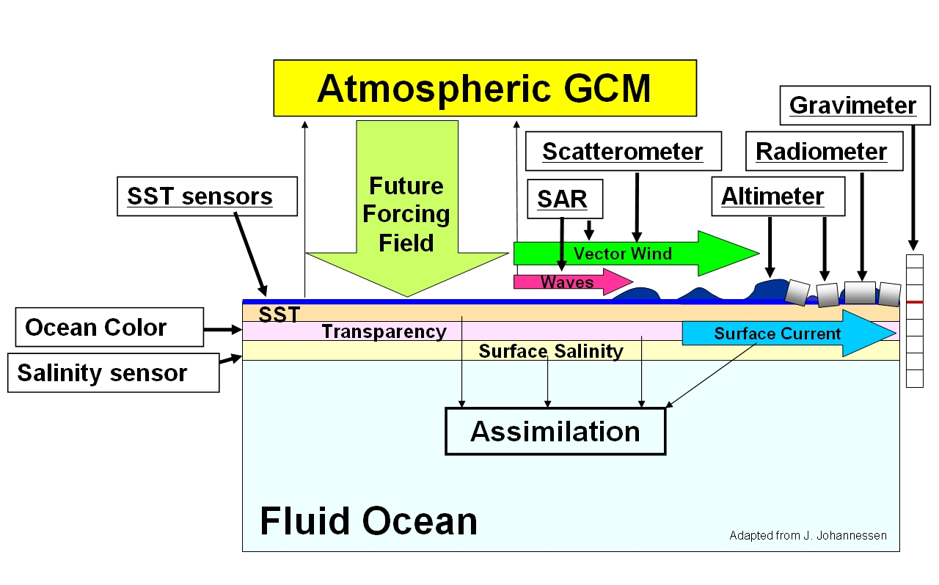

Figure 1. Basic observation parameters required for routine model data assimilation and operational oceanography.

(a) (b)
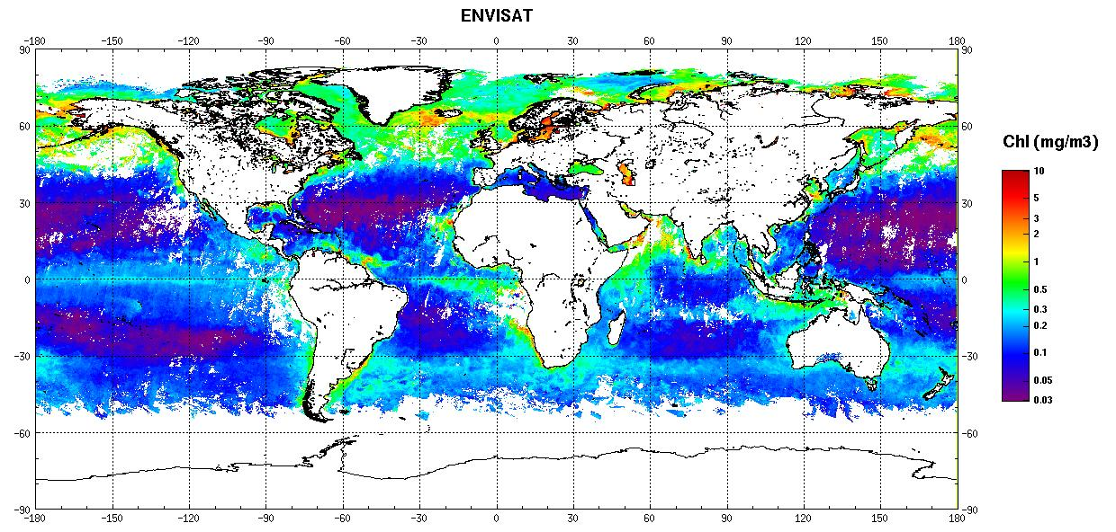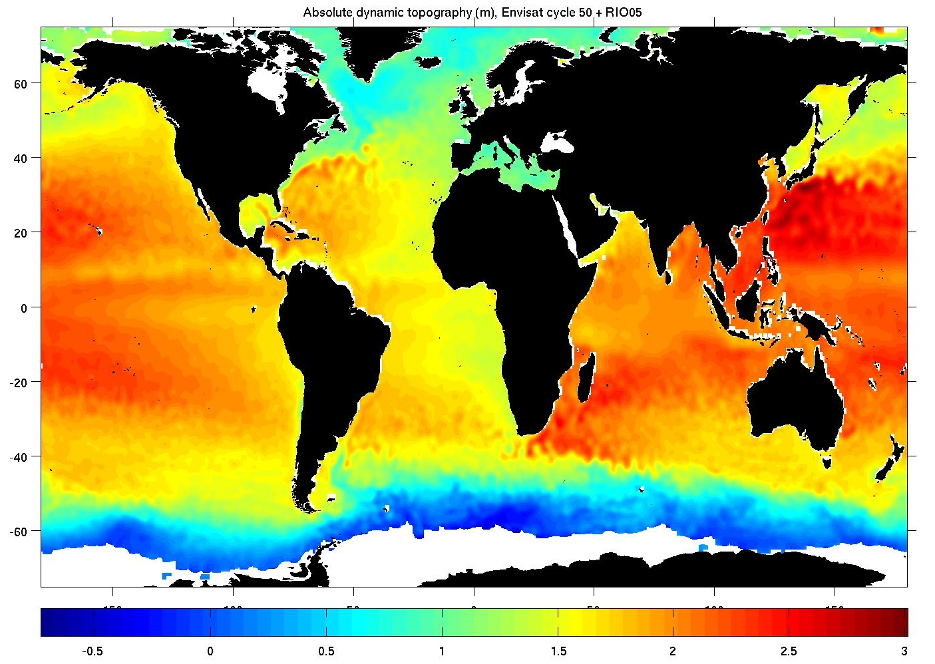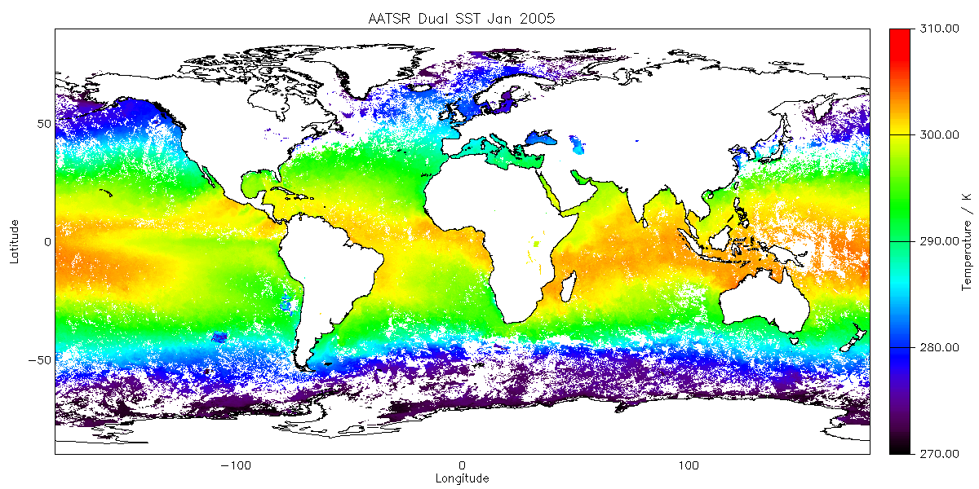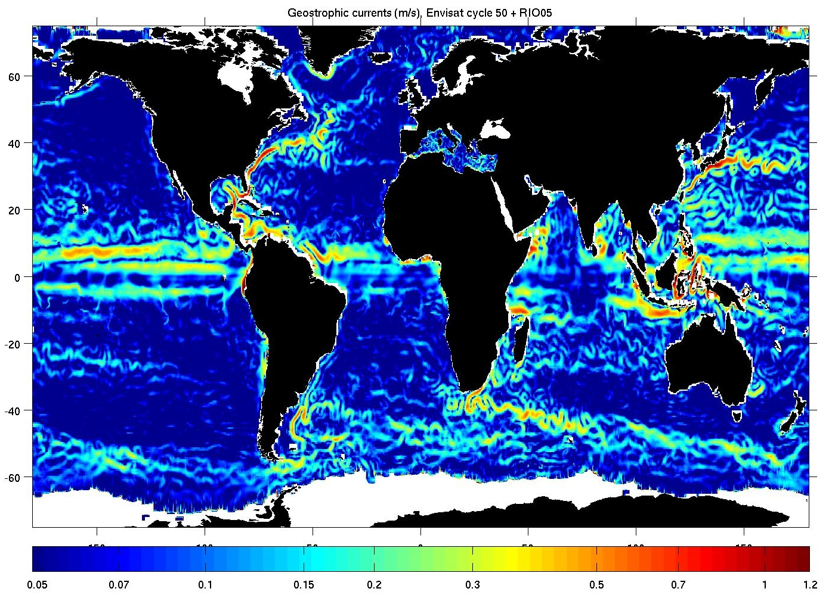
- (c) (d)
Figure 2. Typical examples of routinely available global composite geophysical products: (a) mean absolute dynamic topography; (b) geostrophic currents; (c) Chlorophyll a ocean colour; (d) sea-surface temperature.

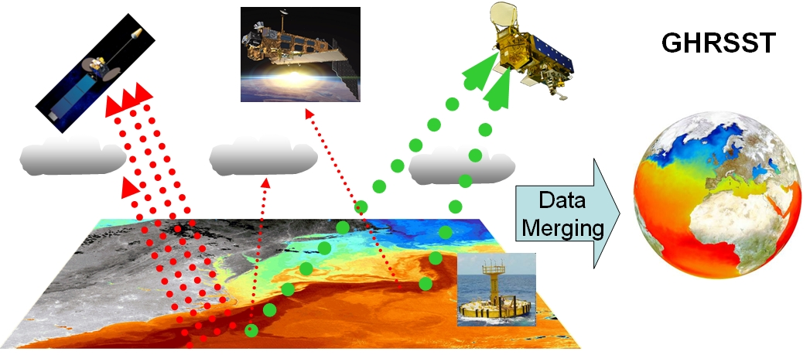

Figure 3. Schematic illustration of the combined benefits of the polar orbiting ThIR and microwave satellite data when combined with high frequency geostationary imager and in-situ data (courtesy Group for High Resolution SST).
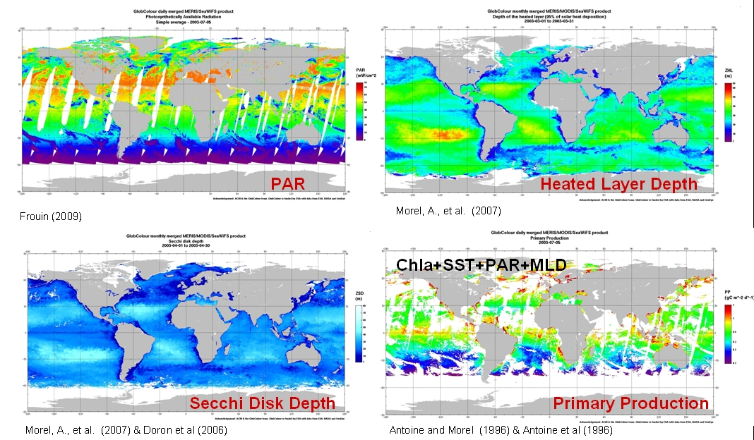

Figure 4. Examples of SeaWifs/MODIS/MERIS synergy products from the GlobColour Project. Panels indicate (a) daily Photosynthetically Available Radiation (PAR) from 5 July, 2003; (b) monthly merged Heated Layer Depth; (c) monthly merged Secchi Disk Depth; and (d) daily Primary Production.
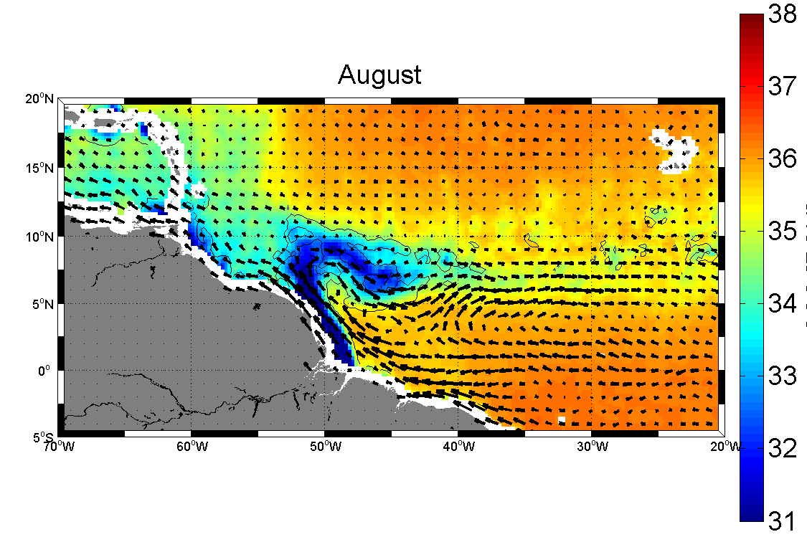
SSS (psu)
(a)
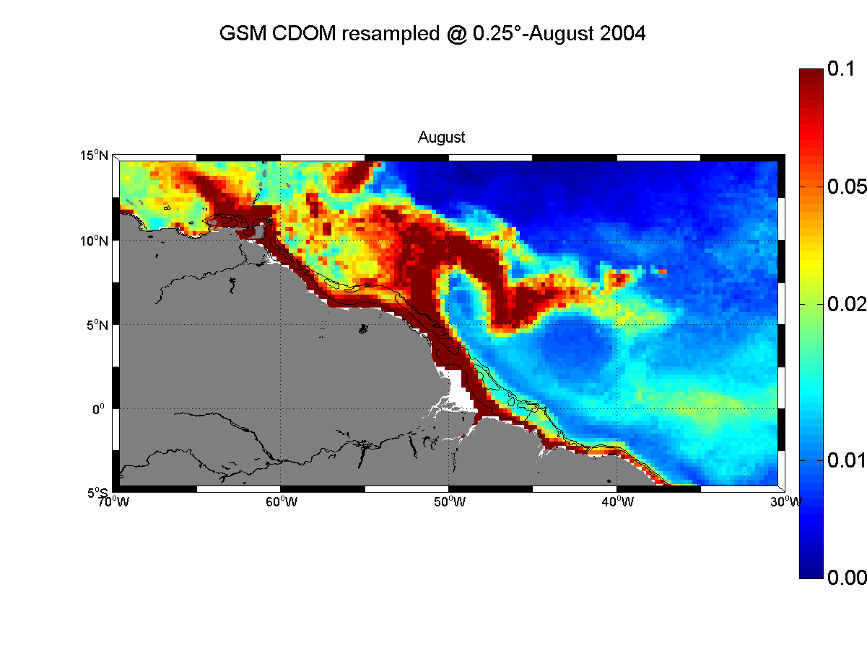
(b)
CDOM

Figure 5. Monthly climatology of (a) AMSR-E SSS and drifter-derived near-surface currents, and (b) MODIS and SeaWifs derived coloured dissolved organic matter (CDOM) absorption coefficient. Courtesy N. Reul et al. (2009).

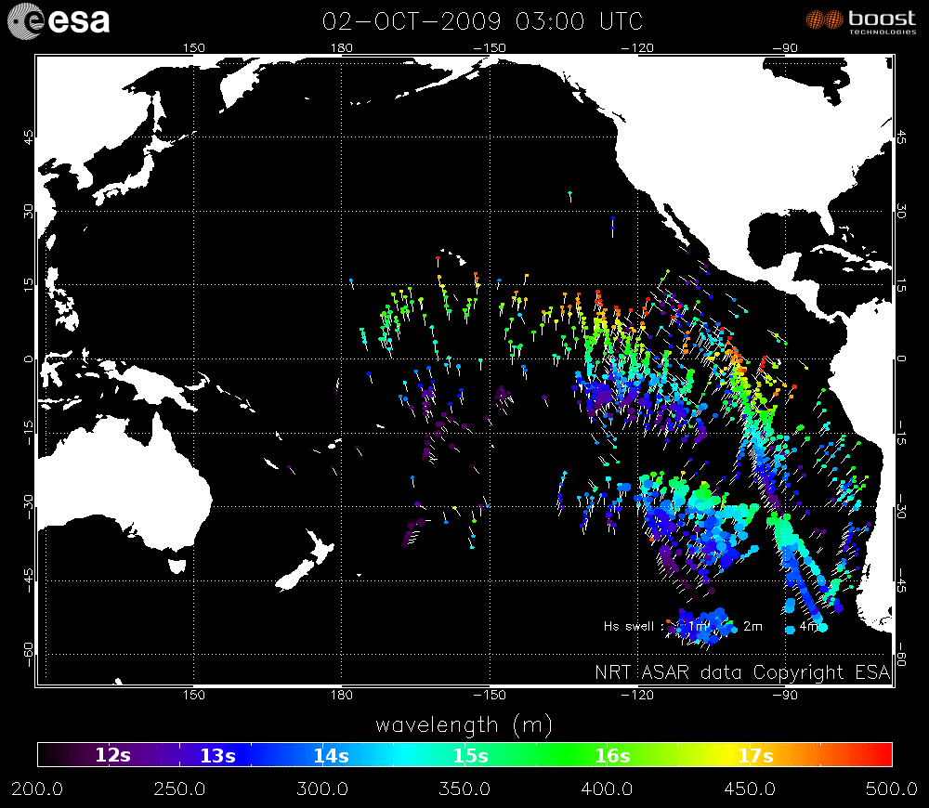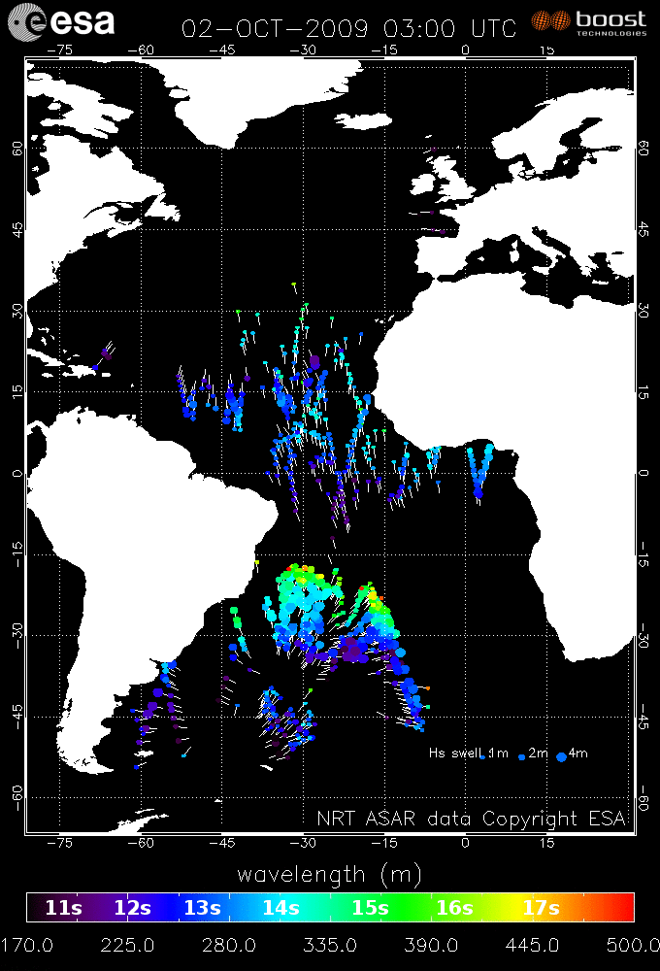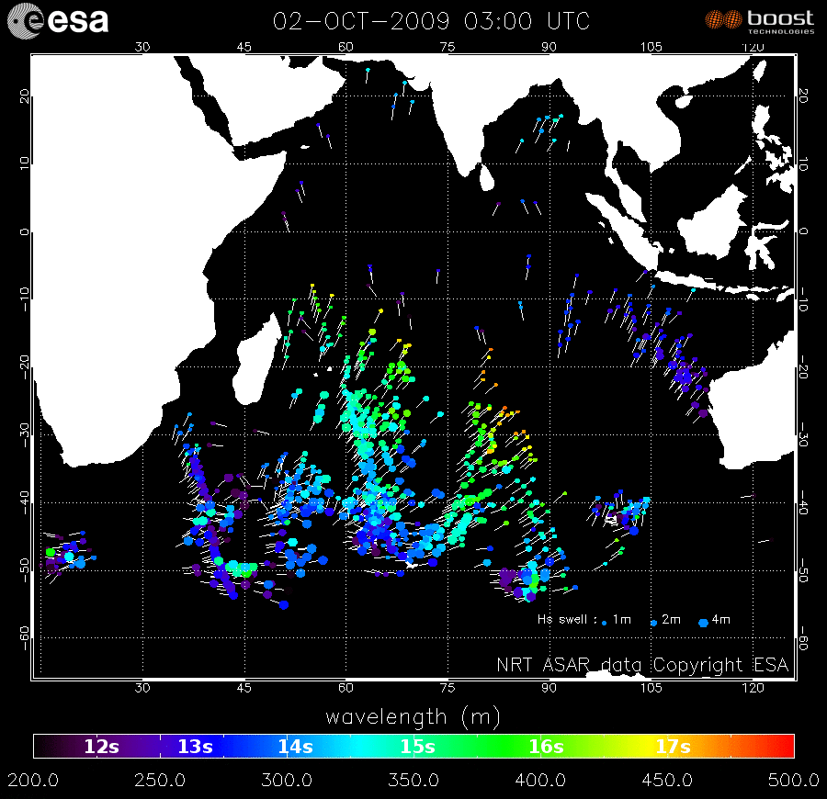

Fig. 6. Example of SOPRANO Level 3 operational wave products for the Pacific Ocean; Atlantic Ocean and Indian Ocean for a single day static realisation of propagating swell waves on 2 October, 2009 (03:00 UTC), from global time-series derived from ASAR Level 2 wave mode data (courtesy F.Collard, CLS).

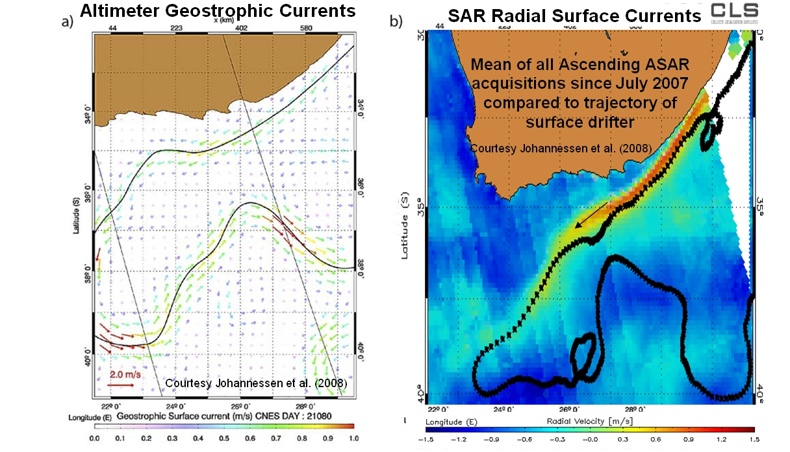
Figure 7. Fig. showing (a) Geostrophic currents from altimeter-derived mean dynamic topography, and (b) line of sight, radial surface currents derived from Envisat ASAR image data.

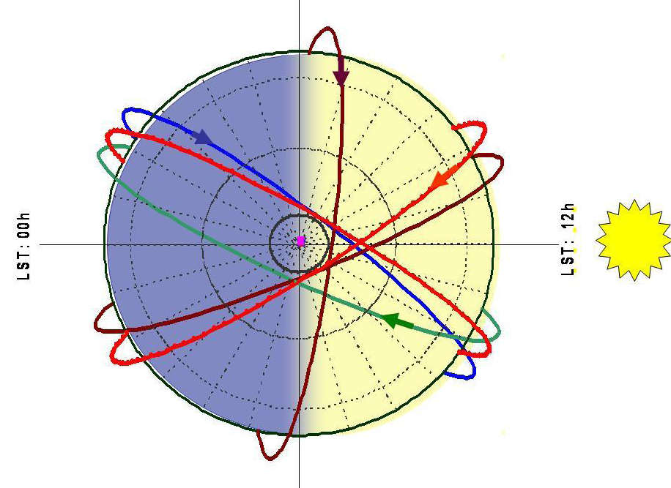
am
pm

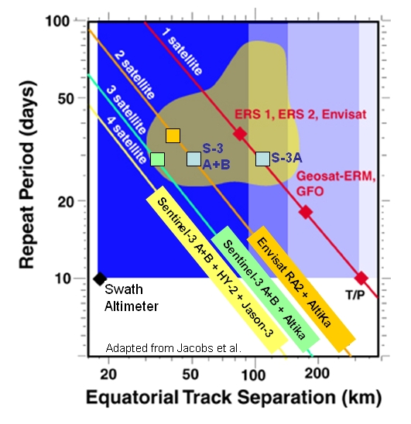

Figure 8a. Schematic illustration of use of am and pm polar orbits to optimise time-space sampling of the globe; and 8b. Ideal sampling of mesoscale ocean variability (brown patch) requires a coordinated Virtual Constellation of several conventional altimeters, including ideally one precise reference mission (tide-free orbit) and more than two in optimised sun-synchronous orbits.

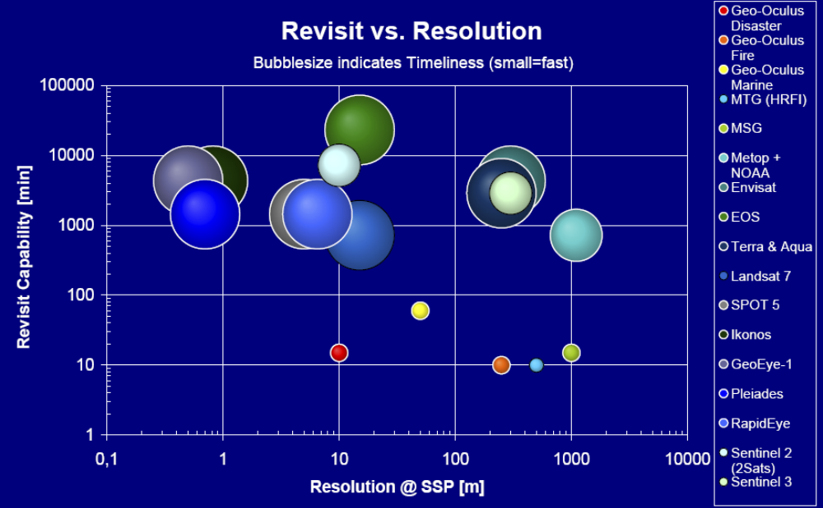

Figure 9. Bubble plot indicating time-space capabilities of optical satellites with Vis/IR instruments, and highlighting the push towards spatial resolutions of <100 m with a revisit of < 15 minutes from Geostationary orbit with the Geo-Oculus concept (courtesy Astrium GmbH).

