SEA LEVEL RISE
Regional and global trends

A. Cazenave¹, D.P. Chambers², P. Cipollini³, L.L. Fu⁴ , J.W. Hurell⁵
M. Merrifield⁶, S. Nerem⁷, H.P. Plag⁸, C.K. Shum⁹, J. Willis⁴

- LEGOS-CNES, Toulouse

- CSR, Austin, Texas

- ,

- JPL

- Uni

- University of Hawaii

- University of Colorado

- University Nevada

- Ohio State University

OCEANOBS2009- Plenary Paper

Abstract

This Plenary Paper on sea level is based on several Community White Papers submitted to OceanObs09. Considerable progress has been realized during the past decade in measuring sea level change globally and regionally, and in understanding the climate-related causes of observed changes. We first review current knowledge about sea level change, globally and regionally. We summarize recent results from the 2007 IPCC 4th Assessment Report (AR4), as well as post-IPCC results relevant to sea level observations, causes and projections. New challenges are identified for the coming decade in terms of observations, modelling and impact studies. From these challenges, a number of recommendations emerge, which are listed below:

1.An accurate (at the <0.3 mm/yr level uncertainty), multi-decade-long sea level record by altimeter satellites of the T/P- Jason class is essential, as is continued funding of the altimeter science team. To meet the goal of 0.3 mm/yr or better in sea level rate accuracy, the global geodetic infrastructure needs to be maintained on the long-term; the Terrestrial Reference Frame must be accurate and stable at the 1 mm and 0.5 mm/yr level; radiometers required for the correction of radar path delays must also be stable (or calibrated) at 0.1 mm/year. A network of tide gauges with precise positioning (GPS, or more general, GNSS) should be maintained with an emphasis on long record lengths and global spatial coverage (e.g., the GLOSS Core Network plus additional stations with especially long record lengths).
2.Continuity of GRACE-type space gravimetry observations is critically needed. No other data exist to measure ocean mass changes directly. No mission is planned by space agencies to take over the current GRACE mission until at least 2017, leading to a likely undesirable gap of 5-8 years in the data record.
3.Consensus results for the Glacial Isostatic Adjustment (GIA) corrections that are needed to interpret GRACE, tide gauges and satellite altimetry observations over ocean, land and ice-sheets should be developed. Specifically, the GIA community should be encouraged to perform intercomparison studies of GIA modelling, similar to what has been done for coupled climate models outputs. The goal should be to produce a global, spatially varying, community wide best-estimate of GIA and its uncertainty that is appropriate for application to global sea level studies (i.e., it should conserve mass, etc.).
4. Long-term maintenance of the Argo network in its optimal configuration is imperative for measuring ocean temperature and salinity; development of a shipboard CTD measurement program for absolute calibration of other in situ hydrographic data is critical to maintain the fidelity of other networks; reanalyses of historical temperature and salinity is strongly recommended; development of new methods/systems to estimate deep changes in ocean heat content and thermal expansion is needed.
5.High priority should be given to the development of integrated, multidisciplinary studies of present-day and last century sea level changes (global and regional), accounting for the various factors (climate change, ocean/atmosphere forcing, land hydrology change—both natural and anthropogenic, solid Earth processes, etc.) that act on a large variety of spatio-temporal scales. Improvement and validation of 2-dimensional past sea level reconstructions is also important, as well as development of attribution studies for global/regional sea level variations using ocean reanalyses.
6. Sea level projections from climate models need to be inter compared to assess uncertainty, and projections need to include regional and decadal variability. Development and inclusion of realistic ice sheet dynamics in coupled climate models is a key issue for projecting sea level change, as the potential contribution from ice sheets like Greenland and Antarctica is much larger than any other source.
Finally, as local (relative) sea level rise is among the major threats of future global warming, it is of primary importance to urgently:
7. Develop multidisciplinary studies to understand and discriminate causes of current sea level changes in some key coastal regions, integrating the various factors that are important at local scales (climate component, oceanographic processes, sediment supply, ground subsidence, anthropogenic forcing, etc.),
8.Implement additional in situ observing systems in vulnerable coastal areas, in particular, tide gauges co-located with GNSS stations for measuring (mainly vertical) ground motions,
9.Improve current altimetry-based sea level observations in coastal zones and continue to develop SWOT (Surface Water and Ocean Topography) satellite mission, a wide-swath altimeter, for accurate future monitoring of local sea level changes at the land-sea interface,
10. For decision support, provide reliable local sea level forecasts on time scales of decades. Improved sea level (global and regional) projections at centennial time scales are also desired.

- Introduction
Sea level rise is a global problem involving both natural and man-made changes in the climate system as well as the response of the Earth to the changes. The impact of sea level rise to our society is felt regionally with a high degree of variability. Sea level rose at a mean rate less than 2 mm/yr during the 20th century, but has increased to greater than 3 mm/yr since the early 1990s based on satellite records. However, the rate is highly variable geographically. Global mean sea level rise will likely accelerate in the coming decades resulting from accelerated ocean warming and the melting of the massive ice sheets of Greenland and Antarctica. Unfortunately, long-term projections of sea level rise from coupled climate models are still very uncertain, both in terms of global mean and regional variability. This is due, in particular, to poor modelling of ice-sheet dynamics and inadequate accounting for decadal variability. Improving our ability to project future sea level rise, globally and regionally, implies developments in both observing systems and modelling in various disciplines at different spatial and temporal scales. Although significant progress has been made in the past decade, it appears timely to establish a long-term international program for sustaining and improving all observing systems needed to measure and interpret sea level change as well as improving future projections of global sea level rise and its regional impacts Despite improvements in understanding, however, it is likely that some limitations to prediction of future sea level will remain. In light of this, it is of paramount importance to maintain a detailed monitoring system for observing both sea level rise and the processes that drive it. In this plenary paper we first review current knowledge about sea level change, globally and regionally. We then summarize recent results from the 2007 IPCC 4th Assessment Report (AR4), as well as post-AR4 results relevant to sea level observations, causes and projections. We also discuss new challenges for the coming decade in terms of observations, modelling and impact studies.

2.DECADE-LONG SEA LEVEL OBSERVATIONS FROM SPACE: WHAT SATELLITE ALTIMETRY HAS TOLD US?
2.1 Observations of the global and regional sea level rates
Although it is sometimes poorly documented in the scientific literature, estimates of modern day increases in global mean sea level (GMSL) based on tide gauges and satellite data are usually intended to represent changes in the total volume of the oceans due to density and water mass modifications. This means that observations have been corrected to account for GIA effects (i.e., both local and global deformations of the Earth’s crust, as well as self-gravitational changes). The importance of GIA effects are discussed below in greater detail, but for the remainder of the document we will adopt the convention that estimates of changes in GMSL refer to changes in ocean volume.
Until the early 1990s, sea level change was measured by tide gauges along continental coastlines and mid-ocean islands. From these observations, a mean rate of 1.7 to 1.8 mm/yr has been reported for the 20th century, in particular for the past 60 years [1-5]. These studies also showed that sea level rise was not linear during the past century but rather subject to decadal to multidecadal variability. This is illustrated in Fig.1 which shows 20th century mean sea level evolution estimated from tide gauges (data from [2] and [5] are superimposed). Non-linear long-term trends are clearly visible.

The launch of TOPEX/Poseidon (T/P) in 1992 ushered in a new era in measuring sea level change. T/P and its successors Jason-1 (2001- ) and Jason-2 (2008- ) have a number of improvements over previous radar altimeters specifically designed to improve the measurement of sea level (e.g., [6]). Computing spatio-temporal variations in GMSL from altimetry is relatively straightforward, and most analyses use a procedure similar to that described in more detail by Nerem [7] with only a few modifications. Essentially, the sea surface height (SSH) along each ground track pass are reduced to SSH anomalies (SSHAs) about the mean SSH using either a mean profile or a global map. The SSHAs for each repeat cycle are then averaged, accounting for the fact that there are more observations in the high-latitudes because of the ground track spacing. From this, one obtains a number representing the GMSL for each repeat period, which in the case of T/P and Jason-1/2 is 10 days. Numerous authors have used altimetry to estimate present-day GMSL from altimetry. The most recent estimated linear trends generally agree that sea level has been rising at a rate in the range 3.0 to 3.5 mm/yr since 1992 (e.g., [8-10]). Differences are generally due to the time-span used to estimate the linear trend, and to differences in satellite orbits and geophysical corrections applied to the data. Fig.2 compares T/P and Jason altimetry-derived sea level curves from two groups (seasonal signal removed; inverted barometer correction and 60-day smoothing applied). The trend over the 1993-2008 time span is similar for the two curves and amounts to 3.3 ± 0.4 mm/year (after correcting for the -0.3 mm/yr glacial isostatic adjustment or GIA effect, [11]). Some differences are noticed at sub-annual and interannual time scale.
It is worth noting that other altimetry missions like GFO, ERS-1/2 and Envisat are also useful for estimating sea level change when state-of-the art corrections are applied (e.g., [12-14]). In addition, the ERS and Envisat satellites allow mapping a large portion of the Arctic Ocean, unlike T/P and Jason.

  - Error budget in global mean sea level
The main difficulty with determining accurate GMSL rise from altimetry is the possibility of drifts and bias changes in the instruments and geophysical corrections. It is not a trivial matter to determine such changes. However, significant work has been done by Mitchum [15,16] to devise methods to accurately calibrate altimeter measurements against a global network of tide gauges in order to detect such bias drifts and/or jumps. Because of such calibration efforts, a large number of drifts and bias changes have been discovered in altimetry data, ranging from an early error in the T/P oscillator correction that caused the estimate to be nearly 7 mm/year too high [17] to drifts in the water vapor correction from the microwave radiometers of T/P and Jason-1 [12,18,19], to changes in the sea state bias model [20] and orbit stability [9]. A recent re-evaluation by Ablain et al. [10] of the total error budget due to orbit, geophysical corrections and instrumental drifts and bias, estimates a global mean sea level trend uncertainty of ~0.5 mm/yr, in good agreement with the external tide gauge calibration. Nevertheless, the possibility of systematic errors affecting both altimeter and tide-gauge based estimates of sea level rise remains. For this reason, more work is needed to quantify potential error sources such as scale errors in the reference frame or inaccurate models of other geophysical processes such as GIA.

  - Regional variability (altimetry era and previous decades)
Satellite altimetry has revealed that sea level is not rising uniformly (Fig.3) during the satellite period. In some regions (e.g., western Pacific), rates of sea level rise are faster by a factor up to 3 than the global mean rate. In other regions rates are slower than the global mean or even negative (e.g., eastern Pacific). Spatial patterns in sea level trends mainly result from ocean temperature and salinity changes reflecting changes in circulation (e.g., [21,22]) or gravitational and deformational effects associated with last deglaciation and ongoing land ice melting (e.g., [23-26]) also cause regional variability in rates of sea level change. While the latter effects remain small, they will eventually become substantial as the contribution from ice sheet loss grows.
Observations of ocean heat content and thermal expansion over the past few decades show that spatial patterns are not stationary but fluctuate both in space and time in response to natural perturbations of the climate system such as ENSO (El Nino-Southern Oscillation), NAO (North Atlantic Oscillation) and the PDO (Pacific Decadal Oscillation) [21]. As a result, sea level trend patterns over the last 50 years will be different from those observed by satellite altimetry over the last 15+ years. This is indeed what reconstructions of 2-dimensional sea level during past decades have confirmed (e.g., [2,27]). These studies combine long tide gauge records of limited spatial coverage with short, global gridded sea level data, either from satellite altimetry or Ocean General circulation Models (OGCMs), and provide information on regional sea level variability for those decades before the altimetry era. Fig.4a,b shows spatial patterns in sea level trends for the 1950-2000 period, from two different reconstructions. Differences with Fig.3 (altimetry period) are clearly visible.

3.What have we learned during the past decade about the causes of sea level change at global and regional scales?
Owing to various satellite and in situ data sets made available during the last decade, considerable progress has been realized recently in quantifying the various causes of present-day sea level rise (ocean temperature and salinity changes, glaciers melting, ice sheet mass loss and land water storage change). We examine each of these contributions below.

3.1 Ocean temperature and salinity measurements
In situ observations of temperature and salinity provide important information about one of the causes of regional and global sea level change. From the late 1960s until recently, ocean temperature has been essentially measured with expandable bathythermographs (XBT) predominantly along shipping routes, complemented by mechanical bathythermographs (MBT) and Conductivity-Temperature-Depth (CTD) systems in a few limited areas. In recent years, an international program of profiling floats, Argo ([28], www.argo.ucsd.edu), has been initiated, providing temperature and salinity measurements globally at approximately 3° resolution. The floats go down to 2000 m with a revisit time of ~ 10 days. In late 2007, the Argo project reached its target size of 3000 profiling floats in the global ocean. Although the array density is not sufficient to resolve small-scale features such as fronts and eddies, Argo provides a comprehensive system for estimating regional and global steric sea level changes attributable to temperature and salinity variations in the upper 2000 m of the ocean. Calibration of the temperature and salinity data is critical. Recent evaluations of the older XBT-based thermal data have found significant, depth-varying biases [29, 30]. While these corrections have only slightly changed the thermal expansion contribution to the sea level trend over the last 50 years, they led to substantial reduction of spurious interannual/decadal anomalies in ocean heat content and thermal expansion. Recent re-evaluations of the trend in thermal expansion over the past 4-5 decades [31-33] range from 0.3 ± 0.01 mm/yr to 0.5 ± 0.08 mm/yr, noting that the uncertainties are formal errors based on sampling and do not reflect any remaining depth-dependent temperature bias. During the 1993-2003 decade (considered in IPCC AR4), the thermal expansion rate was significantly larger (about 1.5 mm/yr) (e.g., [34] and results in Bindoff et al., [21]). Since 2003, this rate has significantly decreased, likely a result of short-term natural variability of the coupled ocean-atmosphere system. Recent results based on Argo range from -0.5 mm/yr [36] for 2003-2007 to 0.8 ± 0.8 mm/yr [37] for 2004-2007.

3.2 Ocean mass change from GRACE
Net water flux into and out of the ocean causes its mass to change. Such changes in ocean mass give rise to gravitational variations that are detectable by the Gravity Recovery and Climate Experiment (GRACE) [38]. This has allowed, for the first time, direct estimates of the global ocean mass contribution to sea level change [36-41]. Recently, published trends in global ocean mass range from a low value of 0.8 mm/year [36] to a high value of 1.7 to 1.9 mm/year [40,41]. Most of this difference is due to the choice of the GIA model used in the processing of the GRACE data. To GRACE, the GIA signal appears as a secular trend in the gravity field that must be removed. This correction is roughly of the same order of magnitude as the expected ocean mass trend. Unfortunately, there is disagreement between GIA models for this particular correction. The GIA correction used by Willis et al. [36]) and Leuliette and Miller [37]) is based on Paulson et al. [42]’s model, and results in a ~1 mm/year increase in ocean mass between mid-2003 and mid-2007. Cazenave et al. [41] used Peltier [43]’s model which results in an ocean mass increase of nearly 2 mm/yr between 2003 and 2008. According to [43], this difference results almost entirely from including a model of Earth’s rotational feedback or not. Unfortunately, there is still significant disagreement among the GIA community over the appropraite rotational feedback effect. Although all authors do agree that ocean mass is rising since 2002, we can only say with certainty that the rate is somewhere between 1 to 2 mm/year. It is worth noting that the highest possible GRACE-based mass trend is compatible with recent estimations based only on contributions from land ice (e.g., [44-46]). However, because the uncertainty in the contribution from land ice is quite large, it is critical to understand the true GIA signal sensed by GRACE in order to constrain the GRACE-based ocean mass component.

3.3 Land ice loss (ice sheets and glaciers)
3.3.1 Ice sheets
During the past two decades, different remote sensing techniques have offered new insight on contemporary mass change of the ice sheets. Radar altimetry (e.g., ERS-1/2 and Envisat satellites) as well as airborne and satellite laser altimetry (IceSat since 2003) allow monitoring of ice sheet elevation change, a quantity that is used to infer ice volume change (e.g., [47-50]). The InSAR (Synthetic Aperture Radar Interferometry) technique provides measurements of glacier surface flow, hence ice discharge into the oceans if glacier thickness is known. When combined with other parameters of surface mass balance (mainly snow accumulation), the net ice sheet mass balance can then be derived [45,46,51]. GRACE is also now routinely used to measure the total mass balance of the ice sheets directly [41, 43, 52-59]. Each technique has its own bias and limitations. GRACE, for instance, is sensitive to GIA: over Antarctica, the GIA effect is of the same order of magnitude as the ice mass effect. Nevertheless, mass balance results from satellite-based sensors agree reasonably well and clearly show accelerated ice mass loss from the ice sheets during the last decade. This acceleration has been attributed to the dynamical response of the ice sheets to recent warming, with most of the ice sheet mass loss resulting from coastal glacier flow [60, 61]. Two main processes have been invoked: (1) lubrication of the ice-bedrock interface resulting from summer melt-water drainage through crevasses, and (2) weakening and break-up of the floating ice tongue or ice shelf that buttresses the ice stream. While the first mechanism may play some role in Greenland where substantial surface melting occurs in summer (e.g., [62]), glaciologists now favour the second mechanism as the main cause able to explain the recent dynamical changes affecting the ice sheets (e.g., [61,63]). Because the ice shelves are in contact with the sea, warming of seawater (e.g., [63,64] and changes in ocean circulation can trigger basal melting and further break-up, allowing the ice flow to speed up [61].
For the 1993-2003 decade, IPCC AR4 estimates nearly equivalent contributions from Greenland and Antarctica to sea level change (0.21 ± 0.035 mm/yr and 0.21 ± 0.17 mm/yr respectively) [65]. Post-IPCC results report significant acceleration of ice mass loss for both ice sheets. For 2003-2008, the mean Greenland contribution has increased to ~0.5 mm/yr (e.g., [46]). Recent results for Antarctica also suggest that this contribution has doubled in the past 5 years (e.g., [45,66]).

3.3.2 Glaciers
Glaciers and ice caps (GIC) are very sensitive to global warming. Here we consider GIC to include all non-seasonal land-ice apart from the Greenland and Antarctic ice sheets. Observations indicate that since the 1970s most glaciers are retreating and thinning, with noticeable acceleration since the early 1990s. Mass balance estimates of GIC are based either on in situ measurements (monitoring of the annual mean snow accumulation and ice loss from melt) or geodetic techniques (measurements of surface elevation and area change from airborne altimetry or digital elevation models). Since only a small number of the world’s mountain glaciers are directly measured, the mass balance of glaciers in the same region are assumed to be similar in order to extrapolate to a global estimate. On the basis of published results, the IPCC AR4 estimated the GIC contribution to sea level rise to be 0.77 ± 0.22 mm/yr over 1993-2003 [65]. Since the IPCC AR4 publication, a few updated estimates of GIC loss have been proposed from traditional mass balance measurements and space-based observations (from GRACE, [67-69] and satellite imagery). For example, Kaser et al. [70] report a contribution to sea level rise of 0.98 ± 0.19 mm/yr for 2001 to 2004, while Meier et al. [44] find the GIC contribution to be 1.1 ± 0.24 mm/yr for the year 2006. Recently, Cogley [71] provided an updated compilation of global average GIC mass balance up to 2005, indicating a 1.4 ± 0.2 mm/yr contribution to sea level rise for 2001-2005, a value much larger than earlier estimates due to better representation of tidewaters glaciers. One should note, however, that all of these studies assume that the glacier melt water (even from inland glaciers) reaches the ocean immediately, which may not be true.

3.3 Land waters
Change in land water storage, due to natural climate variability and human activities (i.e., anthropogenic changes in the amount of water stored in soils, reservoirs and aquifers as a result from dam building, underground water mining, irrigation, urbanization, deforestation, etc.) is another potential contribution to sea level change. However, until recently, this factor could hardly be estimated because global in situ data are lacking. Model-based estimates of land water storage change caused by natural climate variability suggest no long-term contribution to sea level for the past few decades, although interannual/decadal fluctuations may have been significant [72,73]. Direct human intervention on land water storage induces sea level changes. The largest contributions come from ground water pumping (either for agriculture, industrial and domestic use; [74] and reservoir filling (e.g., [75]). Chao et al. [75] suggest that dam-building over the last 50 years has prevented a large amount of runoff from reaching the ocean, and thus has caused a lower rate of sea level change than expected without dams. Surface water depletion has only a small contribution (see Milly et al. [76] for a review).
Since 2002, GRACE allows for determination of the total (i.e., due to climate variability and human activities) land water contribution to sea level. Over the short-record from GRACE, the land water signal (sum of surface, soil and underground reservoirs, plus snow pack where appropriate) is dominated by the interannual variability and has only a modest contribution (<10%) to the sea level trend over this period (e.g., [77-79]).
To date, the evidence suggests that climate-driven change in land water storage mainly produces interannual to decadal fluctuations but (so far) no long-term trend. This is in contrast with direct human-induced change in land hydrology which clearly has led to a ‘secular’ (either positive or negative) change in sea level over the past half-century.

3.4 Sea level budget over the altimetry era
For the 1993-2003 decade, the IPCC AR4 estimated that about 50% of the observed sea level rise was caused by thermal expansion, while glacier melting contributed ~ 30 % and ice sheet mass loss ~15% [21]. The sea level budget was not far from being closed.
For the post-AR4 period (i.e., since 2003), results report accelerated land ice shrinkage. Direct estimates of the total (glaciers plus ice sheets) land ice loss for the last 5 years (e.g., [61,71]) indicate a contribution as large as 80-85% to recent sea level rise, with a (presumably temporary) slow-down in thermal expansion, most likely related to interannual fluctuations in the Earth’s radiative balance.

4.What are the great challenges for sea level studies in the coming decade?
A number of observational goals must be met in order to detect any acceleration in the rate of sea level rise (e.g., [81-81]), compare altimetry-based observations with estimates of natural and anthropogenic-related contributions, understand the causes of sea level change, map and understand regional variability for the recent years and decades, constrain coupled climate models used for sea level projections, and ultimately study coastal impacts of sea level rise. These are discussed below.

4.1 Lengthening the observational time series (Altimetry, GRACE, Argo, Tide Gauges)
Sea level studies require long-term monitoring by altimeter satellites (for sea level), space gravimetry (for ocean mass change, ice sheet mass balance, land water storage change) and Argo (for 3-D temperature and salinity data). This is necessary because interannual fluctuations of 3- to 5-year periods in each of the components can be significantly large to mask secular or decadal to multidecadal variability. Sustained geodetic infrastructures (tide gauges, GPS stations, etc.) are needed as well.

4.1.1 Satellite altimetry
Since the launch of T/P in 1992, the continuity of precise sea level observations has been insured by the successful launch of Jason-1 (2001) and Jason-2 (2008), and by continued funding of efforts by the altimeter science team to understand and remove systematic errors from these observations. Fortunately, plans for a Jason-3 mission (taking over Jason-2) are under discussion, although not yet finalized (the mission is approved both in the USA and Europe but is not yet fully funded).
A long, accurate sea level record is an essential climate observation. Sea level reflects the response of almost all components of the climate system to climate change and variability. It is a particularly useful indicator of global warming. Thus, having a long time series of measurements is critical for differentiating climate signals associated with global warming from natural variability. Even with 17 years of measurements from satellite altimetry, the record still contains significant variability related to ENSO, PDO, etc (e.g., [82]).
Although there is strong evidence that the observed change in sea level rise since the beginning of the 1990s is not related to the difference in sampling between tide gauges and altimetry and is unique in the tide gauge record [81], longer altimetry time-series are necessary to ensure detection of further changes and separation between decadal fluctuations and longer-term trends.
Recommendation :
An accurate (at <0.3 mm/yr level uncertainty), multi-decade-long sea level record by altimeter satellites of the T/P- Jason class is essential, as is continued funding of the altimeter science team.

4.1.2 Geodetic infrastructure requirements for long-term sea level monitoring at the 0.3 mm/yr precision level –or better- by high-precision altimetry systems
Long-term sea level monitoring from altimeter satellites with a rate precision of 0.3 mm/yr implies the following needs:
- Orbit accuracy at the 1 cm level. For this requirement to be met, good tracking networks, multiple tracking systems (e.g., SLR, GPS, DORIS), accurate force models, etc. are needed. With improvements in the satellite tracking networks and the dynamical models for satellite orbital motion, orbit accuracies at the 1-cm level have already been achieved. This has been accomplished in large part due to the combination of multiple tracking techniques that support each other in the orbit determination component. The availability of multiple tracking techniques provides robustness in the event of the failure or degradation of one of the tracking methods and allows cross-validation through inter comparisons of the results based on individual techniques. For that purpose, the existing geodetic infrastructure needs to be maintained over the long term.
- Radiometer drift at less than 0.1 mm/year. It is vital to correct altimeter range measurements for path delay due to water vapour in the atmosphere. This is typically done with on-board radiometers. However, all radiometers that have been flown to date (including those on T/P and Jason-1) have drifted, by amounts as large as several 6 mm/yr [83]. These drifts and bias changes have not been detected for years in previous missions. In order to reach a 0.1 mm/year goal for sea level rate from altimetry, it is vital to have a radiometer that is stable at better than 0.1 mm/year of water path delay, either through on-board calibration or reduced sensitivity to thermal shocks.
1.Terrestrial Reference Frame (TRF) with 1 mm accuracy and 0.5 mm/yr stability.
The TRF, to which altimetry and geodetic measurement are referred, must be accurate and stable over the long term (e.g., [84]). Precise knowledge of the position and velocity of the tracking stations is an inherent requirement for the satellite orbit determination, but as long as the errors are sufficiently random, averaging the orbit error over months or years provides the sub-mm/yr accuracy required for sea level monitoring. It is the systematic errors in the reference frame that are of particular concern. An erroneous drift in the TRF will be reflected in the satellite orbit, leading to implied global and regional sea level changes that are not real [9, 85]. This erroneous trend is approximately 10% of the TRF drift in the measured global sea level and 50% or more regionally. For the objective of 0.3 mm/yr in global sea level accuracy to be met, the reference frame drift should ideally be kept below 1 mm/yr. A goal of 0.5 mm/yr stability seems appropriate.
2.Dedicated tide gauge network with known vertical motions at the 0.1 mm/yr precision. To provide the long-term calibration required for altimeter systems, it is essential to maintain a dedicated tide gauge network (e.g., the GLOSS network), with accurate ground motion measurements. Currently, vertical ground motions are not being measured at many (perhaps most) of the tide gauges, and the altimeter calibration results rest upon the assumption that the various vertical motions average down. The vertical motion of a number of tide gauge must be monitored using precise positioning techniques (e.g., GNSS) and tied into the global reference frame. A high-quality tide gauge network is also important for long-term sea level studies at regional scale (see section 4.5).
Recommendation :
To meet the goal of 0.3 mm/yr or better in sea level rate accuracy, the global geodetic infrastructure needs to be maintained on the long-term. The dedicated tide gauge network (GLOSS) must also be equipped with precise positioning stations (GNSS). The TRF must be accurate and stable at the 1 mm and 0.5 mm/yr level (orbits must be accurate to better than 1 cm RMS ; radiometers must be stable at better than 0.1 mm/yr of water path delay).

4.1.3 Space gravimetry
The GRACE satellites have been invaluable for measuring change in water mass storage across the Earth, but the time series is only 7 years in length. In order to better understand the large-scale mass redistributions associated with climate change and variability, continuous, long-term measurements of gravity are necessary. Thus, an ongoing series of GRACE-type satellites is critically needed. Current estimates for the end of the GRACE mission are 2012. The U.S. NRC (National Research Council) Decadal Survey listed a GRACE follow-on mission as one of its recommended missions for the next 15 years, but in the 2017–2020 time frame. This would mean a gap of 5–8 years in time variable gravity with unacceptable negative impacts on all applications described above.
In 2007, a workshop [86] was held at the European Space Agency on the future of satellite gravimetry. In view of the unique science results from GRACE, the participants strongly supported the idea of a GRACE follow-on mission based on the present configuration, with emphasis on the uninterrupted continuation of time series of global gravity changes (short-term priority). The medium-term priority should be focused on higher precision and higher resolution gravity in both space and time. This step requires (1) the reduction of the current level of aliasing of high-frequency phenomena into the time series, and (2) the improvement of the separation of the observed geophysical signals. Elements of a strategy to address these include formation flights, multi-satellite systems, and improved and comprehensive Earth System modeling. This will open the door to an efficient use of improved sensor systems, such as optical ranging systems, quantum gravity sensors, and active angular and drag-free control. The long-term strategy should include the gravimetric use of advanced clocks (ground based and flying clocks), micro-satellite systems, and space-qualified quantum gravity sensors. In the future high precision clocks could be used for the global comparison at the cm-level of sea level (in conjunction with tide gauges). The required 10⁻¹⁸ relative precision is possible today in the laboratory for single optical clocks. For sea level research these clocks must become operational and clock synchronization has to reach similar precision.
Note that the recently launched GOCE gravity mission (successfully launched in March 2009) will provide a high-precision, high-resolution mean geoid, of very high value for determining the ocean dynamic topography (when combined with satellite altimetry), hence the large-scale ocean circulation. The mission lifetime (at most 18 months, due to its low altitude of ~250 km) will not permit directly measuring the long-term change of the gravity field. However, GOCE will contribute to, for the first time, the determination of the global gravity field at an unprecedented accuracy (several cm RMS in geoid height) and spatial resolution (~100 km). The combination of GOCE and GRACE data allows potentially a more accurate determination of the long-term change of the global gravity field.
Recommendation:
Continuity of GRACE-type observations is critically needed: no mission is currently planned by space agencies over the current GRACE mission, leading to a likely undesirable gap of 5 to 8 years in the data record. A gap-filling mission is strongly recommended.

4.1.4. In situ temperature and salinity measurements; Argo
For ocean warming monitoring, sea level studies, ocean reanalyses using OGCMs and initialisation of coupled climate models, long-term monitoring of 3-D ocean temperature and salinity is essential. The Argo measurements have provided good geographical coverage only since 2004. Although the temperature accuracy of Argo probes is adequate to detect global changes in upper ocean temperature, absolute calibration of Argo pressure observations remains an important issue. For example, an absolute pressure accuracy of 1 db for the global array corresponds to about 5 mm of global steric sea level change. Although small compared with seasonal variations in globally averaged steric sea level [36] or steric increases over a decade or more [33], such errors could obscure changes in globally-averaged steric sea level over periods of a few years. Maintaining the absolute calibration of the Argo array to such accuracy will require an ongoing program to collect and make quickly available high-quality shipboard CTD observations in a systematic and widespread way. Although a comprehensive program of shipboard CTD observations that provides adequate coverage for global sea level rise studies would be impractical, shipboard CTD data remain critical for absolute calibration of other data types. This was recently illustrated by the several studies that made use of CTD data to detect biases in and recalibrate the archives of historical XBT data. This underscores the need to continue to build programs to obtain repeat CTD observations and make them widely available for the purposes of climate-quality inter-calibration activities in near real time. In addition, efforts to accumulate and calibrate historical temperature and salinity observations must remain an important research priority so that present day steric changes can be placed in the appropriate historical context. Finally, a system must be devised to observe changes in temperature and salinity below 2000 m depth. Deep ocean temperature changes have been observed in every ocean basin (e.g., [87,88]), but the contribution of these deep steric changes to global sea level rise remains completely un quantified.

Recommendations:
- Maintain the Argo network in its optimal configuration for the next decade or longer
- Develop a shipboard CTD measurement program for absolute calibration of other data
- Continue to reanalyze historical temperature and salinity data
- Develop methods/systems to estimate deep changes in ocean heat content and thermal expansion

4.1.5. Maintenance of a global tide gauge network
In addition to the role that tide gauges play for altimeter calibration, the maintenance of the tide gauge dataset is important for understanding the nature of decadal to centennial fluctuations in global and regional sea level. Sea level reconstructions based on tide gauge data have emphasized fluctuations on these time scales [2, 4, 5, 27, 81, 90]. Additional studies are needed to understand the regional and global extent of these variations, which in turn will improve the ability to discern accelerations in global sea level rise from long-term fluctuations.
Recommendation :
Extending the overlap of the tide gauge and satellite altimetry observing systems will help to establish the physical context of long-term tide gauge signals. A network of tide gauges should be maintained with an emphasis on long record lengths and global spatial coverage (e.g., the GLOSS Core Network plus additional stations with especially long record lengths).

4.2. GIA modelling and development of consensus results by the community
As discussed above, the GIA corrections applied to GRACE-based ocean mass data and ice sheet mass balance estimates are currently highly uncertain, and there are strong differences in the community regarding whether rotational feedback should be applied to the model or not. Furthermore, GIA corrections to altimeter observations could also introduce small, but important systematic errors in estimates of global sea level rise. However, with longer time-series and other geodetic measurements (e.g., GPS), the potential to improve GIA models is great. Since GIA corrections are quite large for GRACE but not for altimetry, long time-series of altimetry, GRACE, and Argo data can be used to evaluate different GIA models, since in terms of global mean sea level, altimetry minus Argo can be compared to GRACE ocean mass minus GIA. Similarly, it is also possible to compare GRACE-based ocean mass change (GIA corrected) to total land ice loss estimated by non gravimetric remote sensing techniques (InSAR, laser and radar altimetry). Finally, Antarctica mass balance from GRACE and other techniques will provide constraints on GIA in this region. Such cross validation using different approaches and techniques improves our ability to quantify the uncertainty of GIA models.
Recommendation:
Consensus results for the GIA corrections are needed to interpret GRACE and altimeter observations. The geodetic community should be encouraged and supported to produce an improved, consensus estimate of GIA and its uncertainty.

4.3 Integrated sea level studies; Modeling regional sea level changes for the past decades; Past sea level reconstructions.
As briefly mentioned above, patterns of local/regional sea level variability mainly result from: (1) warming and cooling of the ocean, (2) exchange of fresh water with the atmosphere and land through change of evaporation, precipitation and runoff, (3) changes in the ocean circulation, and (4) redistribution of water mass within the ocean. Using OGCMs constrained by observations or not , it has been shown that observed sea level trend patterns result from a complex dynamical response of the ocean, involving not only the forcing terms (e.g., ocean heating) but also water movements associated with wind stress (e.g. [91-94]). Moreover, Wunsch et al. [91] stressed that given the long response time of the ocean, observed patterns only partly reflect forcing patterns over the period considered but also forcing and internal changes that occurred in the past. Other processes also give rise to regional sea level variations; for example, fresh water forcing associated with Greenland ice melting can produce significant sea level rise along the western coast of North Atlantic over a period of decades [22]. The solid Earth response to the last deglaciation and to ongoing melt of land ice in response to global warming, and induced gravitational deformations of the sea surface (e.g., [23-26]) are other causes of regional variability. Efforts devoted to modeling of the various sources of regional variability to provide spatial trend patterns for the 20th century have already been attempted (e.g., Fig.5). Such modeling results need to be validated, in particular by comparisons with past sea level reconstruction approaches (as discussed in section 2.3). Such integrated studies (e.g., [13, 14, 23, 26]) that include steric, geophysical, geodetic, hydrological processes affecting sea level change at regional scales, and 2-dimensional sea level reconstructions based on observations are essential to constrain climate models used for projecting future sea level changes (through comparisons with model hindcasts). Attribution studies of global mean sea level variations using ocean reanalyses would also be useful (e.g., [95]).
Recommendations :
-Develop or improve integrated, multidisciplinary studies that account for the various sources of regional variability in sea level at decadal to secular time scales
- Improve and validate 2-dimensional sea level reconstructions for the past decades
- Develop attribution studies for global/regional sea level variations using ocean reanalyses

  - Sea level projections from coupled climate projections (decadal/century time scale; global and regional variability)
IPCC AR4 projections indicate that sea level will be higher than today’s value by ~ 40 cm by 2100 (within a range of ± 20 cm due to model result dispersion and uncertainty on future greenhouse gases emissions) [96]. However this value is likely a lower bound because physically realistic behavior of the ice sheets was not taken into account. It is now known that a large proportion of current ice sheet mass loss results from coastal glacier flow into the ocean through dynamical instabilities. Such processes have only begun to be understood. Alternatives to coupled climate model projections have been proposed (e.g. [97-99]). Such studies provide empirical sea level projections based on simple relationships established for the 20th century between global mean sea level rate and global mean surface temperature. Using mean temperature projections from climate models, they extrapolate future global mean sea levels. However, as pointed out by Harrison and Stainforth [100], atmospheric CO₂ is today higher than during the last 650,000 years, and, consequently, the past has only limited value for projections of the future. Therefore, extrapolating models calibrated using the last century could be misleading. Moreover, these extrapolations neglect the complex nature of sea level forcing, which is a composite of a number of processes with different responses to temperature changes. The relative contribution of the individual processes is likely to change over time, particularly if ice sheet dynamics plays a larger role in the future. For that reason, the development of community models for ice sheets is an urgent task that will improve sea level projections from climate models. Fig.6 illustrates the evolution of the global mean sea level between 1500 and 2100 based on observations and future projections.
As for the past decades, regional variability in sea level trends is expected to continue in the future. The mean regional sea level map for 2090-2100 provided by IPCC AR4 [96] shows higher than average sea level rise in the Arctic Ocean in response to increasing ocean temperature and decreasing salinity. These model-based projections essentially reflect that part of the regional variability due to long-term climate signals but do not account for decadal/multidecadal natural variability. To evaluate future regional impacts, this information is of crucial importance. Thus decadal climate projections are also needed–in particular for sea level (e.g., [101]). Sea level projections at 10-20 years interval should be proposed by climate models.
Recommendations:
- Improve sea level projections from coupled climate models by inclusion of realistic ice sheet dynamics
-Set up model intercomparison programs for sea level projections
- Develop sea level projections at regional and decadal scales, particularly as a basis for forecasting local coastal sea level in high-risk areas.

  - Study coastal impacts through a multidisciplinary approach
The main physical impacts of sea level rise on coastal areas are rather well known (e.g.,[102,103]). These include: (1) inundation and recurrent flooding associated with storm surges, (2) wetland loss, (3) shoreline erosion, (4) saltwater intrusion in surface water bodies and aquifers, and (5) rising water tables. In many coastal regions, the effects of rising sea level act in combination with other natural and/or anthropogenic factors, such as decreased rates of fluvial sediment deposition in deltaic areas, ground subsidence due to tectonic activity or ground water pumping and hydrocarbon extraction. Change in dominant wind, wave and coastal current patterns in response to local or regional climate change and variability may also impact shoreline equilibrium.
Deltas are dynamical systems linking fluvial and coastal ocean processes [104]. Over the last 2 millennia, agriculture has accelerated the growth of many world deltas [105]. But in the recent decades, dam and reservoir construction as well as river diversion for irrigation has considerably decreased sediment supply along numerous world rivers, destroying the natural equilibrium of many deltas.
Accelerated ground subsidence due to local groundwater withdrawal and hydrocarbon extraction is another problem that affects numerous coastal megacities. Hydrocarbon extraction in the Gulf of Mexico causes ground subsidence along the Gulf coast in the range of 5 to 10 mm/yr [104]. Whatever the causes, ground subsidence produces effective (relative) sea level rise that directly interacts with and amplifies climate-related sea level change (long-term rise plus regional variability). Implementation of regional high-quality tide gauge networks complemented by other observing systems in coastal areas (e.g., GPS, dedicated coastal altimetry systems, etc.) is clearly an important issue for monitoring sea water level and ground motion changes, and discriminating between the various factors acting at local scales.
Recommendations :
As local (relative) sea level rise is among the major threats of future global warming, it is of primary importance to urgently:
- Develop multidisciplinary studies to understand and discriminate causes of current sea level changes in some key coastal regions, integrating the various factors that interfere at local scale (climate component, oceanographic processes, sediment supply, ground subsidence, anthropogenic forcing, etc.),
- Implement additional in situ observing systems in vulnerable coastal areas, in particular high-quality tide gauges co-located with precise position GPS stations for measuring ground motions,
- Improve current altimetry-based sea level observations in coastal zones and continue to develop SWOT (Surface Water and Ocean Topography) satellite mission, a wide-swath altimetry interferometer, for accurate future monitoring of local sea level changes at the land-sea interface,
- Provide local sea level projections at decadal/multidecadal/centennial time scales.
Such efforts are among the priorities of sea level studies. They will provide the necessary scientific background in support of political decisions for coastal management, mitigation and adaptation to rising sea level.
Acknowledgments: We thank Chung-Yen Kuo for preparing Figure 5 & Figure 6.
References
[10] Ablain M., A. Cazenave, Guinehut S. and Valladeau G., 2009. A new assessment of global mean sea level from altimeters highlights a reduction of global slope from 2005 to 2008 in agreement with in-situ measurements, Ocean Sciences, 5, 193-201.
[61] Alley R. , Fahnestock M. and Joughin I., 2008. Understanding glacier flow in changing time, Science, 322, 1061-1062.

[60] Alley R., Spencer M. and Anandakrishnan S., 2007. Ice sheet mass balance, assessment, attribution and prognosis. Annals Glaciology, 46, 1-7.

[95] Balmaseda M.A., Anderson D., Molneti F. and Vidard A., 2009. Attribution of global sea level variations from the ECMWF ORA-S3 ocean reanalyses, Geophys. Res. Lett., in press.

[9] Beckley, B. D., F. G. Lemoine, S. B. Luthcke, R. D. Ray, and N. P. Zelensky, 2007. A reassessment of global rise and regional mean sea level trends from TOPEX and Jason-1 altimetry based on revised reference frame and orbits, Geophys. Res. Lett., 34, L14608, doi:10.1029/2007GL030002.

[21] Bindoff N., Willebrand J., Artale V. , Cazenave A., Gregory J. , Gulev S., Hanawa K., Le Quéré C., Levitus S., Nojiri Y., Shum C.K., Talley L., Unnikrishnan A., 2007. Observations: oceanic climate and sea level. In: Climate change 2007: The physical Science Basis. Contribution of Working Group I to the Fourth Assessment report of the Intergouvernmental Panel on Climate Change [Solomon S., D. Qin, M. Manning, Z. Chen, M. Marquis, K.B. Averyt, M. Tignor and H.L. Miller (eds.)]. Cambridge University Press, Cambridge, UK, and New York, USA.

[41] Cazenave A., Dominh K., Guinehut S., Berthier E., llovel W., Ramillien G., Ablain M., Larnicol G., 2009. Sea level budget over 2003-2008 : a reevaluation from GRACE space gravimetry, satellite altimetry and Argo, Global and Planetary Change, 65, 83-88, doi:10.1016/j/gloplacha.2008.10.004.

[90] Chambers D.P., Mehlhaff C.A., Urban T.J., Fujii D. and Nerem R.S. 2002, Low frequency variations in global mean sea level: 1950-2000, J. Geophys. Res., 107 (C4), 3026, doi:10.1029/2001JC001089.

[20] Chambers D. P., Hayes S. A., Ries J. C., Urban T. J., 2003a. New TOPEX Sea State Bias Models and Their Effect on Global Mean Sea Level. J. Geophys. Res., 108 (C10), 3305,
10.1029/2003JC001839.

[38] Chambers, D. P., J. Wahr, and R. S. Nerem, 2004. Preliminary observations of global ocean
mass variations with GRACE, Geophys. Res. Lett., 31, L13310, doi:10.1029/2004GL020461.

[39] Chambers, D.P., 2006. Observing seasonal steric sea level variations with GRACE and satellite altimetry, J.Geophys. Res., 111 (C3) C03010, 10.1029/2005JC002914.

[75] Chao, B.F., Y.H. Wu and Y.S. Li ., 2008. Impact of artificial reservoir water impoundment on global sea level, Science, doi:10.1126/science.1154580.

[6] Chelton, D.B., J.C. Ries, B.J. Haines, L.-L. Fu, P.S.Callahan, 2001. Satellite altimetry. In Satellite altimetry and Earth sciences, a handbook of techniques and applications, Fu, L.-L., A. Cazenave Eds., vol 69 of Int. Geophys. Series, Academic Press, 1-131.

[54] Chen, J.L., C.R. Wilson and B.D. Tapley, 2006a. Satellite gravity measurements confirm accelerated melting of the Greenland ice sheet, Science, 313, 1958.

[55] Chen JL, Wilson CR, Blankenship, DD, Tapley BD., 2006b. Antarctic mass change rates from GRACE. Geophys. Res. Lett. 33, L11502, doi:10.10292006GL026369.

[67] Chen, J.L., Tapley, B.D., & Wilson, C.R., 2006c. Alaskan mountain glacial melting observed by satellite gravimetry. Earth and Planetary Science Letters, 248(1-2), 368-378.

[ 68] Chen J.L., Wilson C.R., Tapley B.D., Blankenship D.D. and Ivins E.R., 2007. Patagonia icefield melting observed by Gravity Recovery and Climate Experiment (GRACE), Geophys. Res. Lett., 34, L22501,doi:10.1029/2007GL031871.

[2] Church J.A., N.J. White, R. Coleman, K. Lambeck, and J.X. Mitrovica, 2004. Estimates of the regional distribution of sea-level rise over the 1950 to 2000 period. Journal of Climate, 17(13), 2609-2625.

[3] Church J.A., White N.J., 2006. A 20th century acceleration in global sea-level rise, Geophys. Res. Lett. 33, doi:10.1029/2005GL024826.

[71] Cogley J.C., 2009. Geodetic and direct mass balance measurements: cpmparison and joint analysis, Annals of Glaciology, 50, 96-100.

[49] Davis C.H., Li Y., McConnell J.R., Frey M.F., and Hanna E., 2005. Snowfall-driven growth in East Antarctica ice sheet mitigates recent sea level rise, Science, 308, 1898-1907.

[33]Dominguez C., Church J., White N., Glekler P.J., Wijffels S.E., Barker P.M. and Dunn J.R., 2008. Improved estimates of upper ocean warming and multidecadal sea level rise, Nature, 453, doi;10.1038/nature07080.

[1] Douglas BC. 2001. Sea level change in the era of the recording tide gauge. In Sea Level Rise, History and Consequences, ed. BC Douglas, MS Kearney, SP Leatherman, pp. 37--64. San Diego, CA: Academic Press

[104] Ericson J.P., Vorosmarty C.J., Dingman S.L., Ward L.G. and Meybeck L., 2006. Effective sea level rise and deltas: causes of change and human dimension implications, Global and Planet. Change, 50, 63-82.

[64] Gille S. T., 2008. Decadal scale temperature trends in the southern hemisphere ocean, J. Climate, 21, 4749-4765.

[29] Gouretski V. and Koltermann K.P., 2007. How much is the ocean really warming ? Geophys. Res. Lett. 34, L011610, doi :10.1029/GL027834.

[84] Gross, R., Beutler, G., & Plag, H.-P., 2009. Integrated scientific and societal user requirements and functional specifications for the GGOS, in "The Global Geodetic Observing System: Meeting the Requirements of a Global Society on a Changing Planet in 2020", edited by H.-P. Plag & M. Pearlman, 209-224, , Springer Berlin..

[99] Grinsted

[100] Harrison, S. and Stainforth, D., 2009, Predicting Climate Change: Lessons From Reductionism, Emergence, and the Past, Eos Transactions,
90(13), doi:10.1029/2009EO130004.

[4] Holgate S. J., and Woodworth P. L., 2004. Evidence for enhanced coastal sea level rise during the 1990s. Geophys. Res. Lett., 31(L07305), doi:10.1029/2004GL019626.

[63] Holland D., Thomas R.H., De Young B., Ribergaard M.H. and Lyberth B., 2008, Acceleration of Jakobshawn Isbrae triggered by warm subsurface ocean waters, Nature Geosciences, vol. 1, 659-664, doi:10.1038/ngeo316.

[97] Horton, R. et al., 2008. Sea level rise projections from curren generation CGCMs based on the semi empirical method, Geophys. Res. Lett., 35.

[74] Huntington T.G., 2008. Can we dismiss the effect of changes in land water storage on sea level rise, Hydrological Processes, 22, 717-723.

[31] Ishii M. and M. Kimoto, 2009. Reevaluation of historical ocean heat content variations with varying XBT and MBT depth bias corrections, Journal of Oceanography, 65, 287—99.

[5] Jevrejeva S., Grinsted A., Moore J.C. and Holgate S., 2006. Nonlinear trends and multiyear cycles in sea level records, J. Geophys. Res., 111, C09012, doi:10.1029/2005/JC003229.

[48] Johanessen J.

[87] Johnson, G. C., S. G. Purkey, and J. L. Bullister, 2007a. Warming and freshening in the abyssal southeastern Indian Ocean. Journal of Climate, 21, 5351-5363, doi:10.1175/2008JCLI2384.1.

[88] Johnson, G. C., S. Mecking, B. M. Sloyan, and S. E. Wijffels, 2007b. Recent bottom water warming in the Pacific Ocean. Journal of Climate, 20, 5365-5375,
doi:10.1175/2007JCLI1879.1.

[70] Kaser G., Cogley J.G., Dyurgerov M.B., Meier M.F. and Ohmura A., 2006. Mass balance of glaciers and ice caps: consensus estimates fpr 1961-2004, Geophys. Res. Lett, 33, L19501, doi:10.1029/2006GL027511.

[18] Keihm S J, Zlotnicki V, Ruf C S., 2000. TOPEX microwave radiometer performance evaluation. IEEE Trans. Geo. Remote Sens., 38, 1379-1386.

[93] Kohl and Stammer. 2008. Decadal Sea Level Changes in the 50-Year GECCO Ocean Synthesis, J. Climate, 21, 1876-1890.

[86] Koop R. and Rummel R., 2007. The future of satellite gravimetry, Workshop on the future of satellite gracimetry report, ESTEC, Noordwijk, The Netherlands.

[47] Krabill W., E. Hanna, P. Huybrechts, W. Abdalati, J. Cappelen, B. Csatho, E. Frederick, S. Manizade, C. Martin, J. Sonntag, R. Swift, R. Thomas, J. Yungel., 2004. Greenland Ice Sheet: Increased coastal thinning, Geophys. Res. Lett., 31, doi:10.1029/2004GL021533.

[65] Lemke P. et al., 2007. Observations : changes in snow, ice and frozen ground. In: Climate change 2007: The physical Science Basis. Contribution of Working Group I to the Fourth Assessment report of the Intergouvernmental Panel on Climate Change [Solomon S., D. Qin, M. Manning, Z. Chen, M. Marquis, K.B. Averyt, M. Tignor and H.L. Miller (eds.)]. Cambridge University Press, Cambridge, UK, and New York, USA.

[78] Leittenmaier D. and Milly C., 2009. Landwaters and sea level, Nature Geoscience, vol 2, 452-454.

[8] Leuliette E.W., Nerem R. S., Mitchum G. T., 2004. Results of TOPEX/Poseidon and Jason-1 Calibration to Construct a Continuous Record of Mean Sea Level, Marine Geodesy, 27, 79-94.

[37] Leuliette E. and Miller L., 2009. Closing the sea level rise budget with altimetry, Argo and GRACE, Geophys. Res. Lett., 36, L04608, doi: 10.1029/2008GL036010.

[32] Levitus S., Antonov J.L., Boyer T.P., Locarnini R.A., Garcia H.E. and Mishonov A.V., 2009. Global Ocean heat content 1955-2008 in light of recently revealed instrumentation, Geophys. Res. Lett., 36, L07608, doi:10.1029/2008GL037155.

[101] Lin J.L., 2007. Interdecadal variability of ENSO in 21 IPCC AR4 coupled GCMs, Geophys. Res. Lett., 34, L12702, doi:10.1029/2006GL028937.

[27] Llovel W., Cazenave A., Rogel P. and Berge-Nguyen M., 2009a. 2-D reconstruction of past sea level (1950-2003) using tide gauge records and spatial patterns from a general ocean circulation model, Climate of the Past, 5, 1-11.

[79] Llovel W., Dominh K., Cazenave A., and Cretaux J.F., 2009b. Land waters contribution to sea level from GRACE and satellite altimetry, in revision, C.R. Geosciences.

[35] Lombard A., Cazenave A., Le Traon P.Y. and Ishii M., 2005. Contribution of thermal expansion to present-day sea level rise revisited, Global and Planetary Change, 47, 1-16.

[40] Lombard A., Garcia D., Cazenave A. and Ramillien G., Fletchner, Biancale R. and Ishii, M. 2007. Estimation od steric sea level variations from combined GRACE and satellite altimetry data, Earth Planet. Sci. Lett., 254, 194-202.

[94] Lombard A, Garric G., Penduff T. and Molines J.M., 2009. Regional variability of sea level change using a global ocean model at ¼° resolution, Ocean Dyn., doi: 10.1007/s10236-009-0161-6.

[56] Luthcke, S.B., H.J. Zwally, W. Abdalati, D.D. Rowlands, R.D. Ray, R.S. Nerem, F.G. Lemoine, J.J. McCarthy, and D.S. Chinn, 2006. Recent Greenland ice mass loss by drainage system from satellite gravimetry observations, Sciencexpress, 10.1126/science.1130776.

[69] Luthcke S.B., Arendt A.A., Rowlands D.D., McCarthy J.J. and Larsen C.F., 2008. Recent glacier mass changes in the Gulf of Alaska region from GRACE mascon solutions, J. Glaciology, 54, 188, 767-777.
[105] McManus J., 2002. Deltaic responses to changes in river regimes, Marine chemistry, 79, 155-170.
[96] Meehl et al., 2007. Global Climate Projections. In: Climate change 2007: The physical Science Basis. Contribution of Working Group I to the Fourth Assessment report of the Intergouvernmental Panel on Climate Change [Solomon S., D. Qin, M. Manning, Z. Chen, M. Marquis, K.B. Averyt, M. Tignor and H.L. Miller (eds.)]. Cambridge University Press, Cambridge, UK, and New York, USA.

[44] Meier M.F., Dyurgerov M.B., Rick U.K., O'Neel S., Pfeffer W.T., Anderson R.S., Anderson S.P. and Glazovsky A.F., 2007. Glaciers dominate Eustatic sea-level rise in the 21st century. Science, 317(5841), 1064-1067.

[81] Merrifield M. A., Merrifield S. T., Mitchum GT., 2009. An anomalous recent acceleration of global sea level rise, Journal of Climate, in press.

[72] Milly, P.C.D., A. Cazenave, and M.C. Gennero, 2003. Contribution of climate-driven change in continental water storage to recent sea-level rise. Proc. Natl. Acad. Sci. U.S.A., 100(213), 13158-13161.

[76] Milly P.C.D., Cazenave A., Famiglietti J., Gornitz V., Laval K., Lettenmaier D., Sahagian D., Wahr J. and Wilson C., 2009. Terrestrial water storage contributions to sea level rise and variability, Proceedings of the WCRP workshop ‘Understanding sea level rise and variability’, eds. J. Church, P. Woodworth, T. Aarup and S. Wilson et al., Blackwell Publishing, Inc..

[26] Milne G., Gehrels W.R., Hughes C. and Tamisiea M., 2009. Identyfying the causes of sea level changes, Nature Geoscience, vol 2, 471-478.

[15] Mitchum G. T., 1998. Monitoring the stability of satellite altimeters with tide gauges. J. of Atmos. Oceanic Technol., 15, 721-730.

[16] Mitchum G.T. 2000. An Improved Calibration of Satellite Altimetric Heights Using Tide Gauge Sea Levels with Adjustment for Land Motion, Marine Geodesy 23, 145-166.
[24] Mitrovica J.X., Tamisiea, M. E., Davis J. L., and G.A. Milne G. A., 2001. Recent mass balance of polar ice sheets inferred from patterns of global sea-level change, Nature, Vol 409, 1026-1029.
[25] Mitrovica J.X., Gomez, N., and Clark P.U., 2009. The sea-level fingerprint of West Antarctic collapse, Science, Vol. 323, p. 753.
[102] Nicholls R.J., 2002. Rising sea level: potential impacts and responses, in Hester R.E., Harrison R.M. edts. Issues in Environmental science and technology; Global Environmental Change, vol 17, 83-107.
[103] Nicholls R.J., 2007. The impacts of sea level rise, Ocean Challenge, vol 15, n°1, 13-17.
[85] Nerem R.S., Eanes R.J., Ries J.C. and Mitchum G.T., 2000. The use of precise reference frame in sea level studies, in ‘Reference system and Datum Integration’

[7] Nerem R S, 1995. Measuring global mean sea level variations using TOPEX/POSEIDON altimeter data. J. Geophys. Res., 100, 25135-25151.

[17] Nerem R S, Haines B J, Hendricks J, Minster J F, Mitchum G T, White W B., 1997. Improved determination of global mean sea level variations using TOPEX/POSEIDON altimeter data.
Geophys. Res. Lett., 24, 1331-1334.

[82] Nerem R. S., D. P. Chambers, E. Leuliette, G. T. Mitchum, and B. S. Giese, 1999. Variations In Global Mean Sea Level During The 1997-98 ENSO Event, Geophys. Res. Lett., 26, 3005-3008.

[73] Ngo-Duc T., Laval K., Polcher Y., Lombard A. and Cazenave A., 2005a. Effects of land water storage on the global mean sea level over the last half century, Geophys. Res. Lett., Vol.32, L09704, doi:10.1029/2005GL022719.

[42] Paulson A., Zhong S. and Wahr J., 2007. Inference of mantle viscosity from GRACE and relative sea level data, Geophys. J. Int., 171, 497-508.

[11] Peltier W.R., 2004. Global glacial isostasy and the surface of the ice-age Earth : the ICE-5G (VM2) model and GRACE, Annual Rev. Earth Planet Sci, 32, 111-149.

[43] Peltier, W.R., 2009. Closure of the budget of global sea level rise over the GRACE era: the importance and magnitudes of the required corrections for global isostatic adjustment; Quaterly Science Reviews; 28, 1658-1674.

[23] Plag H.P., 2006. Recent relative sea level trends; An attempt to quantify forcing factors, Phil. Trans. Roy, Soc. Lond, A, 364, 1841-1869.

[57] Ramillien G., Lombard A., Cazenave A., E. Ivins, M. Llubes, F. Remy and R. Biancale, 2006. Interannual variations of ice sheets mass balance from GRACE and sea level, Global and Planetary Change, 53, 198-208.

[77] Ramillien G., Bouhours S., Lombard A., Cazenave A., Flechtner F. and Schmidt R. 2008. Land water contributions from GRACE to sea level rise over 2002-2006, Global and Planetary Change, 60, 381-392.
[96] Rahmstorf, S., 2007. A semi-empirical approach to projecting future sea level rise, Science, 315, 368.
[51] Rignot E. and Kanagaratnam P., 2006. Changes in the velocity structure of the Greenland ice sheet, Science, 311, 986-990.

[45] Rignot, E., Bamber, J.L., Van den Broecke, M.R., Davis, C., Li, Y., Van de Berg, W.J., & Van Meijgaard E., 2008a. Recent Antarctic ice mass loss from radar interferometry and regional climate modelling. Nature Geoscience, 1, 106 – 110.

[46] Rignot E., Box J.E., Burgess E. and Hanna E., 2008b. Mass balance of the Greenland ice sheet from 1958 to 2007, Geophys. Res. Lett., 35, L20502,doi:10.1029/2008GL035417.

[28] Roemmich D. and Owens W.B., 2000. The ARGO project: Global ocean observations for understanding for understanding and prediction of climate variability, Oceanography, 13 (2), 45-50.

[83] Scharroo R., Lillibridge J. L., Smith W. H. F., Schrama E. J. O., 2004. Cross-calibration and longterm monitoring of the microwave radiometers of ERS, TOPEX, GFO, Jason, and Envisat. Mar. Geodesy, 27, 279-297.

[12] Scharroo R. and Miller, L. 2006. Global and regional sea level change from multisatellite altimeter data, ESA SP-614, Proceedings of the Symposium on “15 years of progress in radar altimetry”, Venice Lido (Italy).

[66] Sheperd A. and Wingham D., 2007. Recent sea level contributions of the Antarctic and Greenland ice sheets, Science, 315, 1529-1532.

[13] Shum C, Kuo C., and Guo J., 2008. Role of Antarctic ice mass balances in present-day sea level change. Polar Science, 2:149-161.

[14]Shum C., and Kuo, C., 2009. Quantification of geophysical causes of present-day sea level rise, Symposium on ‘Global sea level rise: causes and prediction’, American Association for Advancement of Science (AAAS) Annual Meeting, Chicago.

[50] Slobbe D.C., Ditmar P. and Linderbergh R.C., 2009. Estimating the rates of mass change, ice volume change and snow volume change in Greenland from ICESat and GRACE data, Geophys. J. Int., 176, 95-106.
[22] Stammer D., 2008. Response of the global ocean to Greenland and Antarctica melting, J. Geophys. Res., 113, C06022, doi:10.1029/2006JC001079.
[52] Velicogna I. and Wahr J., 2006a. Revised Greenland mass balance from GRACE, Nature, 443, 329.

[53] Velicogna I. and Wahr J.,2006b. Measurements of time-variable gravity show mass loss in Antarctica, Sciencexpress, 10.1126/science.1123785.

[59] Velicogna I., 2009, Geophys. Res. Lett..

[30] Wijffels S. E., Willis J., Domingues C. M., Barker P., White N. J., Gronell A., Ridgway K., and Church J.A., 2008. Changing expendable bathythermograph fall rates and their impact on estimates of thermosteric sea level rise, J. Climate, 21, 5657–5672.

[34] Willis J.K., Roemmich D., Cornuelle B., 2004. Interannual variability in upper ocean heat content, temperature, and thermosteric expansion on global scales, J. Geophys. Res. 109, doi:10.1029/2003JC002260.

[36] Willis J.K., Chambers D.T. and Nerem R. S., 2008. Assessing the globally averaged sea level budget on seasonal to interannual time scales, J. Geophys. Res. 113, C06015,doi:10.1029/2007JC004517.

[80] Woodworth P., White N.J., Jevrejeva S., Holgate S.J., Chuch J.A. and Gehrels W.R., 2008. Evidence for the accelerations of sea level on multi-decade and century time scales, International Journal of Climatology, doi:10.1002/joc.1771.

[58] Wouters B., Chambers D. and Schrama E.J.O., 2008. GRACE observes small scale mass loss in Greenland, Geopys. Res. Lett., 35, L20501, doixxxxx

[91] Wunsch, C., R.M. Ponte and P. Heimbach, 2007. Decadal Trends in Sea Level Patterns: 1993–2004, Journal of Climate, 20 (24), doi: 10.1175/2007JCLI1840.1.
[19] Zlotnicki V, Desai S D., 2004. Assessment of Jason Microwave Radiometer’s Measurement of Wet Tropspheric Path Delay using Comparisons with SSM/I and TMI. Mar. Geodesy, 27, 241-253.

[62] Zwally, H. J., Abdalati, W., Herring, T., Larson, K., Saba, J. and Steffen, K., 2002. Surface melt-induced acceleration of Greenland ice-sheet flow. Science, 297, 218-222.

Fig.1: Evolution of the mean sea level estimated from tide gauges. Red/blue dots correspond to Church et al. [2] and Jevrejeva et al.[5] estimates.

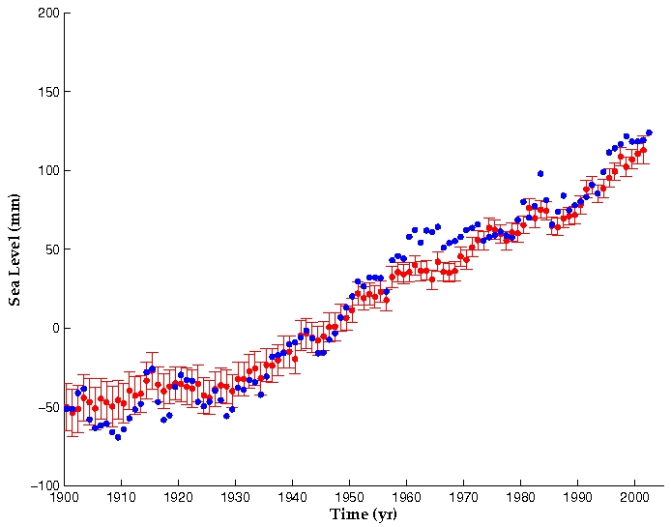

Fig.2: Comparison of altimetry-derived sea level curve for 1993-2008 from two groups. Upper curve (blue dots are smoothed 10-day data): CLS/AVISO; lower curve (blue dots are raw 10-day data): University of Colorado. The seasonal signal has been removed, an inverted barometer correction has been applied, and GIA (-0.3 mm/yr) corrected. The solid red curves correspond to 60-day smoothing.

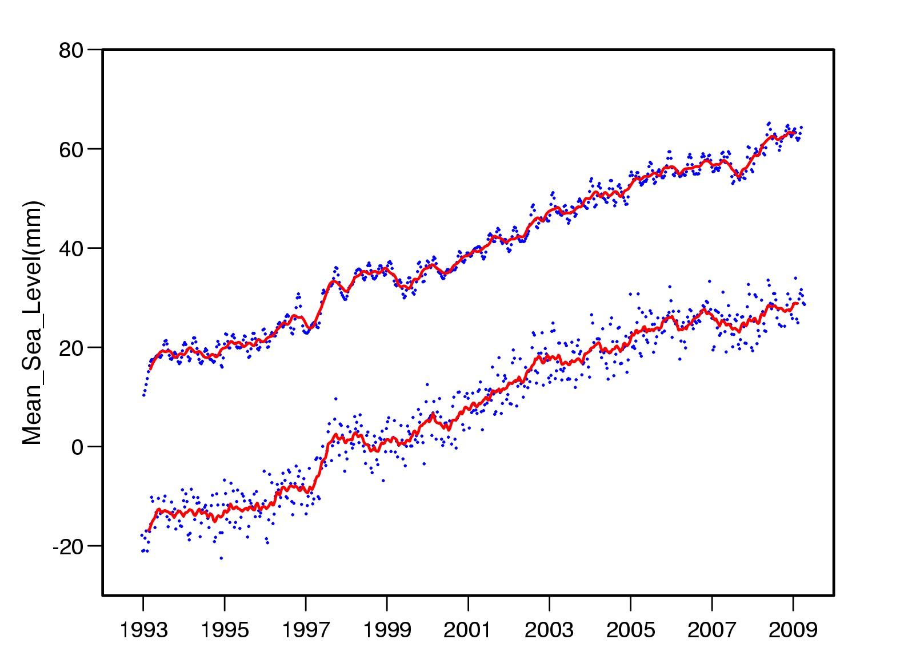

Fig.3: Spatial patterns in sea level trends (1993-2008) from T/P and Jason-1 satellite altimetry. The seasonal signal has been removed, and the inverted barometer correction applied. Source: University of Colorado

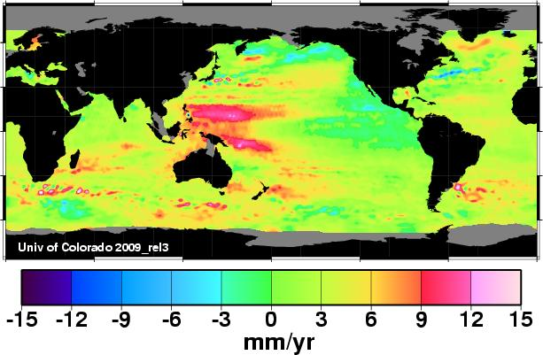

Fig.4: Reconstructed (observed) spatial patterns in sea level trends (from tide gauges and 2-D sea level data) over 1950-2000. (a) from Church et al.[2]; (b) from Llovel et al. [27]. A uniform trend has been removed to each grid.
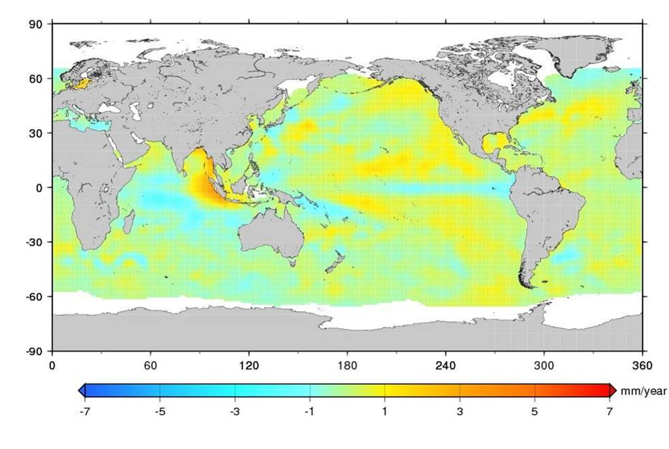
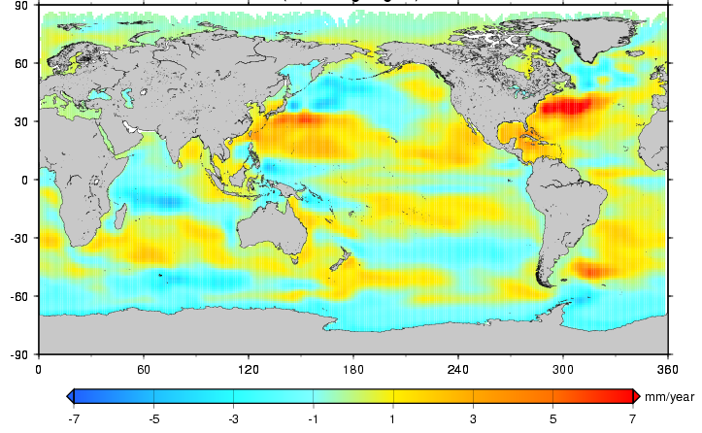

(a)
(b)

Fig.5: Modelled of past regional variability in sea level trends over the 20th century (1900-2007) using thermal expansion, tide gauges, satellite altimetry and GIA. Estimated global mean sea level rise for 20th century: 2.2 ± 0.57 mm/yr. Source: Shum & Kuo [14]
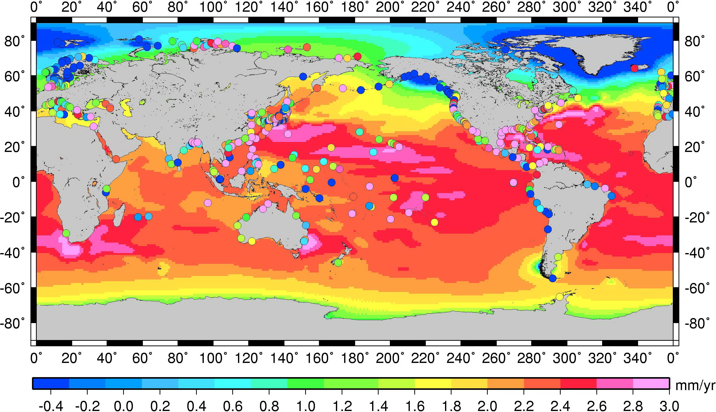

Fig.6: Global mean sea level evolution between 1500 and 2100 based on observations (geology, tide gauges, altimetry) up to 2000 and model projections from coupled climate models and empirical methods for the 21st century. Source: modified from Shum et al.[13].

